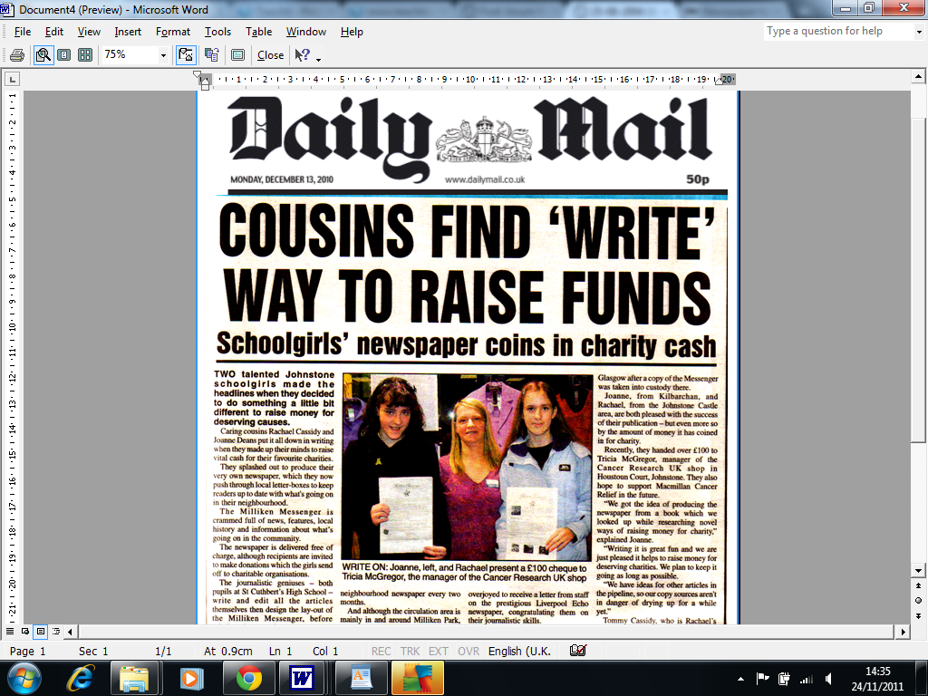
KEY WORDS
Newspaper Name Image Detailed paragraphs
Price Headline Caption
Columns Facts and opinions Subheading

