Assalamu Alaikum,
Alhamdulillah half term is here and next week we will study how coasts are formed, including looking at the processes of erosion and deposition.
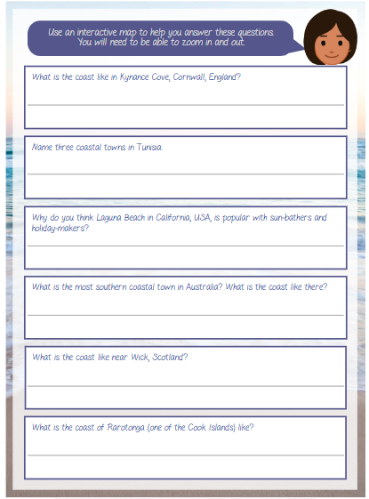
I would like you to do a poster or a project on a Famous Coast that you know (Anywhere in the world – You can choose). Here are some ideas below.
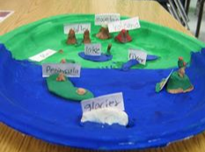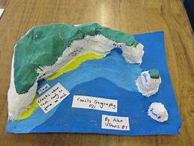
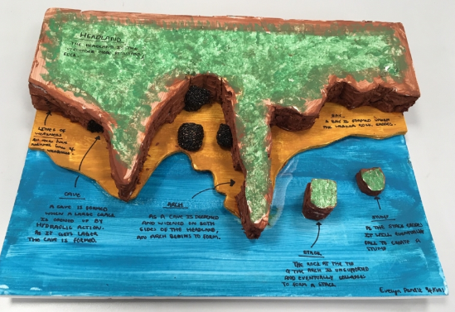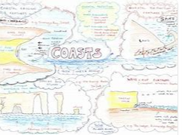
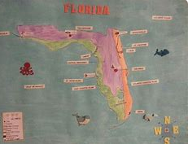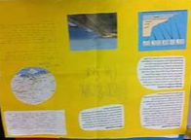
I really look forward to seeing all your amazing posters or projects.
Have Fun
Miss Aisha and Miss Sultana

