Evergreen Primary School
Sexting Safeguarding Policy
Including EYFS

Complied by: Rena Begum
Reviewed by: Zainab Ali
Reviewed on: September 2022
Next review Date: September 2023

Introduction

‘Sexting’ is one of a number of ‘risk-taking’ behaviours associated with the use of digital devices, social media or the internet. It is accepted that young people experiment and challenge boundaries and therefore the risks associated with ‘online’ activity can never be completely eliminated. However Evergreen Primary School takes a pro-active approach in its ICT and Enrichment programmes to help students to understand, assess, manage and avoid the risks associated with ‘online activity’. The school recognises its duty of care to its young people who do find themselves involved in such activity as well as its responsibility to report such behaviours where legal or safeguarding boundaries are crossed.

There are a number of definitions of ‘sexting’ but for the purposes of this policy sexting is simply defined as:

Images or videos generated by children under the age of 18, or of children under the age of 18 that are of a sexual nature or are indecent.

These images are shared between young people and/or adults via a mobile phone, handheld device, computer, ‘tablet’ or website with people they may not even know.

Some of the legalities of ‘sexting’ are outlined in Appendix 1.

There are many different types of sexting (see Appendix 2) and it is likely that no two cases will be the same. It is necessary to carefully consider each case on its own merit. However, it is important that the school applies a consistent approach when dealing with an incident to help protect young people and the school. For this reason the Designated Safeguarding Lead needs to be informed of any ‘sexting’ incidents. The range of contributory factors in each case also needs to be considered in order to determine an appropriate and proportionate response. All colleagues are expected to be aware of this policy.

The decisions made by the Designated Safeguarding Lead will be guided by a pathway (Appendix

Steps to take in the case of an incident

Step 1 Disclosure by a child …

Sexting disclosures should follow the normal safeguarding practices and protocols. A child is likely to be very distressed especially if the image has been circulated widely and if they don’t know who has shared it, seen it or where it has ended up. They will need pastoral support during the disclosure and after the event. They may even need immediate protection or a referral to social services.
The following questions will help decide upon the best course of action:
- Is the child disclosing about themselves receiving an image, sending an image or sharing an image?
- What sort of image is it? Is it potentially illegal or is it inappropriate?
- Are the school child protection and safeguarding policies and practices being followed? For example, is a member of the child protection team on hand and is their advice and support available?
- How widely has the image been shared and is the device in their possession?
- Is it a school device or a personal device?
- Does the child need immediate support and or protection?
- Are there other students and or young people involved?
- Do they know where the image has ended up?
This situation will need to be handled very sensitively. Whatever the nature of the incident, ensure school safeguarding and child protection policies and practices are adhered to.

Step 2 Searching a device – what are the rules?

It may be that the image is not on one single device: it may be on a website or on a multitude of devices; it may be on either a school-owned or personal device. It is important to establish the location of the image but be aware that this may be distressing for the young person involved, so be conscious of the support they may need.
The revised Education Act 2011 brought to bear significant new powers and freedoms for teachers and schools. Essentially, the Act gives schools and/or teachers the power to seize and search an electronic device if they think there is good reason for doing so.
A device can be examined, confiscated and securely stored if there is reason to believe it contains indecent images or extreme pornography. When searching a mobile device the following conditions should apply:
- The action is in accordance with the school’s child protection and safeguarding policies
- The search is conducted by the head teacher or a person authorised by them
- A member of the safeguarding team is present
- The search is conducted by a member of the same sex
If any illegal images of a child are found you should consider whether to inform the police. As a general rule it will almost always be proportionate to refer any incident involving “aggravated” sharing of images to the police whereas purely “experimental” conduct may proportionately be dealt with without such referral, most particularly if it involves the child sharing images of themselves.
Any conduct involving, or possibly involving, the knowledge or participation of adults should always be referred to the police.

If an “experimental” incident is not referred to the police the reasons for this should be recorded in writing.
Always put the child first. Do not search the device if this will cause additional stress to the student/person whose image has been distributed.

Never …
- Search a mobile device even in response to an allegation or disclosure if this is likely to cause additional stress to the student/young person UNLESS there is clear evidence to suggest that there is an immediate problem
- Print out any material for evidence
- Move any material from one storage device to another

Always...
- Inform the school Designated Safeguarding Lead (DSL)
- Record the incident
- Act in accordance with school safeguarding and child protection policies and procedures
- Inform relevant colleagues/senior management team about the alleged incident before searching a device
If there is an indecent image of a child on a website or a social networking site then you should report the image to the site hosting it. Under normal circumstances you would follow the reporting procedures on the respective website; however, in the case of a sexting incident involving a child or young person where you feel that they may be at risk of abuse then you should report the incident directly to CEOP www.ceop.police.uk/ceop-report, so that law enforcement can make an assessment, expedite the case

Step 3 What to do and not do with the image …

If the image has been shared across a personal mobile device:

Always …
- Confiscate and secure the device(s)

Never...
- View the image unless there is a clear reason to do so (see bullet 2 above)
- Send, share or save the image anywhere
- Allow students to do any of the above
If the image has been shared across a school network, a website or a social network:

Always …
- Block the network to all users and isolate the image

Never ...
- Send or print the image
- Move the material from one place to another
- View the image outside of the protocols in your safeguarding and child protection policies and procedures.

Step 4 Who should deal with the incident .. .

Often, the first port of call for a child is a class teacher. Whomever the initial disclosure is made to must act in accordance with the school child protection policy, ensuring that a member of the child protection team and a senior member of staff are involved in dealing with the incident.

The DSL (designated safeguarding lead) should always record the incident. Senior management should also always be informed. There may be instances where the image needs to be viewed and this should be done in accordance with protocols. The best interests of the child should always come first; if viewing the image is likely to cause additional stress, professionals should make a judgment about whether or not it is appropriate to do so.

Step 5 Deciding on a response …

There may be a multitude of reasons why a child has engaged in sexting – it may be a romantic/sexual exploration scenario or it may be due to coercion.
It is important to remember that it won’t always be appropriate to inform the police; this will depend on the nature of the incident. However, as a school it is important that incidents are consistently recorded. It may also be necessary to assist the young person in removing the image from a website or elsewhere.
The flowcharts in Annexes 1 and 2 will help you to decide on your response. If indecent images of a child are found:
- Act in accordance with your child protection and safeguarding policy, e.g. notify SMT/pastoral team
- Store the device securely
- Carry out a risk assessment in relation to the young person (Use Annex 1 and 2 for support)
- Make a referral if needed
- Contact the police (if appropriate)
- Put the necessary safeguards in place for the student, e.g. they may need counselling support, immediate protection and parents must also be informed.
- Inform parents and/or carers about the incident and how it is being managed.

Step 6 Contacting other agencies (making a referral) …
If the nature of the incident is high-risk, consider contacting your local children’s social care team. (Annex 1: ‘Sexting: Response Process for Professionals’ and the ‘Risk Assessment Tool for Young People’ in Annex 2 will help you to decide.) Depending on the nature of the
incident and the response you may also consider contacting your local police or referring the incident to CEOP.
Understanding the nature of the incident will help to determine the appropriate course of action. The following case studies exemplify the varying nature of sexting incidents and appropriate levels of response.

Step 7 Containing the incident and managing student reaction …

The child will be anxious about who has seen the image and where it has ended up. They will seek reassurance regarding its removal from the platform on which it was shared. They are likely to need support from the school, their parents and their friends. Consider engaging with your local police and asking them to talk to the students.
Other staff may need to be informed of incidents and should be prepared to act if the issue is continued or referred to by other students. The school, its children and parents should be on high alert, challenging behaviour and ensuring that the victim is well cared for and protected. The child’s parents should usually be told what has happened so that they can keep a watchful eye over their child, especially when they are online at home.
Creating a supportive environment for students in relation to the incident is very important.

Step 8 Reviewing outcomes and procedures to prevent further incidents
Reviewing the process ensures that the matter has been managed effectively and that the school has the capacity to learn and improve its handling procedures.
The issue of sexting should be referenced within the document Sharing semi nude and Nude Non statutory guidance as well as all relevant school policies. For example:
- ‘Acceptable Use’ policies;
- Behaviour policies;
- Child protection policies
- Anti-bullying policies
- Home-school agreements
Incidents of sexting will not be tolerated and that sanctions will be enforced if any member of the school community breaches any of the policies.
Sexting incidents should follow child protection procedures. Consider a proportionate level of response to each incident, taking care not to further traumatise the victim by imposing unwarranted sanctions upon them. Annexes 1 and 2 offer guidance on appropriate courses of action and considerations when handling an incident.

Covid 19 – addendum
Remote learning : All staff have thoroughly been trained and informed regarding GDPR and the new non statutory semi nude and nude guidance.

‘SEXTING’ POLICY - APPENDIX 1
The Legal Position

It is important to be aware that young people involved in sharing sexual videos and pictures may be committing a criminal offence. Specifically, crimes involving indecent photographs (including pseudo images) of a person under 18 years of age fall under Section 1 of the Protection of Children Act 1978 and Section 160 Criminal Justice Act 1988. Law on non consensual image sharing ( section 33 of the Criminal Justice and Courts Act 2015 added.

Under this legislation it is a crime to:
  - take an indecent photograph or allow an indecent photograph to be taken;
  - make an indecent photograph (this includes downloading or opening an image that has
been sent via email);
  - distribute or show such an image;
  - possess with the intention of distributing images;
  - advertise; and possess such images

While any decision to charge individuals for such offences is a matter for the Crown Prosecution Service, it is unlikely to be considered in the public interest to prosecute children. However, children need to be aware that they may be breaking the law. Although unlikely to be prosecuted, children and young people who send or possess images may be visited by police and on some occasions media equipment could be removed. This is more likely if they have distributed images.
The decision to criminalise children and young people for sending these kinds of images is a little unclear and may depend on local strategies. However, the current Association of Chief Police Officers (ACPO) position is that:
‘ACPO does not support the prosecution or criminalisation of children for taking indecent images of themselves and sharing them. Being prosecuted through the criminal justice system is likely to be upsetting and distressing for children especially if they are convicted and punished. The label of sex offender that would be applied to a child or young person convicted of such offences is regrettable, unjust and clearly detrimental to their future health and wellbeing.’

However, there are cases in which children and young people have been convicted and sent to prison. The important thing to remember is that whilst, as a school, we will want to consider the implications of reporting an incident over to the police, it is not our responsibility to make decisions about the seriousness of the matter; that responsibility lies with the Police and the CPS hence the requirement for the school to refer.
In summary sexting is classed as illegal as it constitutes sharing and/or possessing an indecent image of a child.

‘SEXTING’ POLICY - APPENDIX 2
Different Levels of Sexting
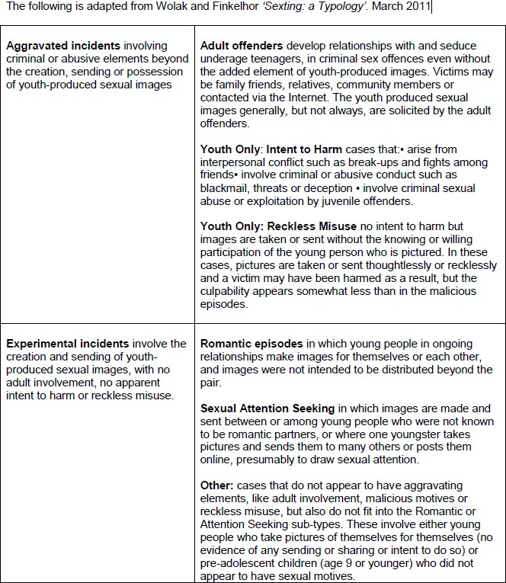

Sexting Policy Appendix 3

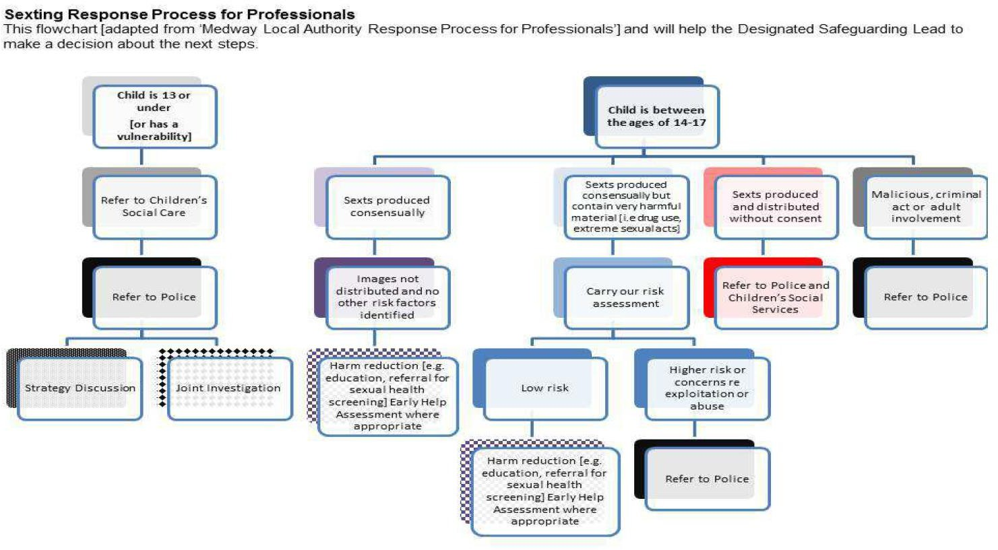

Case study 1
A group of year 6 pupils aged between 10 and 11 were speaking to each other on instant messenger and using webcams. One girl (with mild learning difficulties) was speaking on her laptop, which was upstairs in her bedroom. She was getting ready for bed and accidentally ‘flashed’ on webcam. Another pupil (girl aged 10) from the group told the class teacher what had happened the next day at school, who then reported the concern to the head teacher.
Action
The school’s Designated Child Protection Coordinator (DCPC) discussed the concern with both the children and parents of the other children involved. It was discussed with a local police officer and agreed that police action was not necessary but that they would support the school in speaking to the girl’s parents.
The girl’s parents had not considered the impact and possible risk of locating the laptop and its webcam in her bedroom. They agreed to take the laptop to a family area and only allow webcam use when supervised. The school consulted with social services but no action was taken.
The school revisited the subject of e-safety with all pupils in school (appropriate to age and ability) and wrote a letter to all parents directing them to advice and guidance about online safety at home. Specific advice was given to key stage two pupils about the safe use of webcams and sending images. Specific advice was given to the child concerned with support from the school’s Special Educational Needs officer (SENCO).

