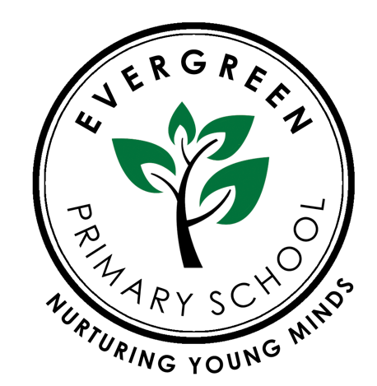

Evergreen Primary School including EYFS
Remote Education Provision: information for parents

Complied by: Rena Begum
Reviewed by: Zainab Ali
Reviewed on: September 2022
Next review Date: September 2023

This information is intended to provide clarity and transparency to pupils and parents or carers about what to expect from remote education where national or local restrictions require entire cohorts (or bubbles) to remain at home.
For details of what to expect where individual pupils are self-isolating, please see the final section of this page.
The remote curriculum: what is taught to pupils at home
A pupil’s first day or two of being educated remotely might look different from our standard approach, while we take all necessary actions to prepare for a longer period of remote teaching. It may consist of printed workbooks/sheets initially.
Following the first few days of remote education, will my child be taught broadly the same curriculum as they would if they were in school?
- We have English, Mathematics and Islamic studies/PSHE taught remotely as we do in school wherever possible and appropriate, we have incorporated other subject areas. However, we may need to make some adaptations in some subjects.
Remote teaching and study time each day
How long can I expect work set by the school to take my child each day?
We expect that remote education (including remote teaching and independent work) will take pupils broadly the following number of hours each day:
Nursery will continue to remain open during national lockdown as per Government guidelines.
Reception | 2 hours (although this may be inappropriate for some young children)
Key Stage 1 | 3.5 hours (although this may be inappropriate for some young children)
Key Stage 2 | 5 hours

Accessing remote education
How will my child access any online remote education you are providing?
Currently teachers will be available throughout the school day and will ensure 1 phone call is made to each child to corroborate the child’s experience of learning during National Lockdown. Teachers will use the information to then respond to work upon return to school. Activities will be a mixture of English, Math’s and Foundation subjects.
Microsoft Teams will be introduced for older children at a future date.

If my child does not have digital or online access at home, how will you support them to access remote education?
We recognise that some pupils may not have suitable online access at home. We take the following approaches to support those pupils to access remote education:
- Laptops will be issued to parents requesting one due to lack of devices in the home. Families have been contacted to inform them to telephone school if they require a laptop. These have been delivered to families who have signed a user agreement.
- Information has been emailed to all families regarding how to contact school for help to enable an internet connection.
- Families may request paper copies of work. This will be delivered weekly , completed work can be sent via scan email from most phone apps
How will my child be taught remotely?
We use a combination of the following approaches to teach pupils remotely:
- recorded teaching (e.g. Invicta Academy / Oak National Academy lessons, video/audio recordings made by teachers)
- uploaded activities prepared by the teacher daily onto the school home learning portal
- printed paper packs produced by teachers (e.g. workbooks, worksheets)
- textbooks and reading books pupils have at home
- commercially available websites supporting the teaching of specific subjects or areas, including video clips or sequences
- long-term project work and/or internet research activities.
How will you check whether my child is engaging with their work and how will I be informed if there are concerns?
- Teachers will keep a record of who is engaging daily in the work set and parents will be contacted weekly if there are any concerns to offer support and advice. The DSL will closely monitor this with the teachers.

How will you assess my child’s work and progress?
- During National Lockdown one teacher from each year group will be available throughout the school day to provide feedback on daily lessons and work and to answer any questions that may arise this will allow clarifications of any misconceptions and challenges to individual children..
Additional support for pupils with particular needs
How will you work with me to help my child who needs additional support from adults at home to access remote education?
We recognise that some pupils, for example some pupils with special educational needs and disabilities (SEND), may not be able to access remote education without support from adults at home. We acknowledge the difficulties this may place on families, and we will work with parents and carers to support those pupils in the following ways:
- We will contact families of children with particular needs weekly to check in on progress and offer support where necessary.
- Work will be differentiated carefully to meet the needs of these children.
- Paper copies will be made available to all who request if they feel their children will access the curriculum better in this way. These copies can be adapted (e.g. enlarged) to meet the needs of particular children)
Remote education for self-isolating pupils
If my child is not in school because they are self-isolating, how will their remote education differ from the approaches described above?
- Children self -isolating at home will receive work through school website on the isolation portal. If the rest of the year group are in school a teacher may not be available all day, as in the case of National Lockdown, but work submitted will be marked and feedback will be given at points during the day.
- The education welfare officer and DSL will closely monitor this

