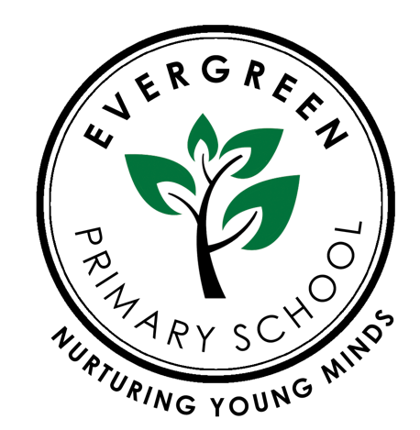

RELATIONSHIPS AND HEALTH EDUCATION POLICY
INCLUDING EYFS

Complied by: Rena Begum
Reviewed by: Zainab Ali
Reviewed on: September 2022
Next review Date: September 2023

Our school is:
a safe, supportive stimulating learning environment; a team of respectful, tolerant, open minded citizens;
a community where everyone aspires to be the very best they can be;
a community of resilient lifelong learners;
a centre of excellence where all achieve success.

PURPOSE

This policy contains information on how our school will meet its legal duties, with which schools must comply, when teaching Relationships Education and Health Education.

CONTENTS

1. Introduction | - 2 -
2. Development of the Policy | - 2 -
3. Consultation with parents | - 3 -
4. Curriculum Content | - 3 -
5. Relationships Education | - 3 -
6. Health Education | - 5 -
7. Delivery | - 7 -
8. Questions | - 8 -
9. Equality and accessibility | - 8 -
10. Sex education | - 9 -
11. Parents’ right to withdraw | - 9 -
12. Monitoring and review | - 10 -
Appendix 1 Consultation partners: | - 11 -

Appendix 2 How Evergreen Primary School consulted parents in the development and delivery of
the curriculum: - 12 -
Appendix 3: How Evergreen Primary School covers the statutory content of relationships and
health education across the school’s curriculum: Appendix 4: Objectives taught and terminology used in the science curriculum as set out in the National Curriculum - 28 -

Introduction
This policy has been written in accordance with the statutory guidance from the Department for Education issued under Section 80A of the Education Act 2002 and section 403 of the Education Act 1996. This policy contains information on how our school will meet its legal duties, with which schools must comply, when teaching Relationships Education and Health Education.

The Relationships Education and Health Education (England) Regulations 2019, make Relationships Education compulsory for all pupils receiving primary education. They also make Health Education compulsory in all schools except independent schools. Personal, Social, Health and Economic Education (PSHE) continues to be compulsory in independent schools.
For the purpose of this policy, “relationships education” is defined as teaching pupils about healthy, respectful relationships, focusing on family and friendships, in all contexts, including online.
For the purpose of this policy, “health education” is defined as teaching pupils about physical health and mental wellbeing, focusing on recognising the link between the two and being able to make healthy lifestyle choices.

Consultation with parents

The school understands the important role parents play in enhancing their children’s understanding of relationships and health. Similarly, we also understand how important parents’ views are in shaping the curriculum.
The school works closely with parents by establishing open communication – all parents are consulted in the development and delivery of the curriculum, as outlined in Appendix 2 of this policy.
Parents are provided with the following information:

- The content of the relationships and health curriculum
- The delivery of the relationships and health curriculum, including what is taught in each year group
- The legalities surrounding withdrawing their child from the subjects
- The resources that will be used to support the curriculum

The school aims to build positive relationships with parents by inviting them into school to discuss what will be taught, address any concerns and help parents in managing conversations with their children on the issues covered by the curriculum.

Parents will be informed at parent meetings and through the school website about the content of the Relationships and Heath Education taught in each year group. Parents will be invited to discuss the content with the class teacher. In addition, parents will be consulted in the review of the curriculum and this policy, and are encouraged to provide their views at any time.

Curriculum Content
Relationships and health education focusses on giving pupils the knowledge they need to make informed decisions about their wellbeing, health and relationships, and to build their self-efficacy. Health education focusses on equipping pupils with the knowledge they need to make good decisions about their own health and wellbeing.

We understand our responsibility to deliver a high-quality, age-appropriate relationship and health curriculum for all our pupils. This policy sets out the framework for our relationships and health curriculum, providing clarity on how it is informed, organised and delivered (Appendix 3).

Relationships Education
The focus in primary school should be on teaching the fundamental building blocks and characteristics of positive relationships, with particular reference to
  - Families and people who care about me
  - Caring friendships
  - Respectful relationships
  - Online relationships
  - Being safe

See table below for the content laid out in the DfE Guidance:

Families | That families are important for children growing up because they can give love, security and stability  The characteristics of healthy family life, commitment to each other, including in times of difficulty, protection and care for children and other family members, the importance of spending time together and sharing each other’s lives  That others’ families, either in school or in the wider world, sometimes look different from their family, but that they should respect those differences and know that other children’s families are also characterised by love and care  That stable, caring relationships, which may be of different types, are at the heart of happy families, and are important for children’s security as they grow up  That marriage represents a formal and legally recognised commitment of two people to each other which is intended to be lifelong  How to recognise if family relationships are making them feel unhappy or unsafe, and how to seek help or advice from others if needed

Caring Relationships | How important friendships are in making us feel happy and secure, and how people choose and make friends  The characteristics of friendships, including mutual respect, truthfulness, trustworthiness, loyalty, kindness, generosity, trust, sharing interests and experiences and support with problems and difficulties  That healthy friendships are positive and welcoming towards others, and do not make others feel lonely or excluded  That most friendships have ups and downs, and that these can often be worked through so that the friendship is repaired or even strengthened, and that resorting to violence is never right  How to recognise who to trust and who not to trust, how to judge when a friendship is making them feel unhappy or uncomfortable, managing conflict, how to manage these situations and how to seek help or advice from others, if needed
Respectful Relationships | The importance of respecting others, even when they are very different from them (for example, physically, in character, personality or backgrounds), or make different choices or have different preferences or beliefs  Practical steps they can take in a range of different contexts to improve or support respectful relationships  The conventions of courtesy and manners  The importance of self-respect and how this links to their own happiness  That in school and in wider society they can expect to be treated with respect by others, and that in turn they should show due respect to others, including those in positions of authority  About different types of bullying (including cyberbullying), the impact of bullying, responsibilities of bystanders (primarily reporting bullying to an adult) and how to get help  What a stereotype is, and how stereotypes can be unfair, negative or destructive The importance of permission-seeking and giving in relationships with friends, peers and adults

That people sometimes behave differently online, including by pretending to be someone they are not
That the same principles apply to online relationships as to face-to face relationships, including the importance of respect for others online including when we are anonymous
The rules and principles for keeping safe online, how to recognise risks, harmful content and contact, and how to report them
How to critically consider their online friendships and sources of information including awareness of the risks associated with people they have never met How information and data is shared and used online
Being safe | What sorts of boundaries are appropriate in friendships with peers and others (including in a digital context)  About the concept of privacy and the implications of it for both children and adults; including that it is not always right to keep secrets if they relate to being safe  That each person’s body belongs to them, and the differences between appropriate and inappropriate or unsafe physical, and other, contact  How to respond safely and appropriately to adults they may encounter (in all contexts, including online) whom they do not know  How to recognise and report feelings of being unsafe or feeling bad about any adult  How to ask for advice or help for themselves or others, and to keep trying until they are heard  How to report concerns or abuse, and the vocabulary and confidence needed to do so  Where to get advice e.g. family, school and/or other sources

Health Education
The aim of teaching pupils about physical health and mental wellbeing is to give them the information that they need to make good decisions about their own health and wellbeing. It should enable them to recognise what is normal and what is an issue in themselves and others and, when issues arise, know how to seek support as early as possible from appropriate sources.

  - Mental wellbeing
  - Internet safety and harms
  - Physical health and fitness
  - Healthy eating
  - Drugs, alcohol and tobacco
  - Health and prevention
  - Basic first aid
  - Changing adolescent body

See table below for the content laid out in the DfE Guidance:

Mental wellbeing | Mental wellbeing is a normal part of daily life, in the same way as physical health. There is a normal range of emotions (e.g. happiness, sadness, anger, fear, surprise, nervousness) and scale of emotions that all humans experience in relation to different experiences and situations.  How to recognise and talk about their emotions, including having a varied vocabulary of words to use when talking about their own and others’ feelings. How to judge whether what they are feeling and how they are behaving is appropriate and proportionate.  The benefits of physical exercise, time outdoors, community participation, voluntary and service-based activity on mental wellbeing and happiness.  Simple self-care techniques, including the importance of rest, time spent with friends and family and the benefits of hobbies and interests.  Isolation and loneliness can affect children and that it is very important for children to discuss their feelings with an adult and seek support.  Bullying (including cyberbullying) has a negative and often lasting impact on mental wellbeing.  Where and how to seek support (including recognising the triggers for seeking support), including whom in school they should speak to if they are worried about their own or someone else’s mental wellbeing or ability to control their emotions (including issues arising online).  It is common for people to experience mental ill health. For many people who do, the problems can be resolved if the right support is made available, especially if accessed early enough.
Internet safety and harms | For most people the internet is an integral part of life and has many benefits.  About the benefits of rationing time spent online, the risks of excessive time spent on electronic devices and the impact of positive and negative content online on their own and others’ mental and physical wellbeing.  How to consider the effect of their online actions on others and know how to recognise and display respectful behaviour online and the importance of keeping personal information private.  Why social media, some computer games and online gaming, for example, are age restricted.  The internet can also be a negative place where online abuse, trolling, bullying and harassment can take place, which can have a negative impact on mental health.  How to be a discerning consumer of information online including understanding that information, including that from search engines, is ranked, selected and targeted.  Where and how to report concerns and get support with issues online
Physical Health and Fitness | The characteristics and mental and physical benefits of an active lifestyle.  The importance of building regular exercise into daily and weekly routines and how to achieve this; for example walking or cycling to school, a daily active mile or other forms of regular, vigorous exercise.  The risks associated with an inactive lifestyle (including obesity).  How and when to seek support including which adults to speak to in school if they are worried about their health.

Healthy Eating | What constitutes a healthy diet (including understanding calories and other nutritional content).  The principles of planning and preparing a range of healthy meals.  The characteristics of a poor diet and risks associated with unhealthy eating (including, for example, obesity and tooth decay) and other behaviours (e.g. the impact of alcohol on diet or health).
Drugs alcohol and tobacco | The facts about legal and illegal harmful substances and associated risks, including smoking, alcohol use and drug-taking.
Health and Prevention | How to recognise early signs of physical illness, such as weight loss, or unexplained changes to the body.  About safe and unsafe exposure to the sun, and how to reduce the risk of sun damage, including skin cancer.  The importance of sufficient good quality sleep for good health and that a lack of sleep can affect weight, mood and ability to learn.  About dental health and the benefits of good oral hygiene and dental flossing, including regular check-ups at the dentist.  About personal hygiene and germs including bacteria, viruses, how they are spread and treated, and the importance of handwashing.  The facts and science relating to allergies, immunisation and vaccination.
Basic First Aid | How to make a clear and efficient call to emergency services if necessary.  Concepts of basic first-aid, for example dealing with common injuries, including head injuries.
Changing adolescent body | Key facts about puberty and the changing adolescent body, particularly from age 9 through to age 11 including physical and emotional changes.  About menstrual wellbeing including the key facts about the menstrual cycle.

Delivery
Relationships and Health Education is taught throughout the whole school curriculum. This includes within the Personal, Social, Health Education (PSHE) curriculum, science curriculum, Physical Education (PE), computing and some aspects are included in religious education (RE). (Please see Appendix 3 for coverage of the statutory content across the school’s curriculum.) Pupils will mainly be taught in their class groups. Single gender lessons will be used as deemed appropriate by the school eg about the changing body. It is important to note that although separated groups may have different activities, the messages and information they receive will be consistent. It is important that children learn about all changes not just their own.
Through effective organisation and delivery of the subject, we will ensure that:

  - Core knowledge is sectioned into units of manageable size.
  - The required content is communicated to pupils clearly, in a carefully sequenced way, within a planned scheme of work.
  - Teaching includes sufficient and well-chosen opportunities and contexts for pupils to embed new knowledge so that it can be used confidently in real-life situations.

In addition, teachers will:
  - Deliver a high-quality and age-appropriate relationships and health curriculum in line with school and statutory requirements.
  - Use a variety of teaching methods and resources to provide an engaging curriculum that meets the needs of all pupils.
  - Ensure they do not express personal views or beliefs when delivering the programme.
  - Model positive attitudes to relationships and health education.
  - Respond to any safeguarding concerns in line with the Child Protection and Safeguarding Policy.

Questions

Teachers will attempt to answer pupils’ questions and concerns in a sensitive, age and development appropriate manner. Individual teachers will use skill and discretion in these situations and refer to the Relationships and Health Education Lead.

Teachers will apply the following principles:

  - Clear ground rules will be established and set out for each session
  - Pupil questions will be encouraged and opportunities to ask questions openly and in private eg. post it notes/question boxes will be provided
  - Clarity about the topics being taught will be shared with pupils
  - If a child’s question is not appropriate to answer in front of the class, the teacher will explain calmly that this is not part of today’s discussion and will discuss later.
  - Individual questions may be answered by the teacher at the end of the session.
  - Some questions may be referred to the child’s parents to provide an answer; in these circumstances the class teacher will make contact.

All staff members at the school will undergo training on a yearly basis to ensure they are up-to-date with the relationship and health education programme and associated issues.
Members of staff responsible for teaching the subjects will undergo further training led by the relationships and health education subject leader, to ensure they are fully equipped to teach the subjects effectively.

Training of staff will also be scheduled around any updated guidance on the programme and any new developments, which may need to be addressed in relation to the programme.

Equality and accessibility
The school creates a safe environment where all staff and children are respected and free to express their beliefs and opinions without fear of discrimination. The school understands its responsibilities in relation to the Equality Act 2010, specifically, that it must not unlawfully discriminate against:
- Women/girls and men/boys
- People of different races
- Disabled people

- People with different religions or beliefs or with no religion or belief
- People of different ages
- Lesbian, gay and bisexual and straight people
- People who have changed their sex
The school is committed to making reasonable adjustments wherever possible to promote accessibility and inclusivity of the curriculum. The school understands that pupils with SEND or other needs (such as those with social, emotional or mental health needs) are entitled to learn about relationships and health education, and the programme will be designed to be inclusive of all pupils.
Teachers will understand that they may need to be more explicit and adapt their planning of work and teaching methods in order to appropriately deliver the programme to pupils with SEND or other needs.
The curriculum will be taught within the context of family life, taking care to ensure that there is no stigmatisation of children based on their home circumstances along with reflecting sensitively that some children may have a different structure of support around them.
Provisions under the Equality Act 2010 allow our school to take positive action, where it can be evidenced to be proportionate, to respond to particular disadvantages affecting a group because of a protected characteristic. When deciding whether support is necessary to support pupils with a particular protected characteristic, we will consider our pupils’ needs, including the gender and age range of our pupils.

We will encourage children to be respectful of the differences between boys and girls, but we will also be careful of assuming that boys and girls have distinct characteristics which can lead to negative stereotyping. For example, we will discourage negative characterisation of gender such as “boys don’t cry”, or “girls shouldn’t play football” and dispel any manifestations of discrimination from an early age. In order to foster healthy and respectful peer-to-peer communication and behaviour between boys and girls, the school implements a robust Behaviour Policy, which sets out our expectations of pupils.

Sex education

The Proprietors have agreed that the school will not be delivering sex education except as part of Health education where the changing of the adolescent body topics will be taught in single sex groups and, where possible, by a member of staff of the same gender.

In line with our school’s safeguarding policy, if a child is at risk of sexual harm, additional actions will be taken to ensure children have the knowledge and skills to keep themselves and others safe.

Parents’ right to withdraw
Parents do not have the right to withdraw their children from relationships and health education.

Monitoring and review

This policy will be reviewed on an annual basis by the relationships and health education subject lead, Head Teacher and Proprietors The next scheduled review date for this policy is 07 July 2022. This policy will also be reviewed in light of any changes to statutory guidance, feedback from parents, staff or pupils, and issues in the school or local area that may need addressing.
The Proprietorial board is responsible for approving this policy.
Any changes made to this policy will be communicated to all staff and parents by the school website.

Appendix 2 How Evergreen Primary School consulted parents in the development and delivery of the curriculum:
Our school understands the important role parent’s play in enhancing their children’s understanding of relationships and health. Parents’ views are important in shaping the curriculum.
Our school works closely with parents by establishing open communication – all parents are consulted in the development and delivery of the curriculum through zoom meeting letters and surveys. Parents are provided with the following information:

- The content of the relationships and health curriculum
- The delivery of the relationships and health curriculum, including what is taught in each year group.
- The legalities surrounding withdrawing their child from the subjects
- The resources that will be used to support the curriculum.

Our school aims to build positive relationships with parents and we invite them into school to discuss what will be taught, address any concerns and help parents in managing conversations with their children on the issues covered by the curriculum.
Parents are encouraged to provide their views at any time.

Linked Policies
This policy must be read in conjuncture with the following linked policies

- Mental health  - PSHE | - Anti Bullying  - Cyber Bullying | - Behavior Policy  - Digital Resilience Policy | - Child Protection

Appendix:
Sexual violence and sexual harrassment:
The Department for Education published the new ‘Keeping Children Safe in Education’ For 01st September 2022. Part five: Child on child sexual violence and sexual harassment will be adhered to in monitoring any sexual violence behaviour offline/online.

https://assets.publishing.service.gov.uk/government/uploads/system/uploads/attachment_data/file/999239/SVSH_2021.pdf

Appendix 3: Relationships and Health Education Statutory Content & Shared Resources – this is a working document, more information is found within the curriculum compliance audit
Families
Statutory Content
- That families are important for children growing up because they can give love, security and stability  - The characteristics of healthy family life, commitment to each other, including in times of difficulty, protection and care for children and other family members, the importance of spending time together and sharing each other’s lives  - That others’ families, either in school or in the wider world, sometimes look different from their family, but that they should respect those differences and know that other children’s families are also characterised by love and care  - That stable, caring relationships, which may be of different types, are at the heart of happy families, and are important for children’s security as they grow up  - That marriage represents a formal and legally recognised commitment of two people to each other which is intended to be lifelong | EYFS (Not Statutory)  My Mum/ My Dad – Anthony Browne Owl Babies – Martin Waddell Monkey Puzzle – Julia Donaldson Peace at last – Jill Murphy  Stick Man – Julia Donaldson  Children to share photos of their family members
 | Key Stage One (Y1&2)
 | Lower Key Stage 2 (Y3&4)
 | Upper Key Stage 2 (Y5&6)
- How to recognise if family relationships are making them feel unhappy or unsafe, and how to seek help or advice from others if needed

Caring Relationships
Statutory Content |  | Year Groups
- How important friendships are in making us feel happy and secure, and how people choose and make friends  - The characteristics of friendships, including mutual respect, truthfulness, trustworthiness, loyalty, kindness, generosity, trust, sharing interests and experiences and support with problems and difficulties  - That healthy friendships are positive and welcoming towards others, and do not make others feel lonely or excluded  - That most friendships have ups and downs, and that these can often be worked through so that the friendship is repaired or even strengthened, and that resorting to violence is never right  - How to recognise who to trust and who not to trust, how to judge when a friendship is making them feel unhappy or uncomfortable, managing conflict, how to manage these situations and how to seek help or advice from others, if needed |  | EYFS (Not Statutory)
 |  | Key Stage One (Y1&2)
 |  | Lower Key Stage 2 (Y3&4)
 | Upper Key Stage 2 (Y5&6)

Respectful Relationships
Statutory Content
- Practical steps they can take in a range of different contexts to improve or support respectful relationships  - The conventions of courtesy and manners  - The importance of self- respect and how this links to their own happiness  - That in school and in wider society they can expect to be treated with respect by others, and that in turn they should show due respect to others, including those in positions of authority  - About different types of bullying (including cyberbullying), the impact of bullying, responsibilities of bystanders (primarily reporting bullying to an adult) and how to get help  - What a stereotype is, and how stereotypes can be unfair, negative or destructive  - The importance of permission-seeking and giving in relationships with friends, peers and adults | EYFS (Not Statutory)  The Rainbow fish – Marcus Pfister Tidy Titch – Pat Hutchins  Learning the names of our new friends  Respecting one another and the classroom provision Using manners at lunchtime and around school  Anti-Bullying Alliance- Resources for Anti-Bullying Week  Ways to Look after yourself- washing hands, eating your lunch and doing things that make you happy  Permission seeking – rules for playing games, asking adults for permission e.g. to go out of the classroom and why it is important (fire,  safety)
 | Key Stage One (Y1&2)
 | Lower Key Stage 2 (Y3&4)
 |  | Upper Key Stage 2 (Y5&6)

Online Relationships
Statutory Content | Year Groups
- The importance of respecting others, even when they are very different from them (for example, physically, in character, personality or backgrounds), or make different choices or have different preferences or beliefs  - That people sometimes behave differently online, including by pretending to be someone they are not  - That the same principles apply to online relationships as to face-to face relationships, including the importance of respect for others online including when we are anonymous  - The rules and principles for keeping safe online, how to recognise risks, harmful content and contact, and how to report them  - How to critically consider their online friendships and sources of information including awareness of the risks associated with people they have never met  - How information and data is shared and used online | EYFS (Not Statutory)
 | Key Stage One (Y1&2)
 | Lower Key Stage 2 (Y3&4)
 | Upper Key Stage 2 (Y5&6)

Being Safe
Statutory Content
- What sorts of boundaries are appropriate in friendships with peers and others (including in a digital context)  - About the concept of privacy and the implications of it for both children and adults; including that it is not always right to keep secrets if they relate to being safe  - That each person’s body belongs to them, and the differences between appropriate and inappropriate or unsafe physical, and other, contact  - How to respond safely and appropriately to adults they may encounter (in all contexts, including online) whom they do not know  - How to recognise and report feelings of being unsafe or feeling bad about any adult  - How to ask for advice or help for themselves or others, and to keep trying until they are heard  - How to report concerns or abuse, and the vocabulary and confidence needed to do so  - Where to get advice e.g. family, school and/or other sources | EYFS (Not Statutory)  Bog baby – Jeanne Willis What is a secret? Discussion Privacy- Using the toilets Little Red Riding Hood
 | Key Stage One (Y1&2)
 | Upper Key Stage 2 (Y5&6)
 | Lower Key Stage 2 (Y3&4)

Changing adolescent body
Statutory Content
- Key facts about puberty and the changing adolescent body, particularly from age 9 through to age 11 including physical and emotional changes.  - About menstrual wellbeing including the key facts about the menstrual cycle.  - identify, name, draw and label the basic parts of the human body and say which part of the body is associated with each sense.  - describe the differences in the life cycles of a mammal, an amphibian, an insect and a bird  - describe the life process of reproduction in some plants and animals.  - describe the changes as humans develop to old age.  - notice that animals, including humans, have offspring which grow into adults | EYFS (Not Statutory)  The very hungry caterpillar – Eric Carle Bog baby – Jeanne Willis
 | Key Stage One (Y1&2)
 | Lower Key Stage 2 (Y3&4)
 | Upper Key Stage 2 (Y5&6)

Mental Wellbeing
Statutory Content
- that mental wellbeing is a normal part of daily life, in the same way as physical health.  - that there is a normal range of emotions (e.g. happiness, sadness, anger, fear, surprise, nervousness) and scale of emotions that all humans experience in relation to different experiences and situations.  - how to recognise and talk about their emotions, including having a varied vocabulary of words to use when talking about their own and others’ feelings.  - how to judge whether what they are feeling and how they are behaving is appropriate and proportionate.  - the benefits of physical exercise, time outdoors, community participation, voluntary and service-based activity on mental wellbeing and happiness.  - simple self-care techniques, including the importance of rest, time spent with friends and family and the benefits of hobbies and interests.  - isolation and loneliness can affect children and that it is very important for children to discuss their feelings with an adult and seek support.  - that bullying (including cyberbullying) has a negative and often lasting impact on mental wellbeing.  - where and how to seek support (including recognising the triggers for seeking support), including whom in school they should speak to if they are worried about their own or someone else’s mental wellbeing or ability to control their emotions (including issues arising online).  - it is common for people to experience mental ill health. For many people who do, the problems can be resolved if the right support is made available, especially if accessed early enough. | EYFS (Not Statutory)  Feelings Fans- naming feelings  SEAL Photo cards-identifying feelings Children’s Mental Health Week Resources Anti-Bullying Week Resources  Go Noodle Mindfulness and exercise activities
 | Key Stage One (Y1&2)
 | Lower Key Stage 2 (Y3&4)
Upper Key Stage 2 (Y5&6)
Children’s Mental Health Week Resources Anti-Bullying Week Resources
Go Noodle Mindfulness and exercise activities SEAL Feelings Detective Posters
Hobbies- What hobbies do you have now and what hobbies do you see yourself having when you are older? How does following a hobby affect our health? Discussion.

Internet Safety and Harm
Statutory Content
- that for most people the internet is an integral part of life and has many benefits.  - about the benefits of rationing time spent online, the risks of excessive time spent on electronic devices and the impact of positive and negative content online on their own and others’ mental and physical wellbeing.  - how to consider the effect of their online actions on others and know how to recognise and display respectful behaviour online and the importance of keeping personal information private.  - why social media, some computer games and online gaming, for example, are age restricted.  - that the internet can also be a negative place where online abuse, trolling, bullying and harassment can take place, which can have a negative impact on mental health.  - how to be a discerning consumer of information online including understanding that information, including that from search engines, is ranked, selected and targeted.  - where and how to report concerns and get support with issues online. | EYFS (Not Statutory)  Links to Anti-Bullying Week, Child Mental Health Week and Safer Internet Day  https://www.thinkuknow.co.uk/
 | Key Stage One (Y1&2)
 | Lower Key Stage 2 (Y3&4)
 | Upper Key Stage 2 (Y5&6)

Physical Health and Fitness

Statutory Content
- the characteristics and mental and physical benefits of an active lifestyle.  - the importance of building regular exercise into daily and weekly routines and how to achieve this; for example walking or cycling to school, a daily active mile or other forms of regular, vigorous exercise.  - the risks associated with an inactive lifestyle (including obesity).  - how and when to seek support including which adults to speak to in school if they are worried about their health. | EYFS (Not Statutory)  - Take 10 in classrooms  - Joe Wicks Routines  - Links during Child Mental Health Week
Key Stage One (Y1&2) playground topic DT
Toys past and present autumn 1 plan bee
PE scheme of work

Lower Key Stage 2 (Y3&4)
-Take 10 in classrooms
-Joe Wicks Routines
-Links during Child Mental Health Week
-Discussion about who they can go to if they are concerned about their health

Upper Key Stage 2 (Y5&6)
-Take 10 in classrooms
- Joe Wicks Routines
- Links during Child Mental Health Week
- Discussion about who they can go to if they are concerned about their health

Healthy Eating
Statutory Content
- what constitutes a healthy diet (including understanding calories and other nutritional content).  - the principles of planning and preparing a range of healthy meals.  - the characteristics of a poor diet and risks associated with unhealthy eating (including, for example, obesity and tooth decay) and other behaviours (e.g. the impact of alcohol on diet or health). | EYFS (Not Statutory)  Food- https://www.nhs.uk/change4life Healthy Eating Resources  oral hygiene
Key Stage One (Y1&2)
Food- https://www.nhs.uk/change4life Healthy Eating Resources
Healthy and Unhealthy- sorting pictures of foods Teeth and sugar- coke experiment
Lower Key Stage 2 (Y3&4)
Food- https://www.nhs.uk/change4life Food Pyramid
 | Healthy and Unhealthy- sorting pictures of meals and explaining why
 | Healthy Eating Resources
 | Teeth and diet- facts. Investigation- Which drink contains the most sugar? Eating and digestion Science planbee
 | Upper Key Stage 2 (Y5&6)
 | Food- https://www.nhs.uk/change4life
 | Food Wheel
 | Healthy Eating Resources
 | Healthy Eating- nutritional content of food and traffic light system (food packaging)
 | Investigation- Which food contains the most calories?

Health and Prevention
Statutory Content
- how to recognise early signs of physical illness, such as weight loss, or unexplained changes to the body.  - about safe and unsafe exposure to the sun, and how to reduce the risk of sun damage, including skin cancer.  - the importance of sufficient good quality sleep for good health  and that a lack of sleep can affect weight, mood and ability to learn.  - about dental health and the benefits of good oral hygiene and dental flossing, including regular check-ups at the dentist.  - about personal hygiene and germs including bacteria, viruses, how they are spread and treated, and the importance of handwashing.  - the facts and science relating to allergies, immunisation and vaccination. | EYFS (Not Statutory) Sun Safe resources Teeth Resources
 | Key Stage One (Y1&2) Sun Safe resources Teeth Resources
Lower Key Stage 2 (Y3&4)
Sun Safe resources Teeth Resources

 | Upper Key Stage 2 (Y5&6)

Basic First Aid
Statutory Content
- how to make a clear and efficient call to emergency services if necessary.  - concepts of basic first-aid, for example dealing with common injuries, including head injuries. | EYFS (Not Statutory)  Who to go to in school if you hurt yourself.
Key Stage One (Y1&2)
Who to go to in school if you hurt yourself. Calling 999 in an emergency.
Red Cross Life Live it: Stay safe
Lower Key Stage 2 (Y3&4)
Who to go to in school if you hurt yourself. Calling 999 in an emergency.
Red Cross Life Live it: Stay safe
Upper Key Stage 2 (Y5&6)
Who to go to in school if you hurt yourself. Calling 999 in an emergency.
Red Cross Life Live it: Stay safe
first aid practical workshop summer term 2 -

Appendix 4: Objectives taught and terminology used in the science curriculum as set out in the National Curriculum

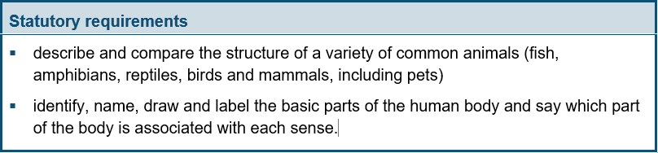
Year 1:
Notes and guidance (non-statutory)
Pupils should use the local environment throughout the year to explore and answer questions about animals in their habitat. They should understand how to take care of animals taken from their local environment and the need to return them safely after study. Pupils should become familiar with the common names of some fish, amphibians, reptiles, birds and mammals, including those that are kept as pets.
Pupils should have plenty of opportunities to learn the names of the main body parts (including head, neck, arms, elbows, legs, knees, face, ears, eyes, hair, mouth, teeth) through games, actions, songs and rhymes.
Pupils might work scientifically by: using their observations to compare and contrast animals at first hand or through videos and photographs, describing how they identify and group them; grouping animals according to what they eat; and using their senses to compare different
textures, sounds and smells.

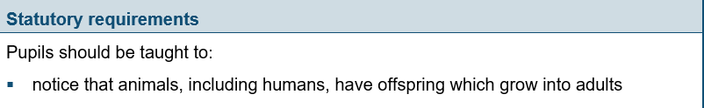
Year 2:

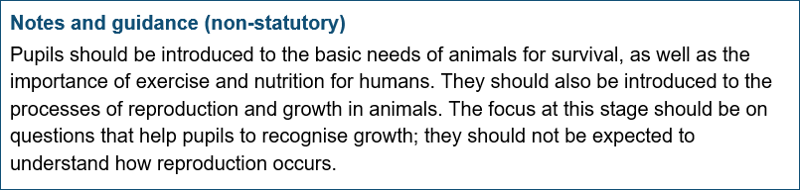

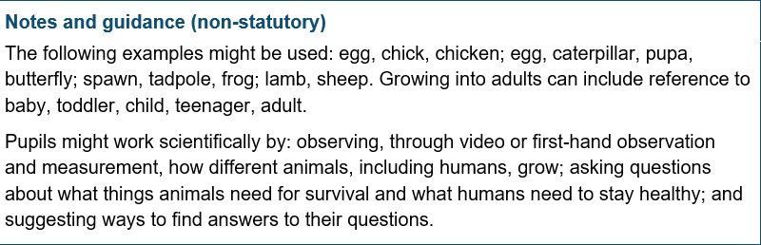

Year 3 and Year 4 – nothing linked

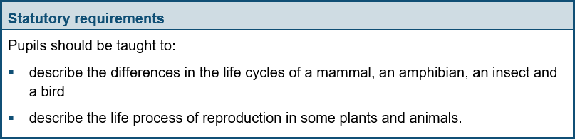
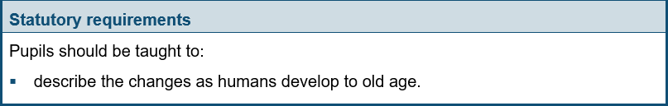
Year 5:

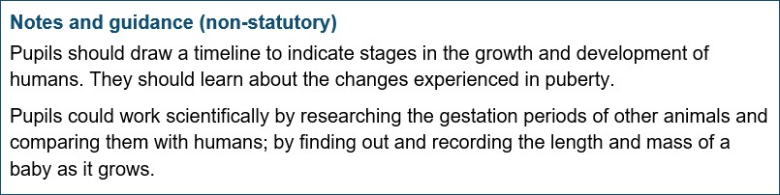
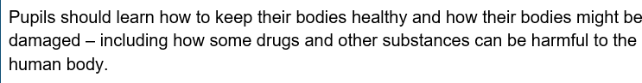
Year 6:

