Year 2 Homework

We would like you to have a go at spelling these words, try to write it out four times, correct yourself if you make a mistake, practice make perfect!
Example: sharp
Word: sharp
sharp
sharp
sharp

Spelling words | X1 | X2 | X3 | X4
wolves
break
whole
half
Plant
Once you have completed these words, please practice spelling out the word of the week.
Our word of the week is Moonlit lit by the moon
Phase 3
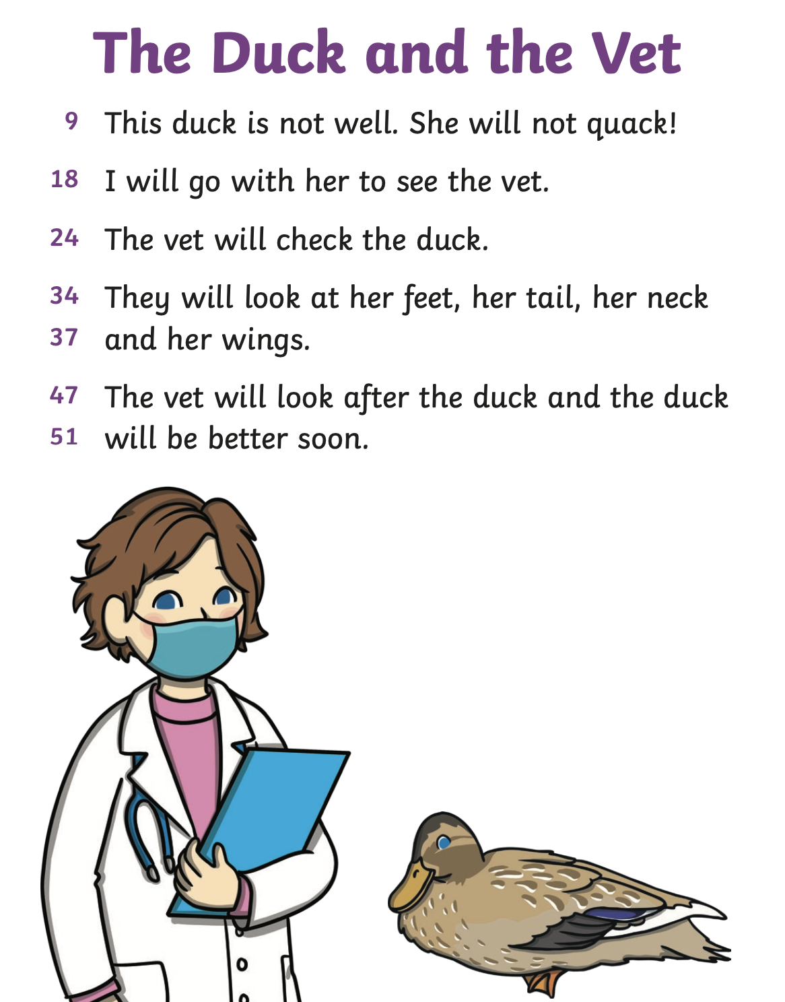

Phase 2
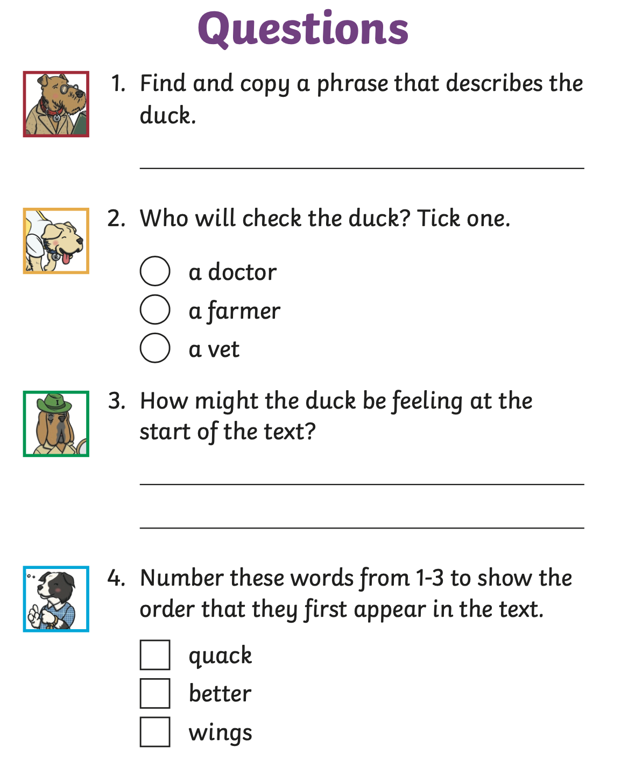

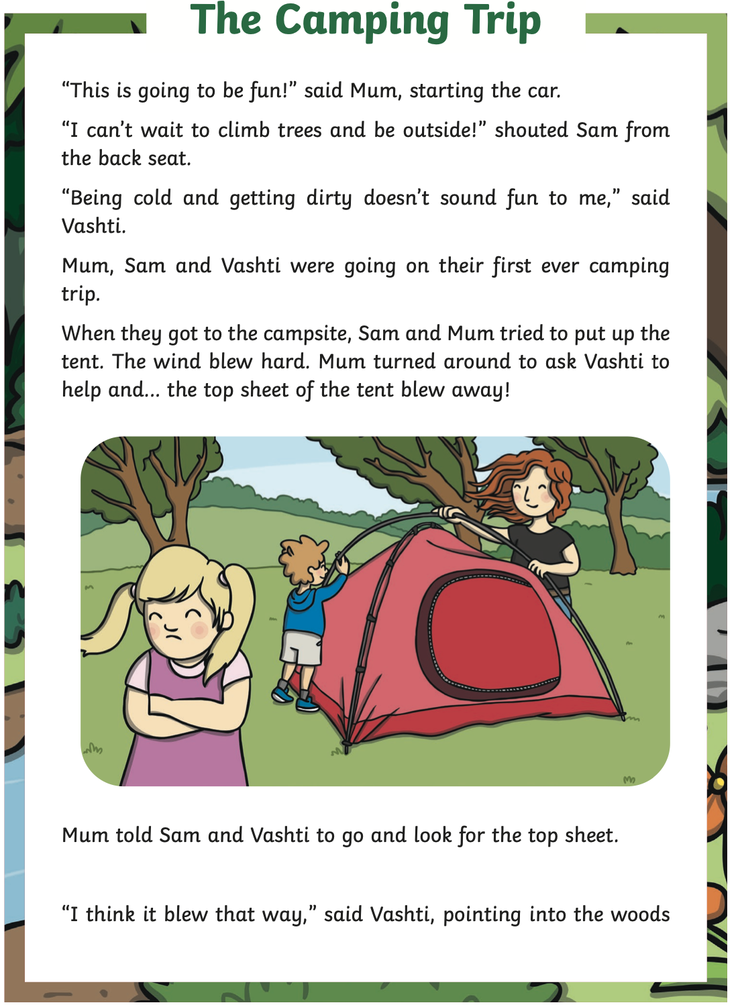
Phase 4- 6
