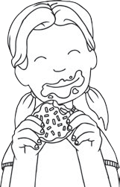 | 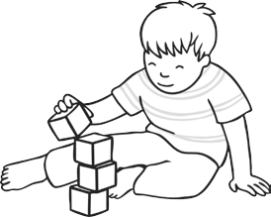 | 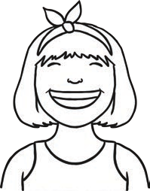 | 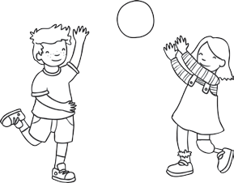 | 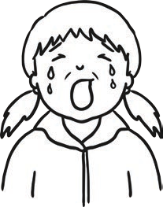
eat | build | smile | play | cry
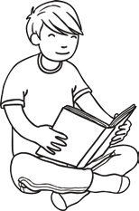 | 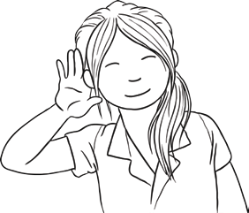 | 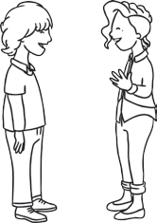 | 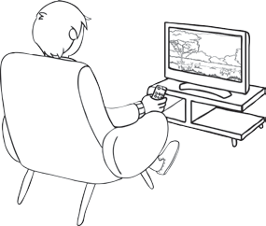 | 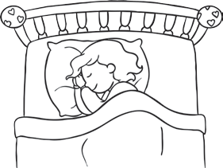
read | listen | talk | watch | sleep

- We with our toys and games.

- I when I am sad.

- At school, we to the teacher.

- At night, I in bed.

- You can on the phone.

- I can lots of books.

- You can a tower with bricks.

- I when I am happy.

- We films on the TV.

- I my lunch at school.

Fill in the gaps using the right verb from the box.

eat | build | smile | play | cry
read | listen | talk | watch | sleep
- We with our toys and games.

- I when I am sad.

- At school, we to the teacher.

- At night, I in bed.

- You can on the phone.

- I can lots of books.

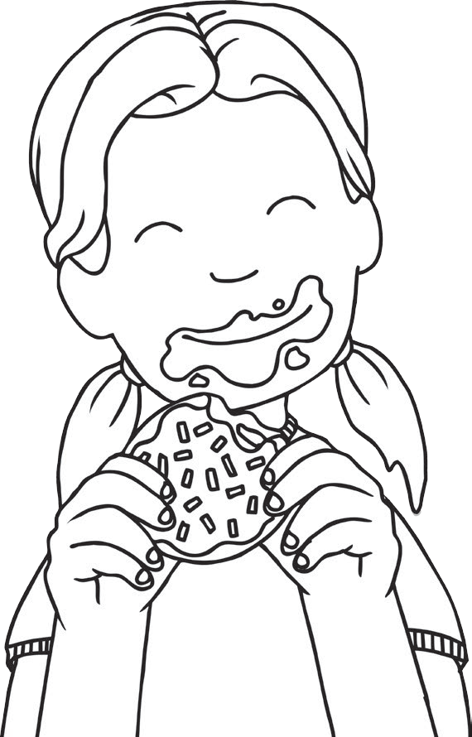
- You can a tower with bricks.

- I when I am happy.

- We films on the TV.

- I my lunch at school.

Fill in the gaps using a verb which makes sense.

- We with our toys and games.

- I when I am sad.

- At school, we to the teacher.

- At night, I in bed.

- You can on the phone.

- I can lots of books.

- You can a tower with bricks.

- I when I am happy.

- We films on the TV.
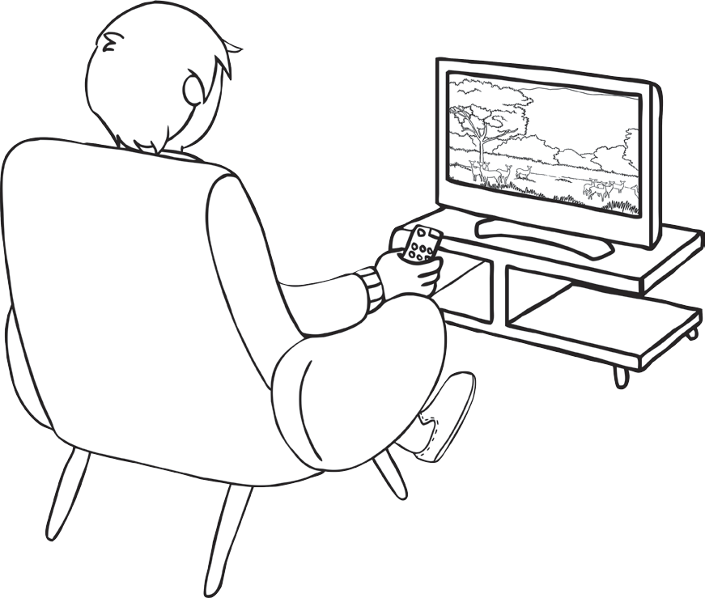
- I my lunch at school.

