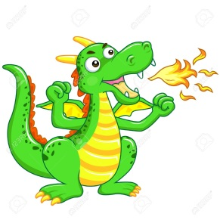

Dragon Words !

Word | Read | Cover and Write
Example: a
a
the
to
of
I
no
me
it
in
and

