Year 3&4 Homework – Week 3
**Homework is due in on every Tuesday, please complete it in your red homework books and hand it in on time. **
YEAR 3 MATHS:
In Maths this week, Year 3 have been learning to round numbers to the nearest 10. Please complete the questions in the pages below. Feel free to challenge yourself andattempt the trickier questions

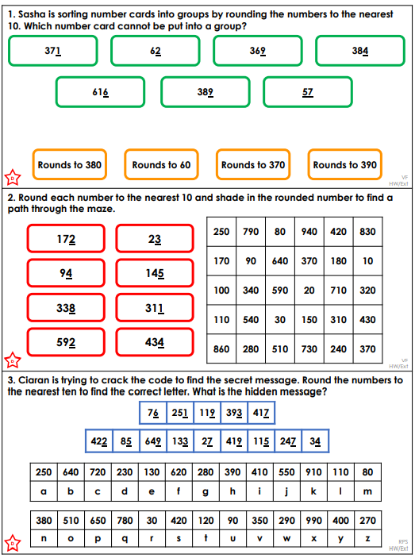
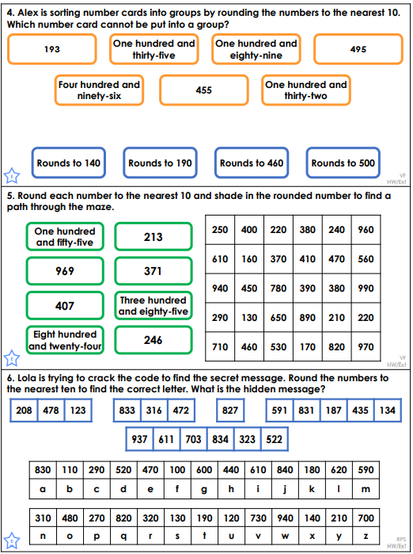

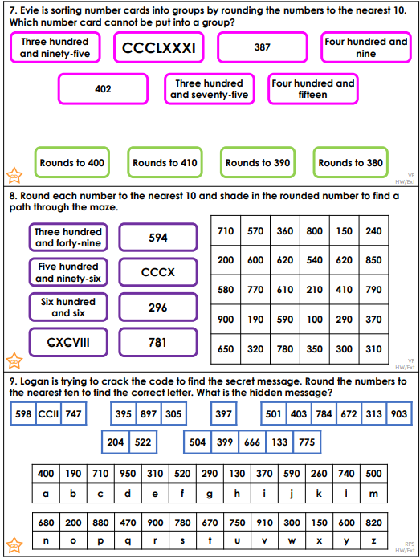

Challenge:

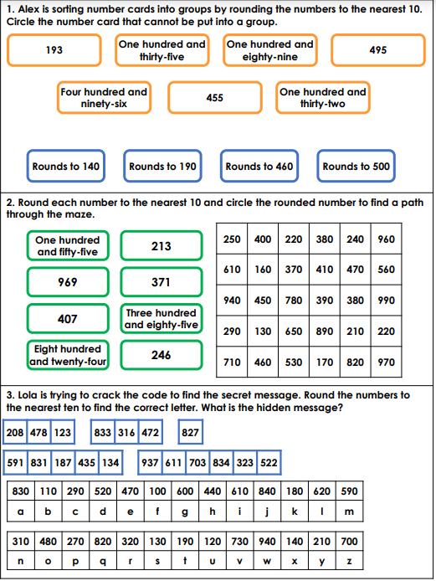
Year 4 Maths
Year 4 have been learning about rounding numbers to 100. Complete the worksheet below to consolidate your learning. Please feel free to challenge yourself with the trickier questions
