Reception Homework
Phonics: This week your child has been learning the first set of sounds in Phonics. Please get your child to practise writing these letters in their homework books.
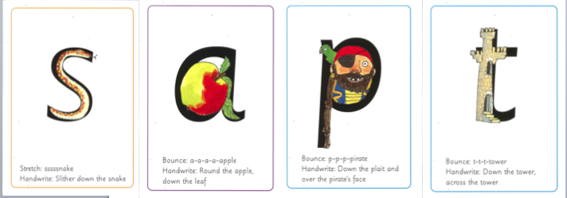
Maths: To make your child familiar with numbers, get your child to draw pictures of all the places they can see numbers around their home.

