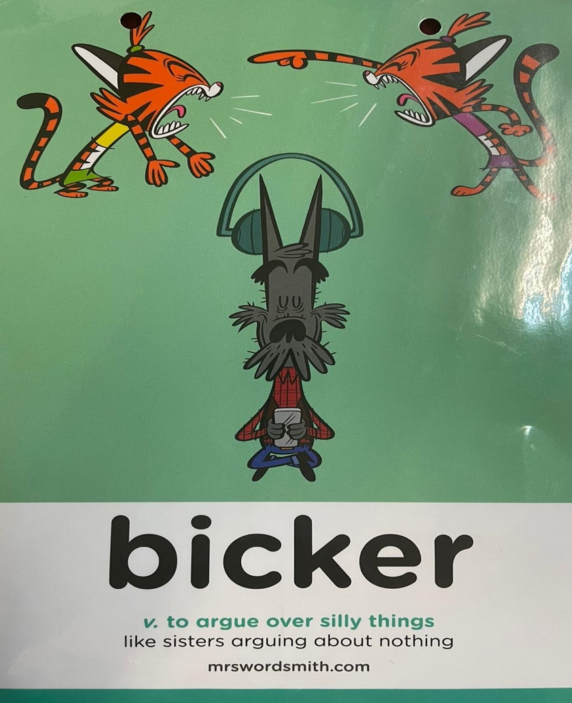
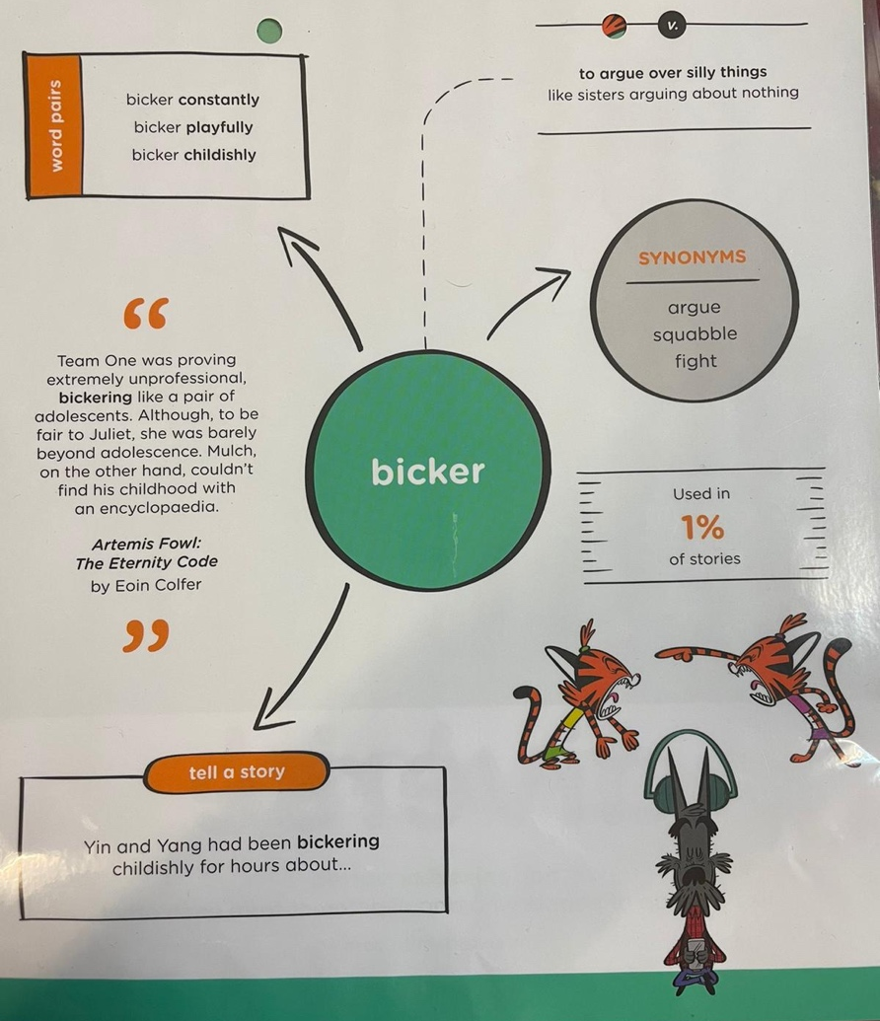
Word of the week

Write one sentence using the word of the week and another sentence using one of the synonyms.

Bicker

Argue

Squabble

Fight

