Year 5 & 6 Homework – Week 3

**Homework is due in on Friday 26th March, please complete it in your red homework books and hand it in on time. **

WORDS OF THE WEEK: for the words below, please find out the definition and create sentences using the words.
Resort
Reveal

Spelling:
A spelling test will be done on the Friday, so please learn the spellings below. Write the definition and create a sentence for each word below.
profit
prophet
stationary
stationery
steal
steel
wary
weary
who’s
whose

SUNFLOWER PROJECT
‘And your Lord revealed to the bees; Build your hives in mountains, trees and what they build. Then eat from every fruit and follow your Lord’s enslaved paths…’
“The Earth is green and beautiful, and Allah has appointed you his stewards over it. The whole Earth has been created a place of worship, pure and clean. Whoever plants a tree and diligently looks after it until it matures, and bears fruit is rewarded.”
In light to these beautiful sayings, highlighting the importance of bees amongst other creatures, taking care of our environment, and the children studying the book ‘Holes’ in English, we have launched a sunflower project for year 5&6.
It is a competition to see who can grow a sunflower at home to save the bees, and measure to see if your sunflower is growing the tallest.
Students will be provided with the seeds and will therefore be expected to complete their ongoing homework for this project across this term, given different activities to complete every week.
Good luck to you and your sunflower plants year 5& 6!

YEAR 5 MATHS:
In Maths this week, Year 5 have been learning to calculate the area of compound shapes. Please complete the questions in the pages below. Feel free to challenge yourself and attempt the more tricker questions!
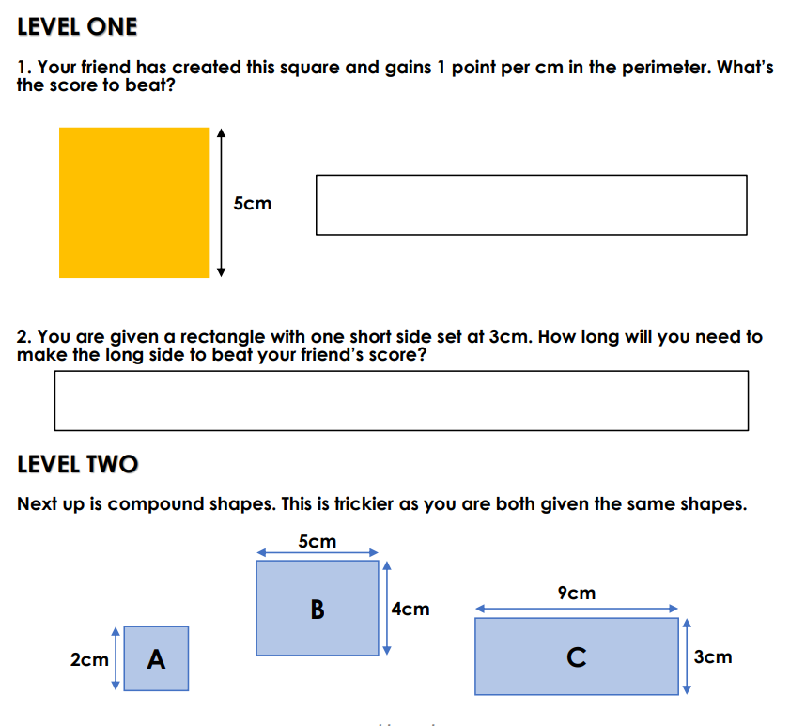
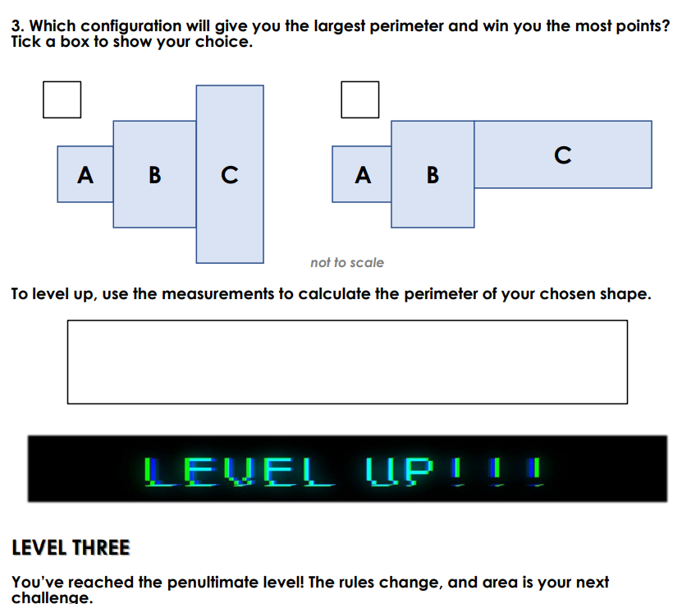
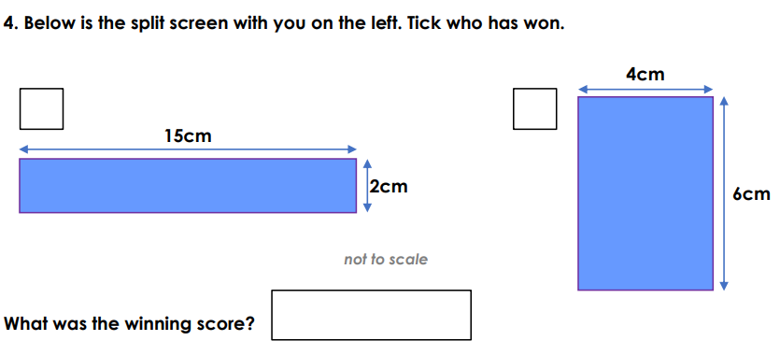
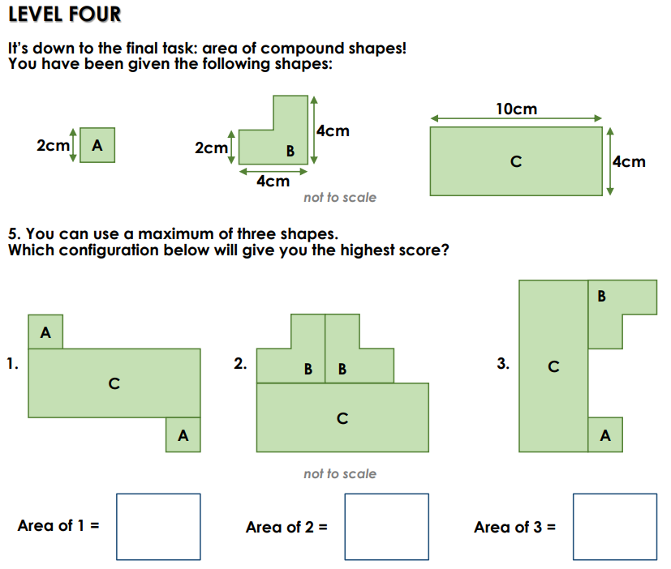
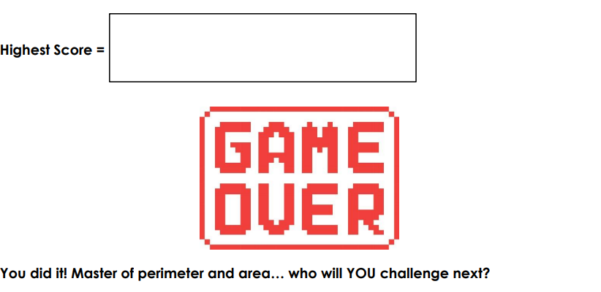

Year 6 Maths
Year 6 have been learning ratio and fractions. Complete the worksheet below to consolidate your learning. Please feel free to challenge yourself with the more tricker questions!

DEVELOPING:
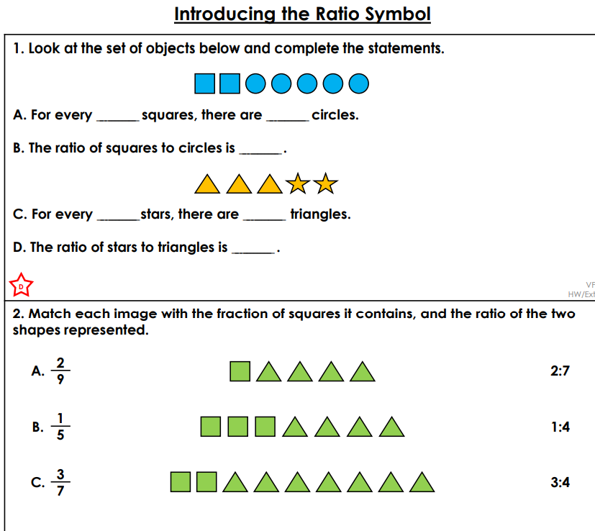
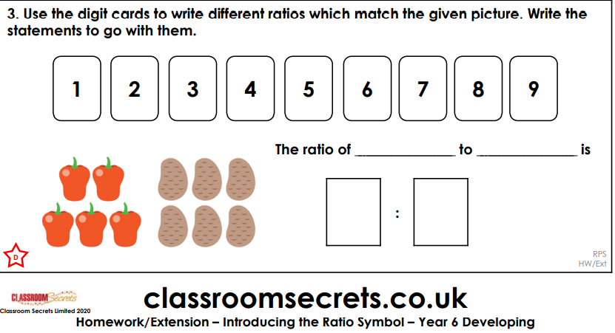
EXPECTED:
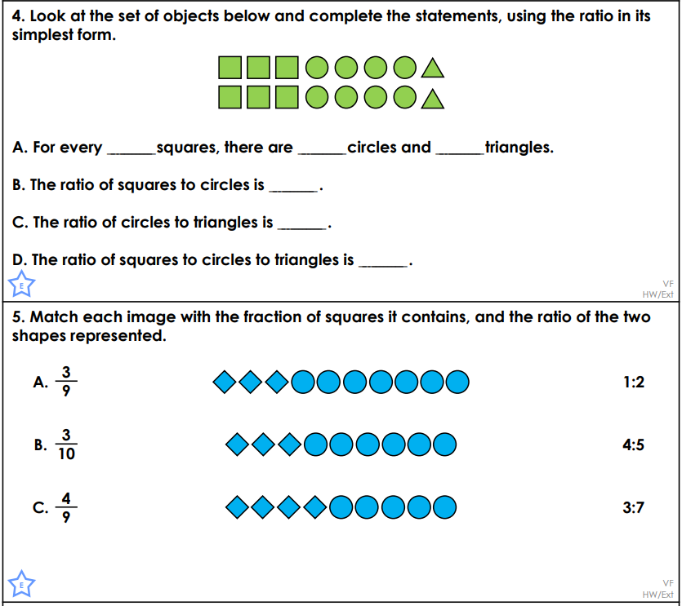
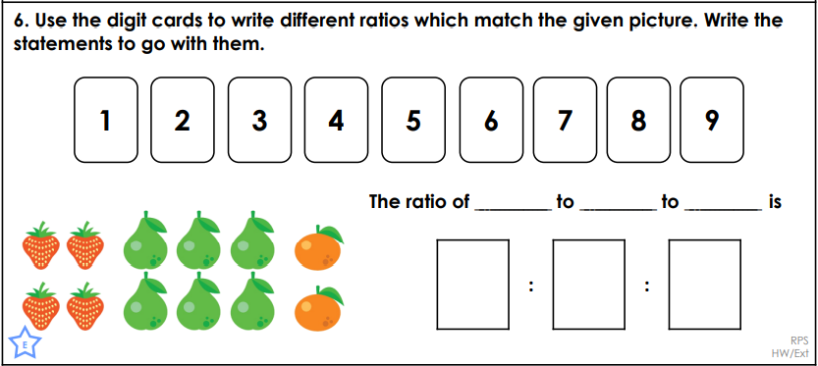

GREATER DEPTH:
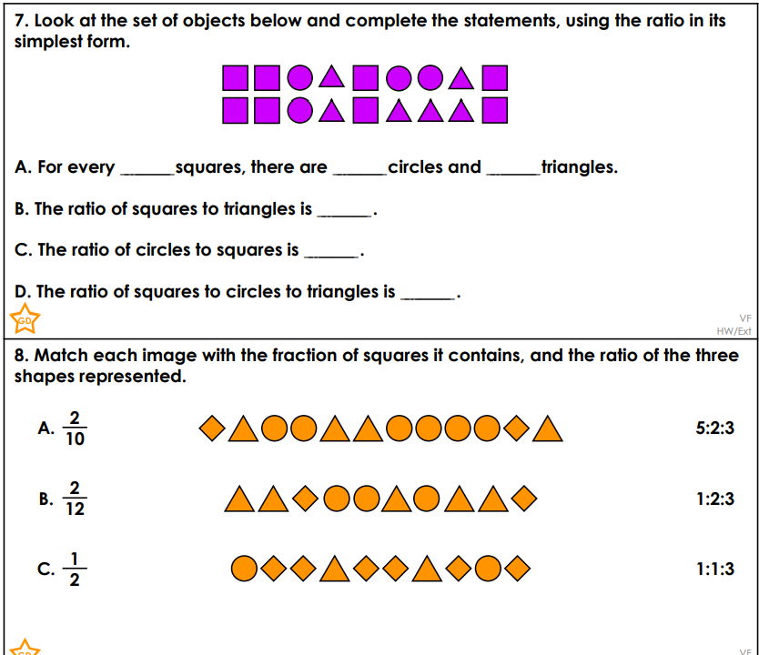
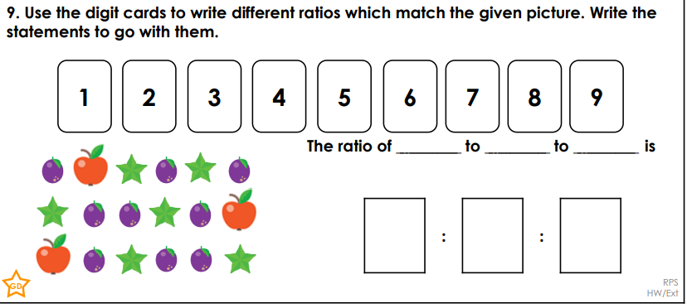

ENGLISH
Both Year 5 & 6 – Please read the text below and answer the reading comprehension questions.

