**Year 5 & 6 Spring 2** *2021*

**We will ensure that Islamic knowledge is incorporated into the curriculum insha’Allah.**

This half-term, children will be exploring a fantasy text called Holes by Lois Sachar.

Children will be learning to write:

* a setting description
* a detailed paragraph about how tension is built with close reference to the text
* about Green Lake in Past and Present paragraph
* Research using ICT facilities and creating a fact file in Word or PowerPoint. 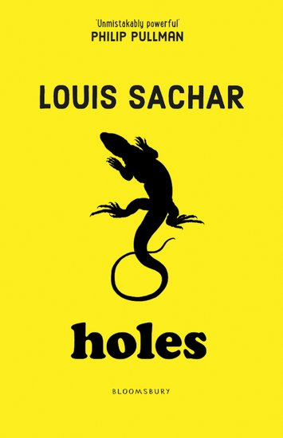

**RE**

**Computer Science**

**Art**

In PE this half-term, children will be learning rounders skills 

**PE**

**English**

**Science**

**Science**

**Science**

**Mathematics**

**Half Term Curriculum Overview**

We will be learning about PowerPoint Presentation skills. 

To recognise that expressing in different religious faith involves feeling, emotions, music, singing, dance and art.

We will be looking at: Extreme Earth

* To find out about the Earth’s climate and areas of extreme temperatures
* To find out about tsunamis, volcanoes and earthquakes across the world.

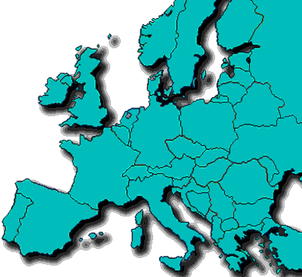

This half-term, children will be learning a range of different topic in Maths.

* Add 3 or more fractions
* Improper fractions to mixed numbers
* Order and compare decimals Understand percentages as fractions and decimals Equivalent F.D.P.
* Substitution Formulae
* Forming equations
* Solve simple one-step and two equations

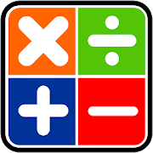

**Humanities**

The topic this term is about a Sense of Place children will:

* Look at how artists use perspective and investigate ways of recreating images accurately.
* Create a piece of landscape inspired by the chosen artist.

Children will receive homework on Fridays and they will need to make sure that they bring it back the following Tuesday. Children will also be given spelling on Friday following a test on Monday. All children should be reading at least 30 minutes every day home.

**Homework**

In science we will be learning about Properties and Changes of Materials. We will be able to:

* Understand that some changes of state and dissolving and mixing processes can be reversed through filtering, sieving and evaporating whilst others cannot.
* To give reasons based on evidence from comparative and fair tests.

