Week 7
Yr 3 and 4 reading comprehension
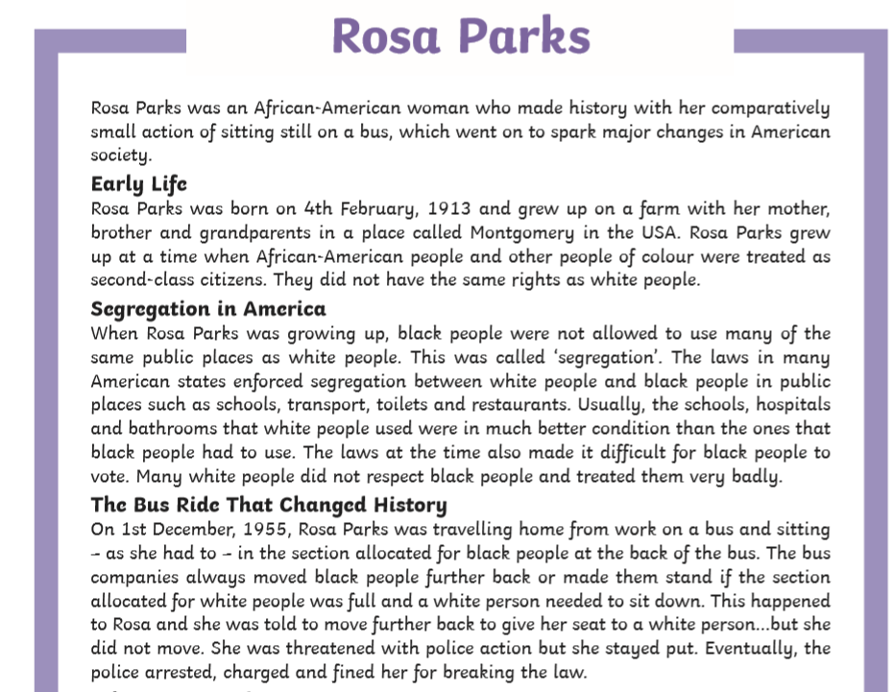

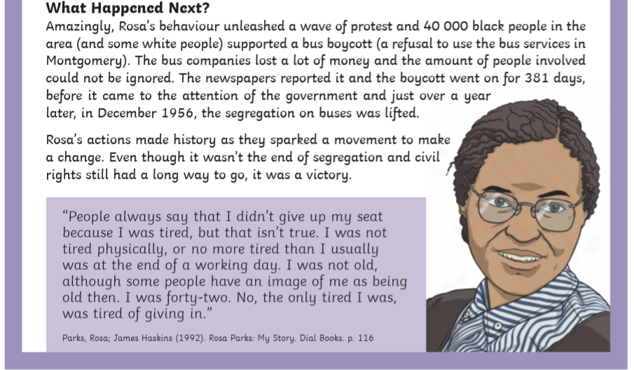

Questions- Year 3 can answer questions 1 to 7
Year 4 should attempt to answer all the questions.
- Please answer in full sentences e.g. Where did Rosa Grow up?
- Answer- Rosa grew up in_____________________________
Rosa Parks Questions
- Where did Rosa grow up?
- What is ‘segregation’?
- How were the facilities provided for black and white people different?
- How old was Rosa when she did not move on the bus?
- If you boycott something, what are you doing?
- In 1955, how were the buses in Montgomery segregated?
- In ‘The bus Ride That Changed History’ section, why has the author used an ellipsis?

