Half term
English comprehension – Year 3 & 4
L.O: To answer reading comprehension questions by deducing and inferring information. Read the extract, then read the questions and findevidence from the text to answer the questions.
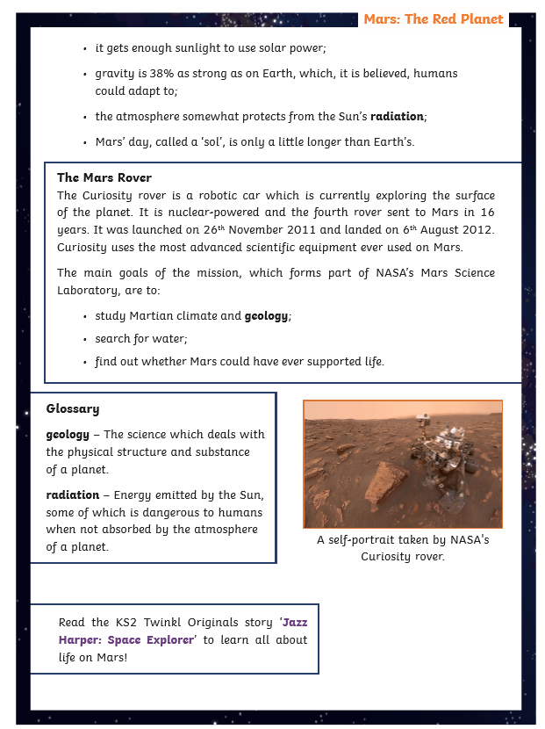

Questions- Year 3 can answer questions 1 to 7
Year 4 should attempt to answer all the questions.
- Please answer in full sentences e.g. What is a day called on Mars and how long is it?
- Answer- The day is called __________ on Mars because_________________
Mars: The Red Planet Questions
- Tick the correct response.
We cannot breathe on Mars because the atmosphere does not have enough:
air
carbon dioxide
atmosphere
oxygen
- Find and copy the correct word to complete the sentence. Mars is named after the god of .
- Which of these are reasons why Mars is a good place to explore? Tick two. Mars gets enough sunlight to use solar power.
A day on Mars is very short. There is no gravity on Mars.
There is a little water in the soil on Mars.
- How many moons does Mars have and what are their names?

- What is a day called on Mars and how long is it?

- Find and copy one caption from the text.

- Why does it seem odd at first that NASA has chosen to explore Mars and not Venus?

- Why do you think the author has put the facts about Mars’ size and atmosphere into a ‘quick facts’ box?

