Week 4
English comprehension – Year 3 & 4
L.O: To answer reading comprehension questions by deducing and inferring information.
Read the extract, then read the questions and find evidence from the text to answer the questions.
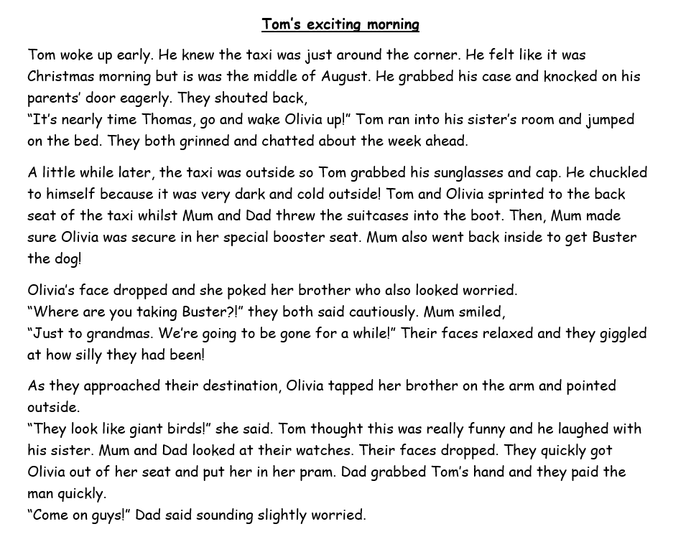

Questions-
Year 3 can answer questions 1 to 5
Year 4 should attempt to answer all the questions.
- Please answer in full sentences e.g. How do we know Tom felt excited in Paragraph One?
- Answer- Tom felt excited in Paragraph One because ……
Questions
- How do we know Tom felt excited in Paragraph One? Try and find all the clues.
- Why do you think Tom chuckled to himself when he went outside in Paragraph Two?
- Where do you think Tom is going? Explain why you think this.
- Pretend you are Tom. Write down how you are feeling and what you are thinking as you travel in the taxi.
- Why has Tom packed sunglasses?
- Why do you think Olivia and Tom were worried when Mum went back into the house to get Buster?
- What do you think Olivia was pointing to when she said, “they look like giant birds!”?
- What do you think happened when Mum and Dad looked at their watches in paragraph four?
- Pretend you are Dad at the end of the passage. Write a few sentences explaining your thoughts and feelings.

