Word of the week

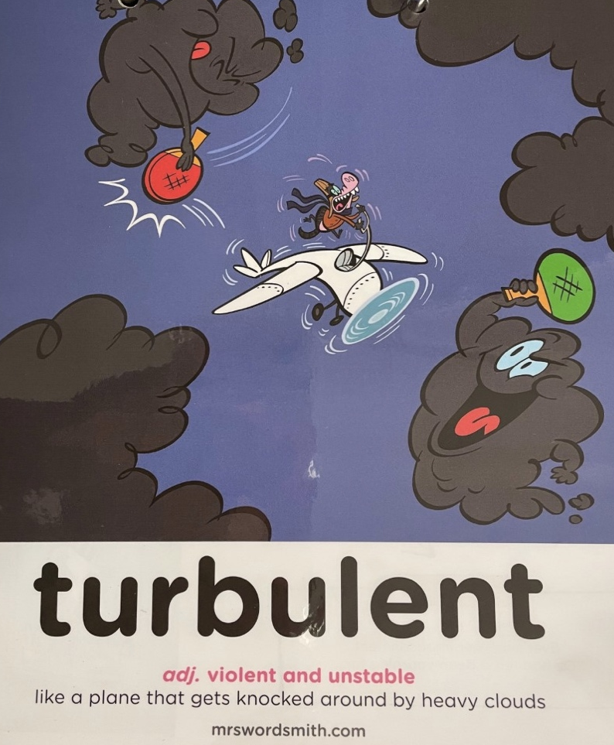

Write one sentence using the word turbulent and one using one of the synonyms.

Turbulent:

Stormy:

Unstable:

Violent:

