Spellings
Parents, please help your child to draw columns in homework book and practice these spellings. Choose five words from the list and create sentences with each word. Each sentence must include at least two high frequency words.
- High frequency words are words that appear in written text. They are a mixture of decodable and tricky / exception words. Words that have to be learnt and recognised by sight.

The sound spelt /ch/ spelt ‘ch’ Will to be tested on 22/10/20
chip
chick
catch
fetch
kitchen
notch
hutch
rich
much
such

Multiplications Word problems.

Answer the following problems in your homework book and please show your working out.

- If 2 taxis arrive at the party at the same time, each carrying 5 passengers, how many people arrive at once?

- Eight animals walked onto the ark in 2s. How many pairs of animals were there?

- There are 4 seats in each cart on the ride. How many seats are there in 10 carts?

- Six people came to the show and they paid £5 each. How much were the ticket sales altogether?

We enjoyed reading and learning lots from “if the world were…” by Joseph Coelho.
Now I want you to answer the following questions for me and write the answers in your homework book using full sentences.

If you need to recall the book watch the video. https://www.youtube.com/watch?v=nWnBn6sZzXE https://www.youtube.com/watch?v=bicEHK9cllQ

What did Sophia and her Grandad do during Spring?
- What did Sophia’s Grandad buy her in Summer?
- What did Sophia’s grandad make her during Autumn? What did he make it out of?
- What tales did Sophia’s grandad tell her during Winter?

Word of the week
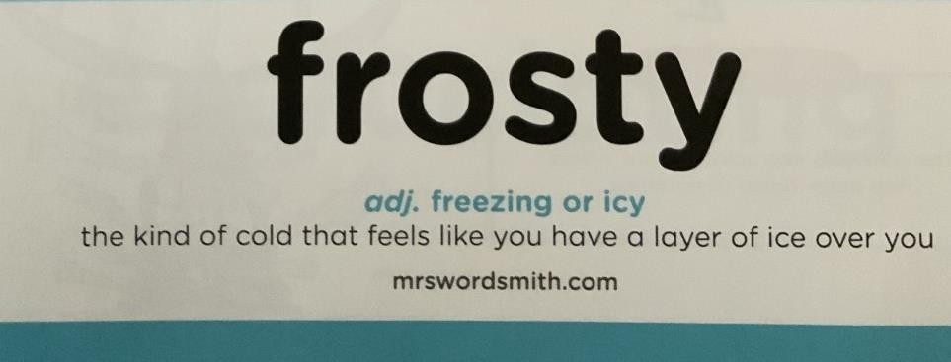

Can you write two sentences in your homework book using the word frosty. Be creative!

.

