Word of the Week:
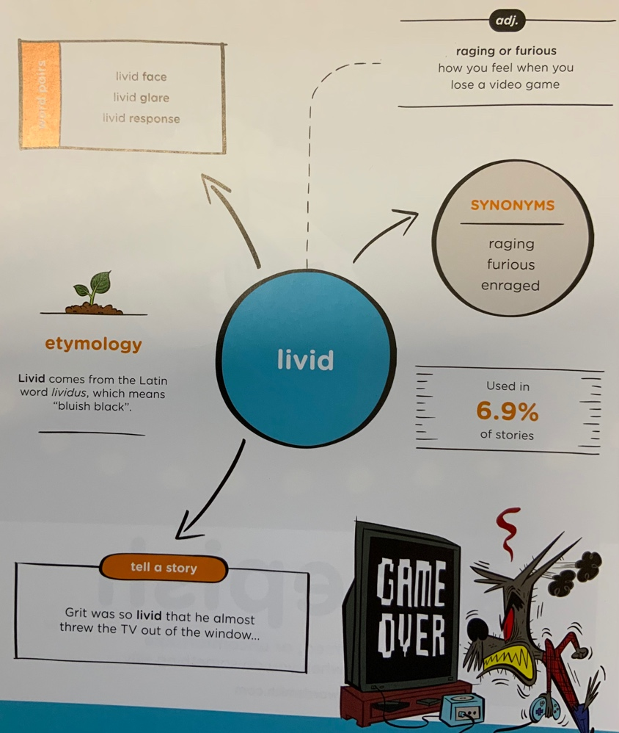

Can you write two sentences where this word is being used in different ways

Sentence 1:

Sentence 2:

