W5 Homework – Due Tuesday 13th October 2020
Look at the picture below.
Answer these questions in your homework book in FULL SENTENCES!
Questions:
- Give the creatures names.

- Why does the purple creature have a peg on its nose?

- Why are its cheeks bulging?

- Is the large character an ogre? A troll? Something else?

- Why does he have his foot in a bowl?

- How is he feeling? Why?

- Why are there flies around him?

- Add thought bubbles to this picture.

- Which characters do you like the most? Why?

- Which character can you best relate to? Why?

- Why is the title ‘Pegged’? Give this image a new title. Explain your choice.

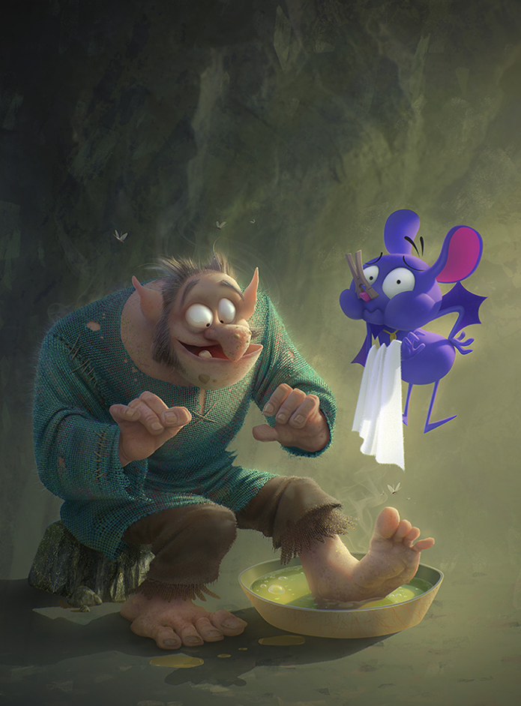

Spelling Test  Write these words down 5 times in your books  Remember we have a spelling test on Tuesday 13th October 2020  - Immigration  - Migrated  - Italians  - America  - Italy  - Poverty  - Better  - Education  - Facts  10.Opinions | Times Table:  Revise time tables that you are not confident in.  You can write them out and get your mum, dad or brother and sister to test you.

