KS1 Flip Learning
We are going to start our term with a lovely book; Send for a SuperHero by Michael Rosen.

- Does the name Michael Rosen remind you of another book we have read?

- 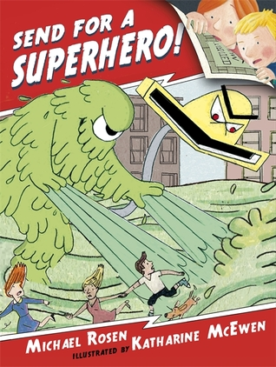

- Click on the following link to reading time with Kaitlyn: please make sure you listen to it carefully.
- https://www.youtube.com/watch?v=wT80G8jfwJU

Kaitlyn read Send for a SuperHero during COVID-19 lockdown for all of us to enjoy. I think that was very nice of her.

- Write 3 adjectives in your homework book that I could have used instead of nice.

Stop the video when Kaitlyn reads the page about Class Perfect and look at the children trying to be nice:

- Make a list of all the things they are doing
- Make another list of things you would like to see and try to make your Class Perfect.

