Thursday 10th September 2020
Year 4
Week 1 – Homework
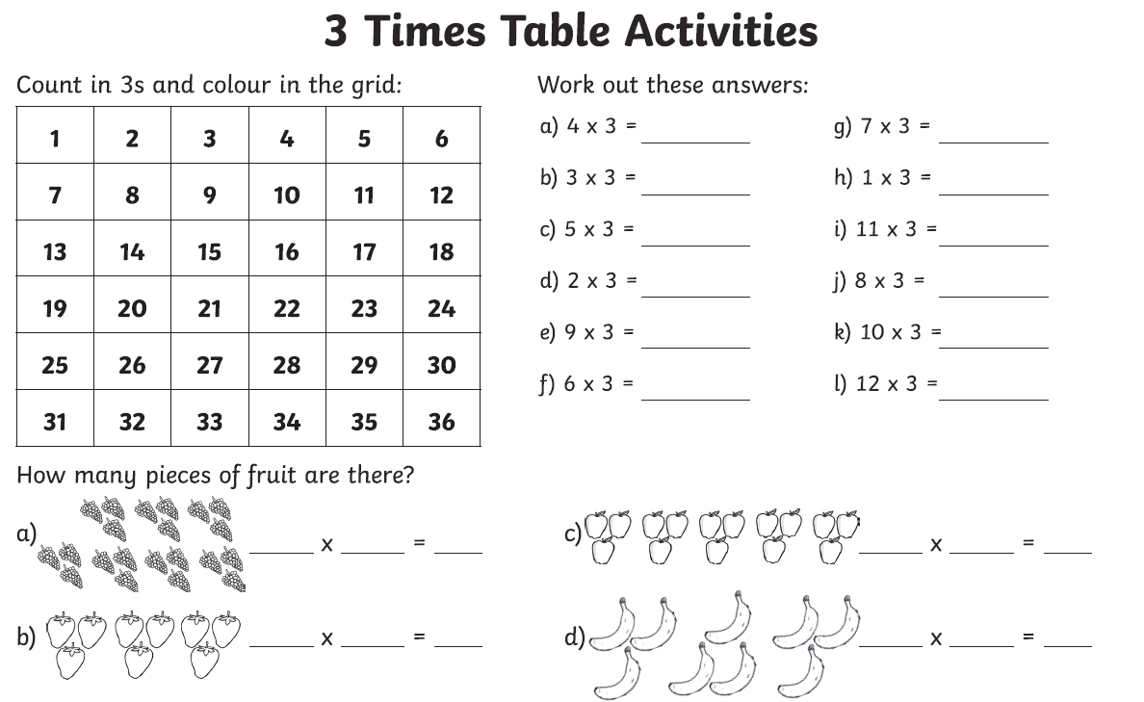

Week 1 – Year 4 Spelling
