Week 18 - Monday 20th July 2020
Year 3/4

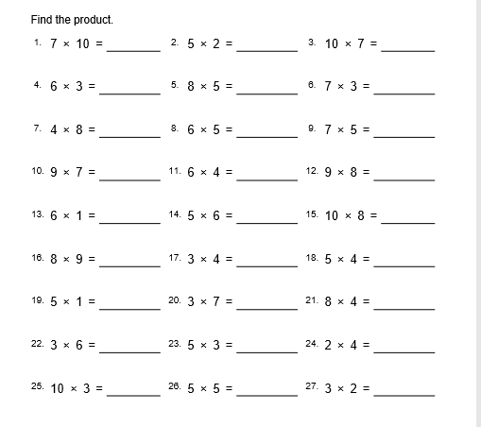

Year 4 Challenge

