Phonics Phase 1: Alliteration - week 18
Model as per example below to teach your child the letter and the initial sound it makes. Ask your child to name each letter and the initial sound then say the sound and the pictures. Write each letter out showing them how to hold the pencil in a tripod grip. You can use dot-to-dot to start with but eventually they should be able to copy it by themselves. Children to also practice writing their name.

E.g- This is the letter 'a'. It makes the initial sound 'a'.
a, a, apple a, a, ant a,a arrow
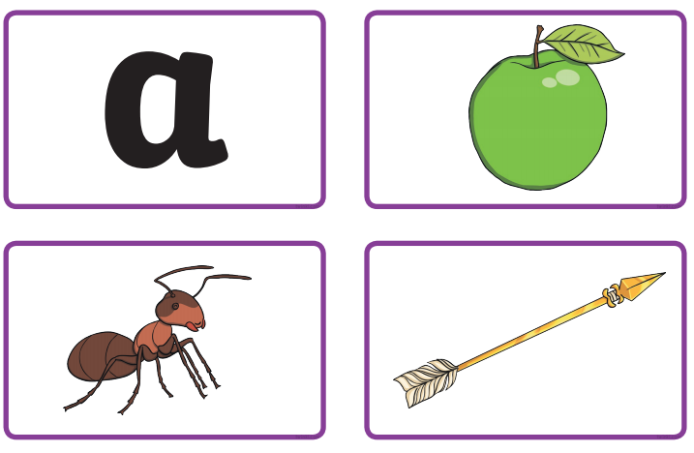
This is the letter 'b'. It makes the sound 'b'
b,b baloon b,b, boot, b,b, bat
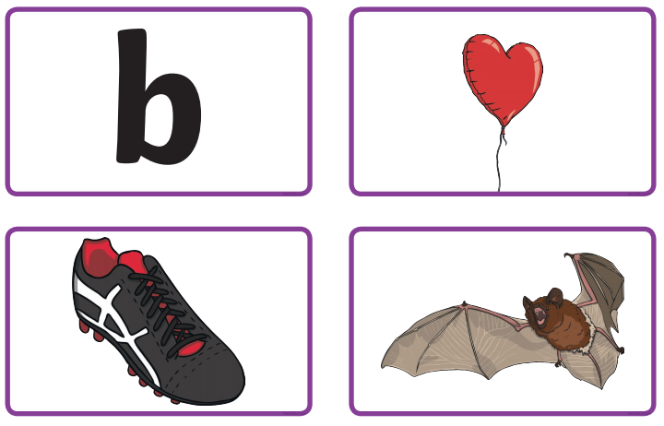

This is the letter 'c'. It makes the sound 'c'
c,c cat c,c, cap c,c, car
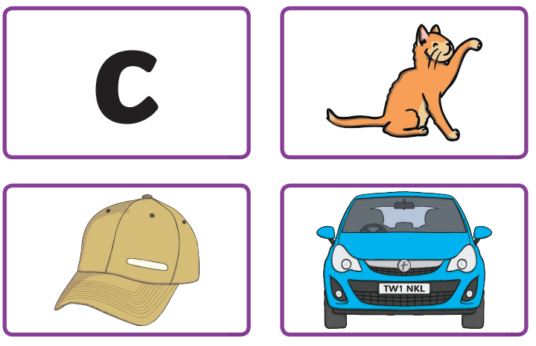

This is the letter 'd'. It makes the sound 'd'
d,d dog d,d, dig, d,d, dolphin
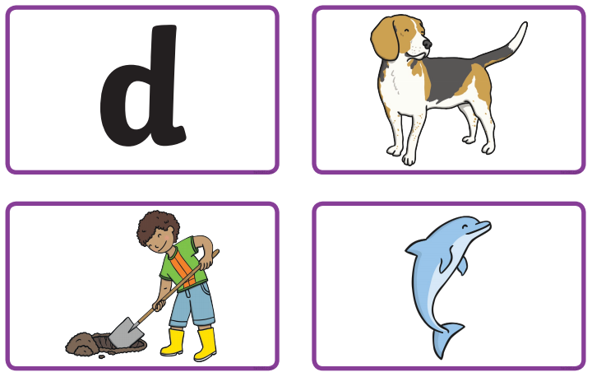

This is the letter 'e'. It makes the initial sound 'e'.
e, e, eggs e, e, elf e,e elephant
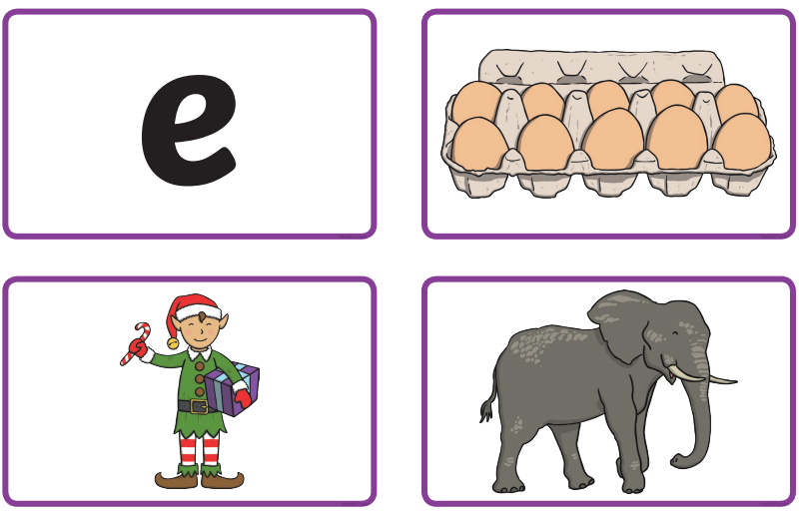

This is the letter 'f'. It makes the sound 'f'
f,f fan f,f, fire, f,f, fox
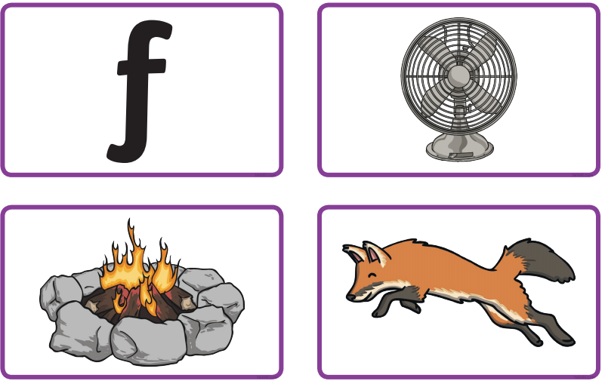

This is the letter 'g'. It makes the sound 'g'
g,g gloves g,g, gate g,g, goat
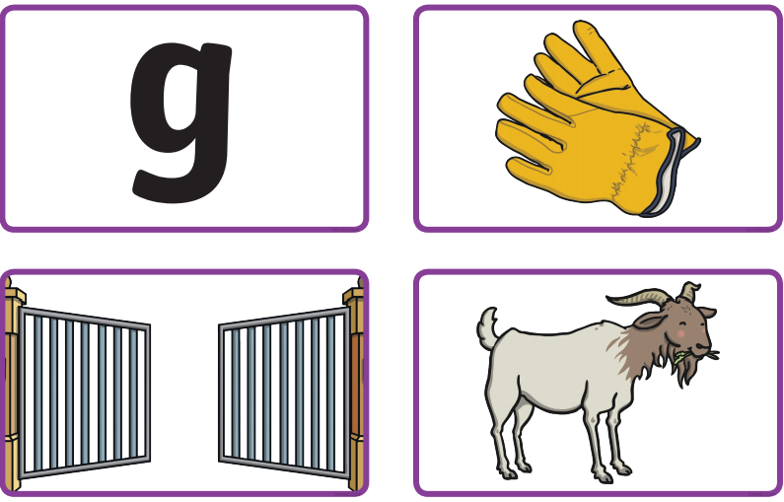

This is the letter 'h'. It makes the sound 'h'
h,h hat h,h, hand h,h, hen
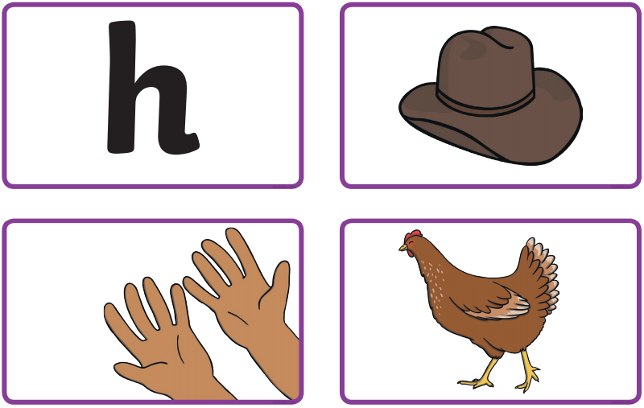

This is the letter 'i'. It makes the initial sound 'i'.
i, i, ink i, i, iguana i,i, igloo
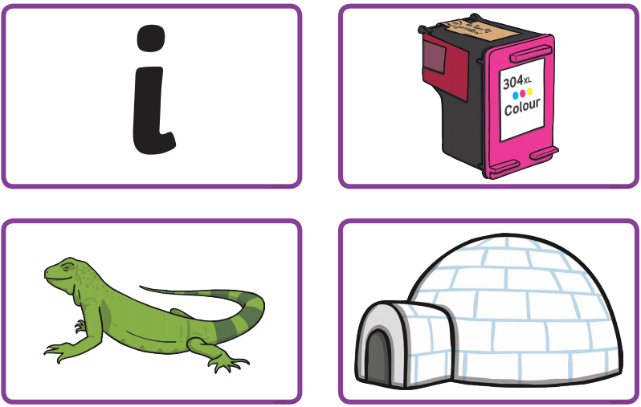

This is the letter 'j'. It makes the sound 'j'
j,j, jelly j,j, jumping jack j,j, jam
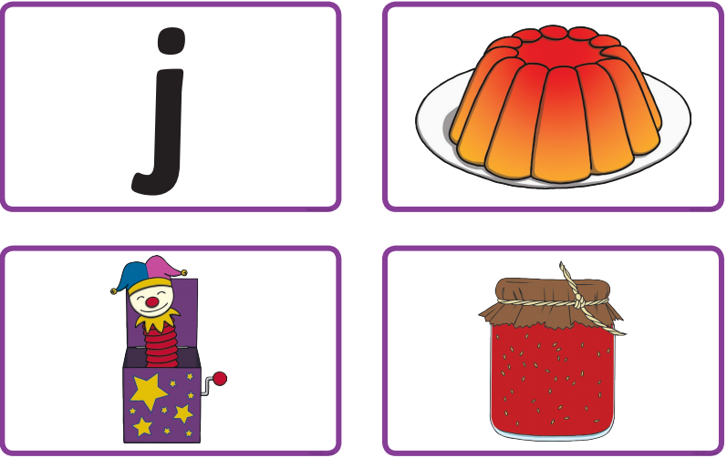

This is the letter 'k'. It makes the sound 'k'
k,k king k,k, key k,k, kite
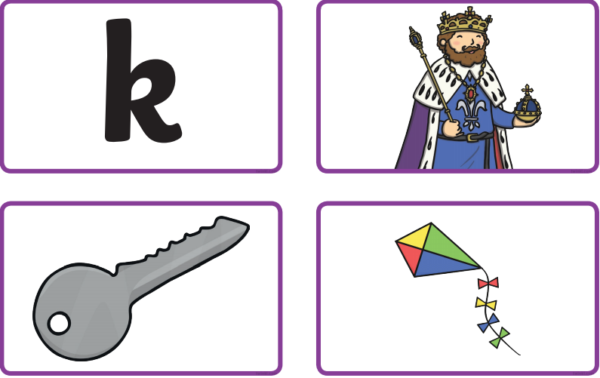

This is the letter 'l'. It makes the sound 'l'
l,l, log l,l, lemon l,l, leaf
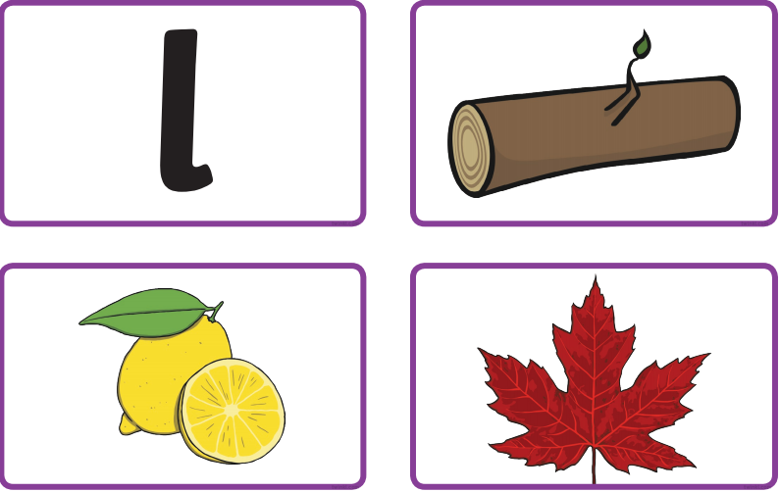

This is the letter 'm'. It makes the initial sound 'm'.
m, m, mop m, m, map m,m, mouse
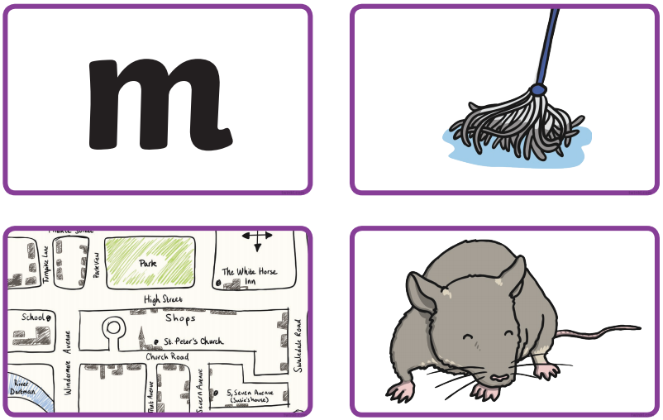

This is the letter 'n'. It makes the sound 'n'
n,n, nose n,n, net n,n,nest 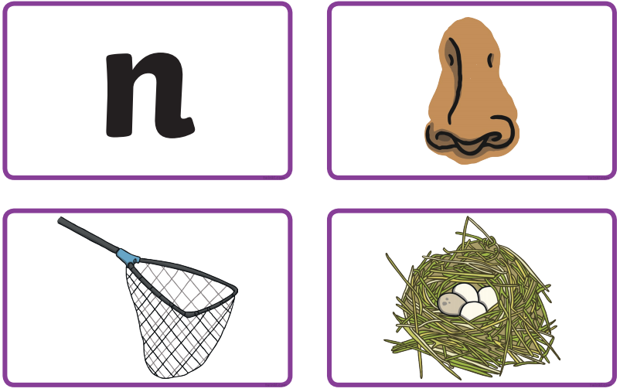

This is the letter 'o'. It makes the sound 'o'
o,o, octopus o,o, orange o,o, ostrich
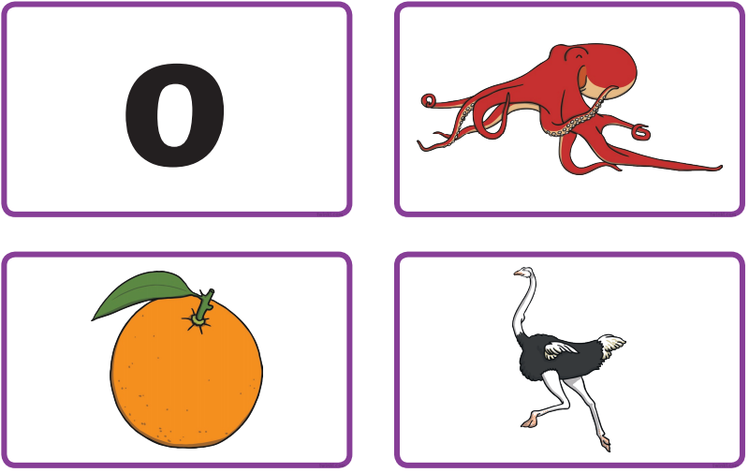

This is the letter 'p'. It makes the sound 'p'
p,p, pizza p,p, pencil p,p, pig
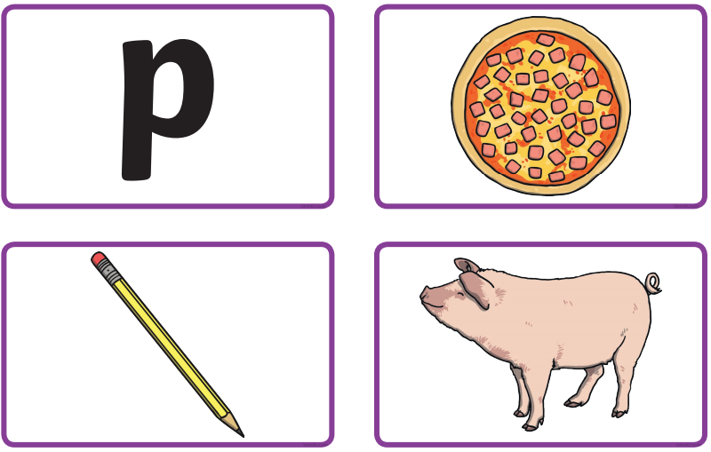

This is the letter 'q'. It makes the initial sound 'q'.
q, q, que q, q, quilt q,q, queen
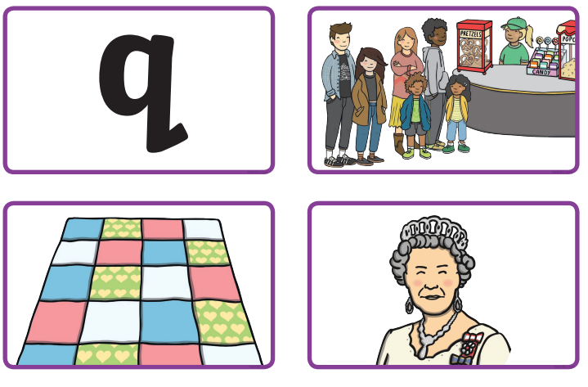
This is the letter 'r'. It makes the sound 'r'
r,r, rabbit r,r, rainbow r,r,rat
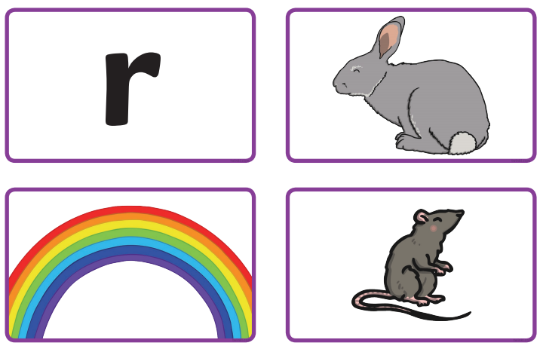

This is the letter 's'. It makes the sound 's'
s,s, sun s,s, saw s,s, sandwich
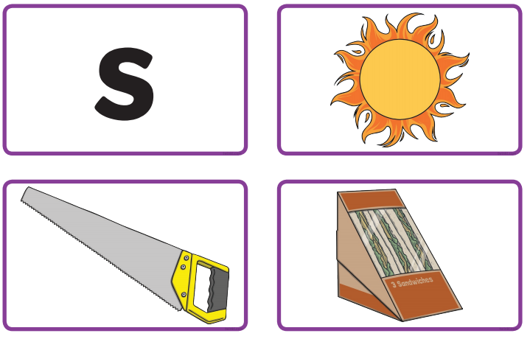

This is the letter 't'. It makes the sound 't'
t,t, torch t,t, tent t,t, turtle
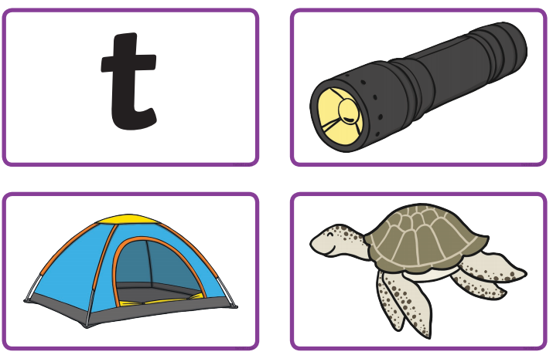

This is the letter 'u'. It makes the initial sound 'u'.
u, u, umbrella u, u, udder u,u, underpants
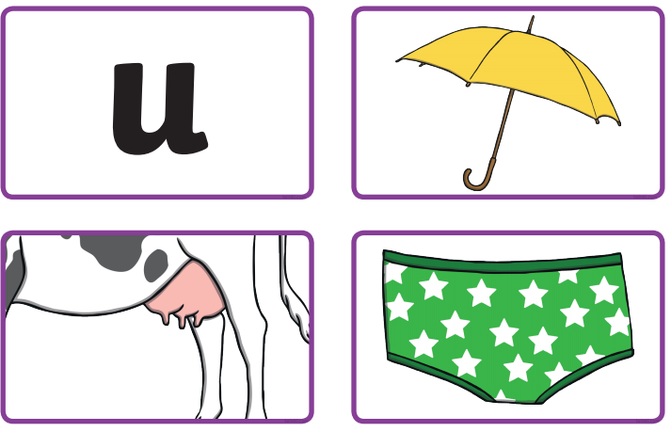

This is the letter 'v'. It makes the sound 'v'
v,v, volcano v,v, vulture v,v,van
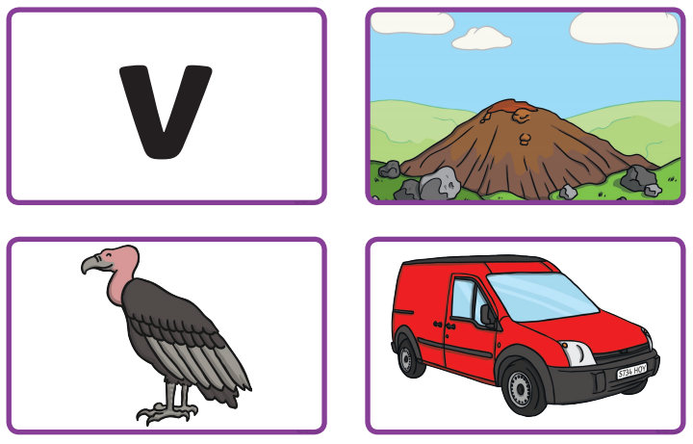

This is the letter 'w'. It makes the sound 'w'
w,w, watch w,w, witch w,w, web
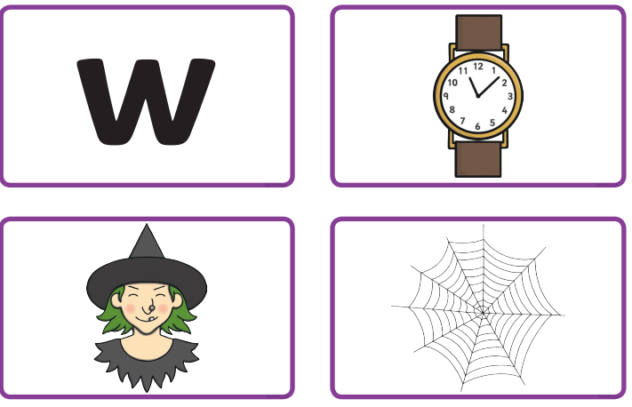

This is the letter 'x'. It makes the sound 'x'
x,x, Fox x,x, axe x,x, box
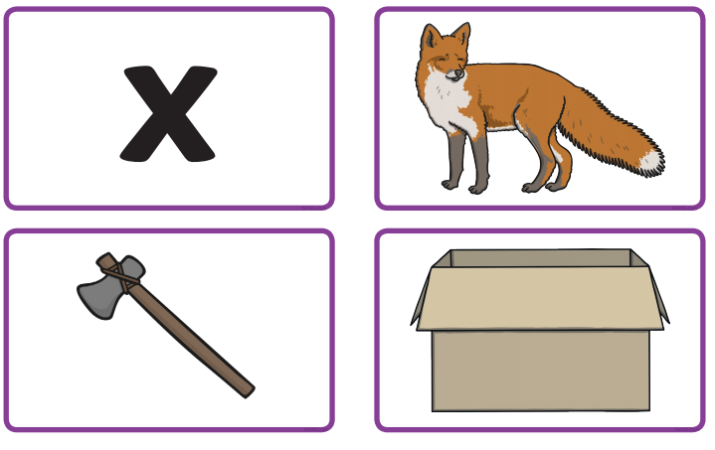

This is the letter 'y'. It makes the sound 'y'
y,y, yoyo y,y, yellow y,y, yoghurt
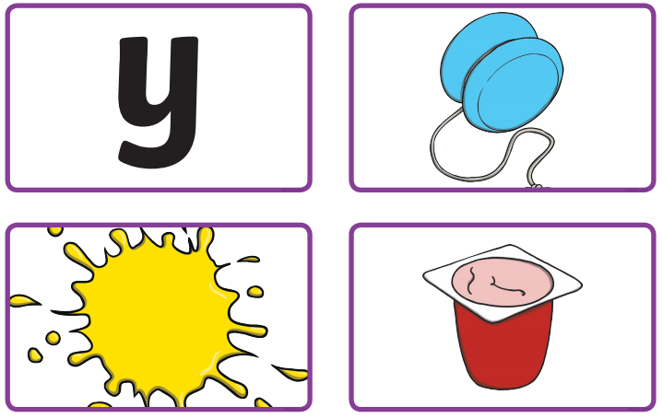

This is the letter 'z'. It makes the sound 'z'
z,z, zoo z,z, zip z,z, zebra
