

Monday activity
Read the story or watch the video
https://www.youtube.com/watch?v=75NQK-Sm1YY

Recreate the story with your child.
Resource required:
Real fruit/food used in the story or you can using pictures/drawings
Ask your child the following questions:
What fruit did the caterpillar eat on Monday and how many did he eat? Ask them to pick the correct fruit.
What fruit did the caterpillar eat on Tuesday and how many did he eat? Ask them to pick the correct fruit.
What fruit did the caterpillar eat on Wednesday and how many did he eat? Ask them to pick the correct fruit.
What fruit did the caterpillar eat on Thursday and how many did he eat? Ask them to pick the correct fruit.
What fruit did the caterpillar eat on Friday and how many did he eat? Ask them to pick the correct fruit.
What did the caterpillar eat on Saturday and how many did he eat? Ask them to pick the correct food item.
Matching game
Tuesday activity
Can you match the correct fruit/food with the correct day the caterpillar eats it.
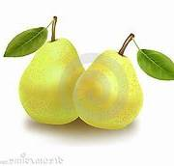
Monday
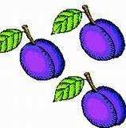
Tuesday

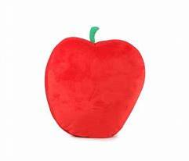
Wednesday

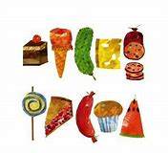
Thursday

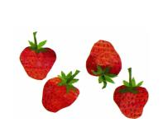
Friday

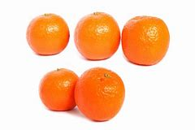
Saturday

Matching the numeral with the correct quantity
Wednesday activity
1

2
3
4

5

Mark making on paper
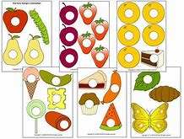

Thursday activity
Can you draw one apple 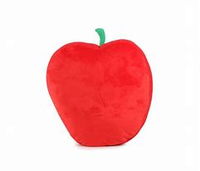and write the number 1.

Can you draw two pears 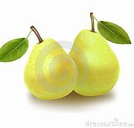 and write number 2

Can you draw three plums 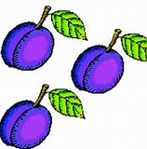 and write number 3.

Can you draw 4 strawberries and write number 4.

Can you draw 5 oranges 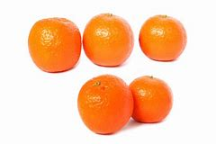 and write number 5.

Now can you draw 1 chocolate cake, 1 ice cream corn, 1 pickle, 1 slice Swiss cheese, 1 salami, 1 lollipop, 1 piece of cherry pie. 1 sausages, 1 cup cake and 1 slice of water melon

Friday Activity

