Week 17
Monday 13th July 2020
Reading comprehension
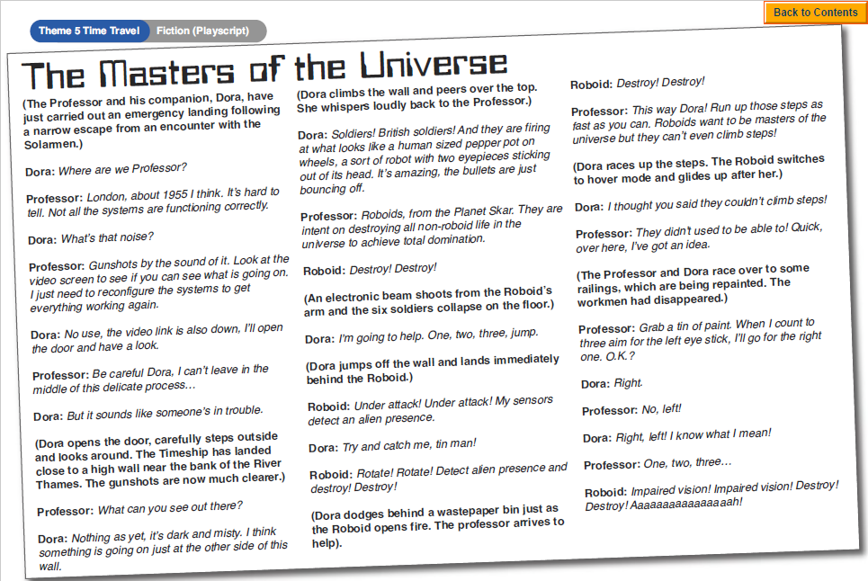
Questions
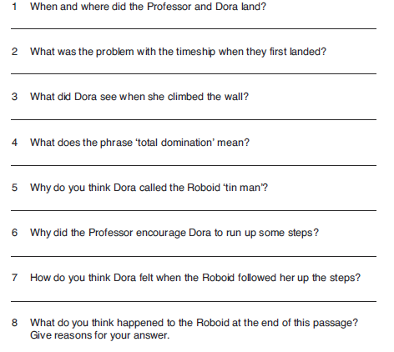
Challenge: Write a short playscript describing how the Professor and Dora get back to their time ship and head off on their next adventure.

Tuesday 14th July 2020
English SPAG
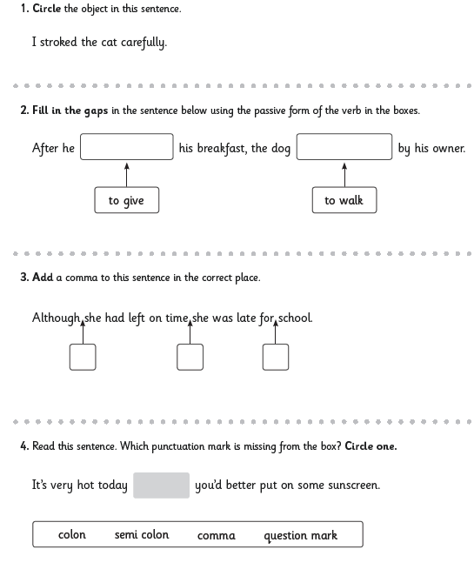
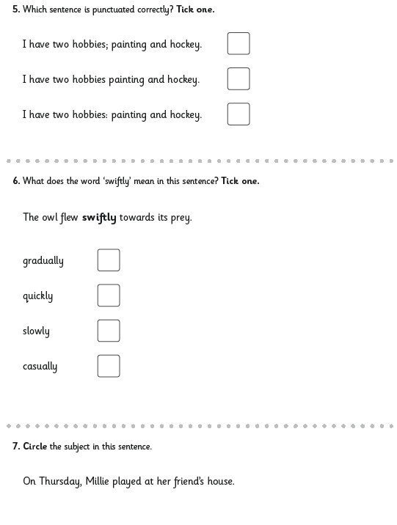
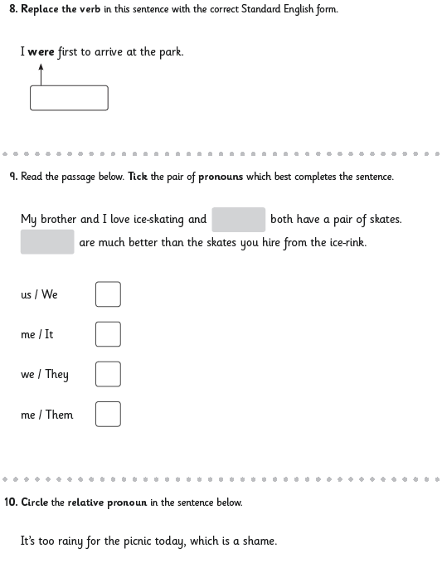
Wednesday 15th July 2020
English Writing
Setting the scene
Often, a story can hook you in by setting the scene through description of the setting. The author paints a picture in your mind by describing in detail using all 5 senses: sight, hearing, scent, touch/feeling and taste.
In the following pages below are pictures of different settings. Choose one that grabs your attention and then:
- Jot down some simple words to describe what you might see, hear, smell, feel or even taste if you were in the scene.
- Using a thesaurus and your imagination, add adjectives, adverbs or powerful verbs to describe each word.
- Use your notes to create a piece of descriptive writing. Remember to use full sentences, including correct punctuation, and try to use a mixture of simple and complex sentences.
- When you have finished your piece, read it carefully to make sure it makes sense. Use a dictionary to check your spellings.
Look at the example below and try to guess which scene was chosen as description of setting:
- dilapidated, neglected, stench, musty, weeds, vines, damp, shiver, uneasy, shadows
- Neglected dilapidated mansion, musty stench, cold damp air, wild weeds wrapped
- As I stood, gazing at the dilapidated mansion. I shivered, as though, ice had replaced my spine. The cold air enveloped my entire body. The multiple layer of clothing could not protect me against the deathly cold. The walkway leading up to house were cracked. Weeds and dandelions poked out from these cracks. Red scarlet roses grown wildly in thick batches by the gate. The moonlight cast a ghoulish glow on the house. Vines formed a twisted maze upon the side of house, reaching their tentacles towards the roof. The house’s walls showed black decay by neglect. Splotches of original paint hinted at the house’s former magnificence. Cobwebs covered the corners of the doors, tiny black spiders threading towards their prey. The house was fit for the kings and queens of the supernatural!
The door begrudgingly creaked open. A musty, stale stench crept into my nose, leaving a bitter taste in my mouth. The house was dead silent except for the intermittent creaks and moans. Black and brown mold dotted the ceiling in clusters, evident of rain seeping through the roof. I quietly entered the dark living room. Windows covered with grime and dirt, the calm moonlight struggled to penetrate the darkness in thin thread rays. Faint shadows roamed around the room. Curled wallpaper sprawled across the almost rotted wooden floors. Picture frames hanged off-centered. A misplaced grand bookcase stood the corner of the room, undisturbed for a long time. Perhaps, selecting the correct book could reveal a secret doorway into a labyrinth!
Now your turn...

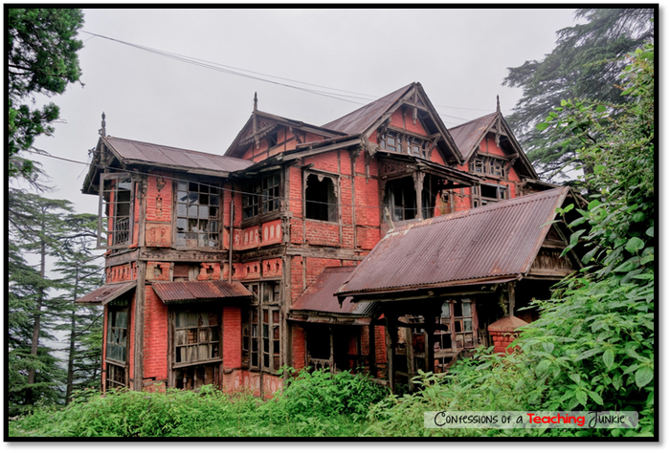

Thursday 16th July 2020
Spellings
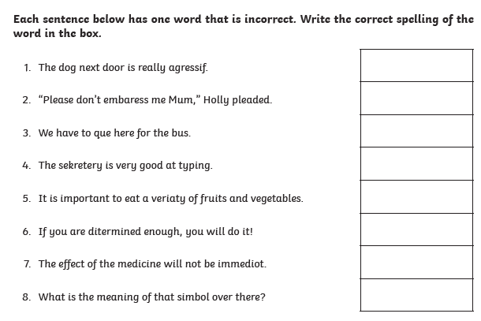
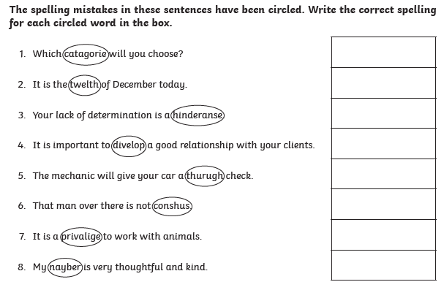
Now write a sentence using each word that you corrected. Make sure the word is written in the correct context.

Friday 17th July 2020
Reading comprehension
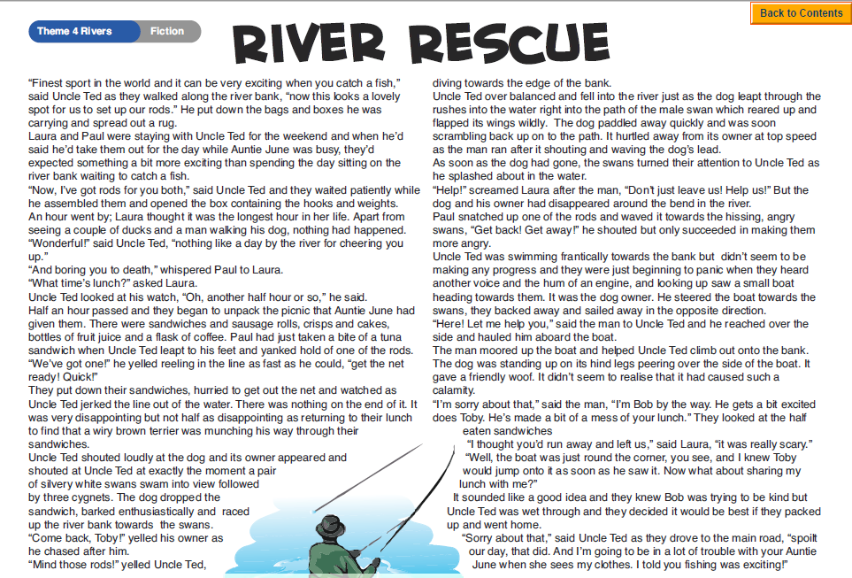
Questions
