Week 17 Monday 13th July 2020 - English comprehension – Year 3 & 4 L.O: To answer reading comprehension questions by deducing and inferring information. Complete the following Questions once you have read the information text on Muhammad Ali
Questions- Year 3 answer questions 1 to 5 (Children in school should attempt all)
Year 4 should attempt to answer all the questions.
- Please answer in full sentences e.g. There are 4 events that take place. Write them in order.
Answer- The first event that takes place is

- What year did Muhammad Ali change his name?
- Who could delay their draft into the military? (There are three answers)
- Why did Muhammad Ali refuse to be drafted?
- Find and copy a word that means to put something off.
- Fill in the missing words
Many people believed that the draft was _________ as most American soldiers ___________ to Vietnam were from poor and working class families.
- Why do you think most people who avoided the draft were people who had more money?
- Explain why you think the US Government punished people for avoiding the draft.
- Do you think stripping Ali of his world title was a fair punishment? Answer yes or no and explain your reason.
- Ali was not able to fight for over three and a half years. Why do you think it might have been difficult for him to return to boxing after all that time? Explain your reasons.
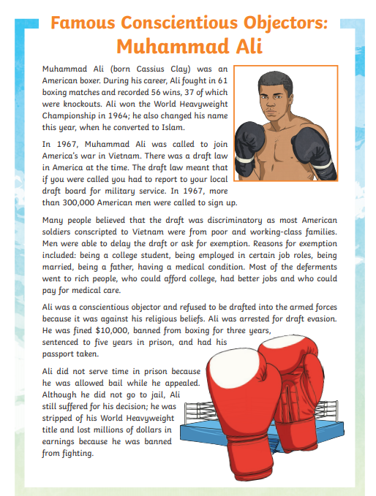 | 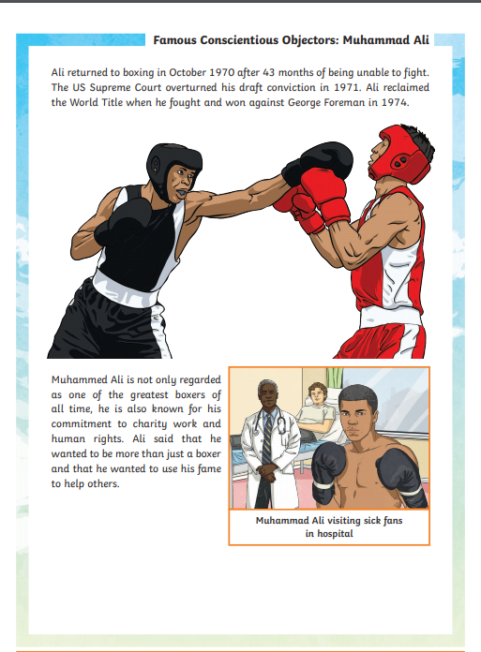

Tuesday 14th July 2020
English Grammar and Punctuation Test 1
Students MUST write the date and title in their books. Copy the question in your book and answer.

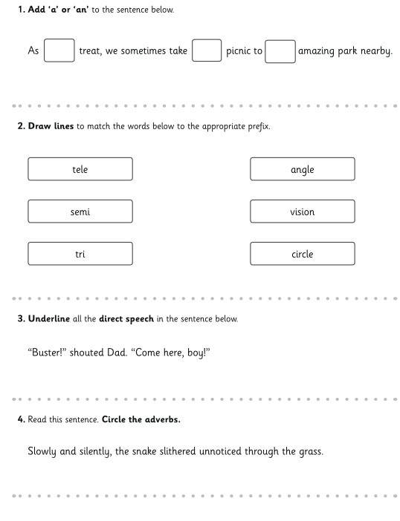 | 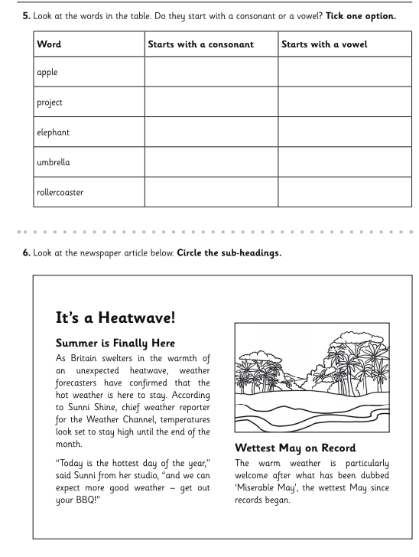

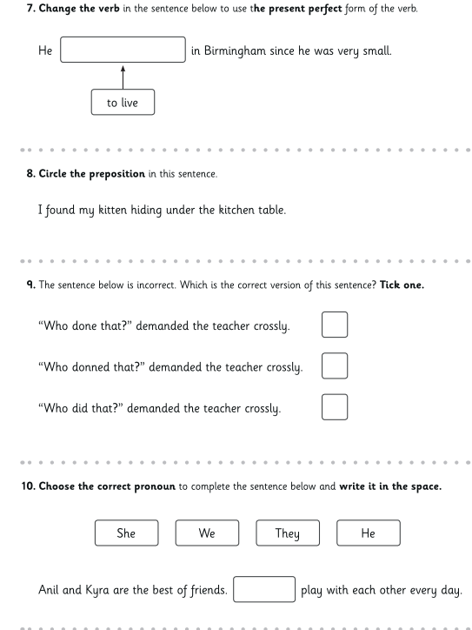

Tuesday 14th July 2020
Spellings
Write and learn the following words in your book.
Write the words 5 times.
Write the definitions down using a dictionary or google search.
Use each word in a sentence.
Do not forget to use a capital letter and full stop in your sentences.
Challenge- can you use at least 2 of the words from the list in a sentence?
Example- I need special strength to get out of my bed every Monday morning.
- Separate
- Special
- Straight
- Strange
- Strength
- Suppose
- Surprise

Week 17
Wednesday 15th^{th} July 2020 English writing – Year 3 & 4: My Life – Autobiography
Task: LO: I can write my own autobiography
TASK:
Write about your own life.
Focus on important and interesting events in your life making sure you write in chronological order.
Points to remember:
- When and where you were born
- Your family
- Starting school
- Making new friends
- New experiences and feelings related to these experiences
- People who have influenced you.
Remember: write in chronological order.

Use ‘Features of an autobiography’ to write your biography.

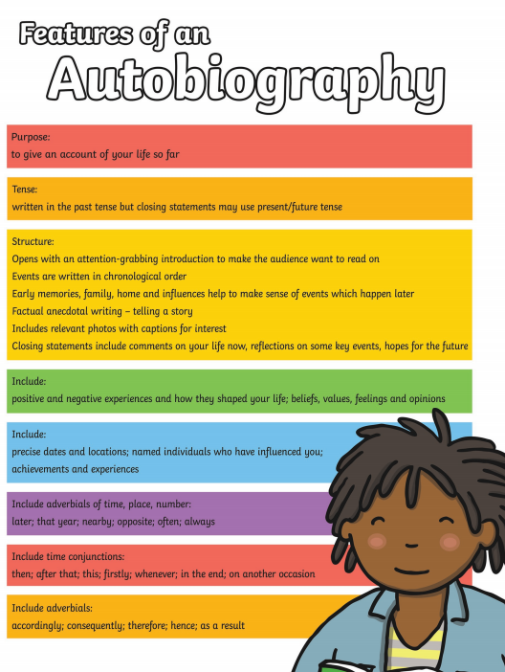

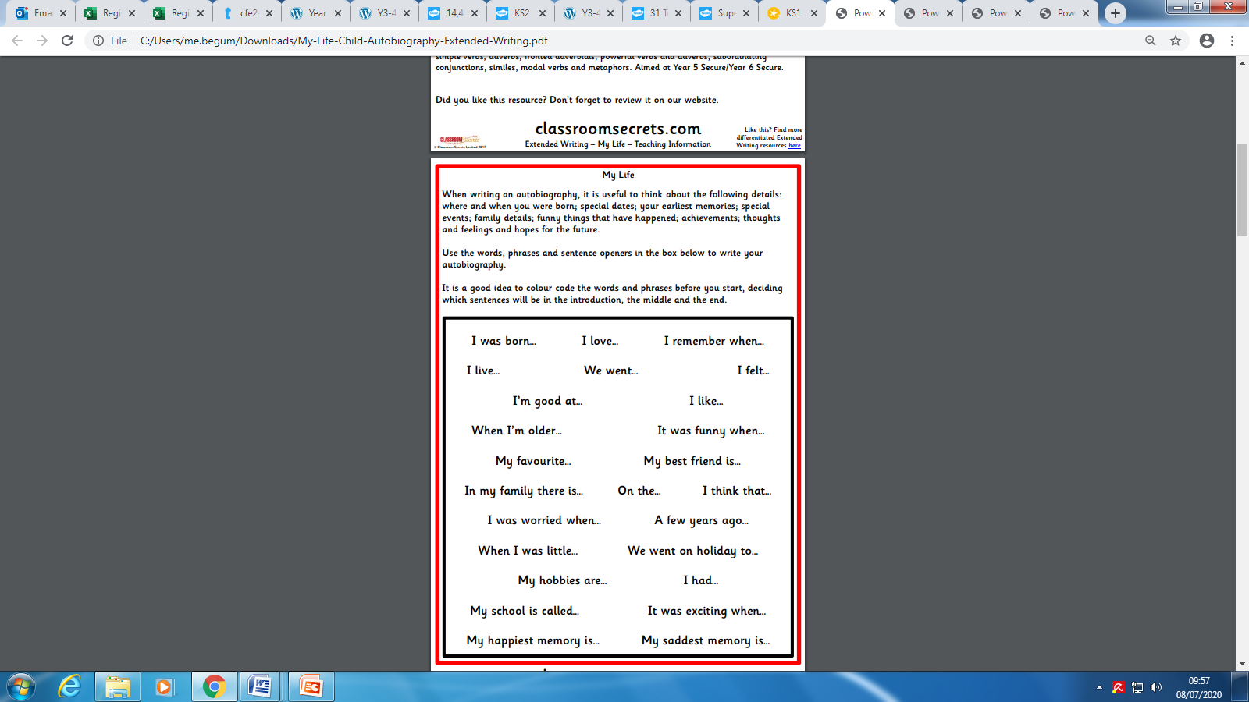

Week 17
Thursday 16nd July 2020

Reading and book review – Year 3 & 4
Copy and Paste the link http://203.72.178.240/~aweb1102/6information/6_5_06/0008.pdf

Book review by: ________________________________________________________
Title:_____________________________________________
Author: ___________________________________________
Non-fiction Fiction
What is the book about?
______________________________________________________________________________________
_____________________________________________________________________________________
Who would this book be suitable for? Age/interests

______________________________________________________________________________________
What was your favourite part? (Describe)
______________________________________________________________________________________
Year 4 challenge: Would you/would you not recommend the book to someone else? Why?

Week 17
Friday 17th July 2020
Comprehension: Read Laura’s Diary entries and answer the questions in your home learning book. Make sure you date your work and write the title. Remember answers should be written in full sentences.
Year 3: Complete question 1-6
Year 4: Complete ALL
- Which is your favourite diary entry? Why?
- Who is the diary about? How do you know?
- What do you think might happen next? What will the next diary entry be about?
- Is this a fiction or a non fiction text? Explain why.
- Did you learn anything new about christmas and advent after reading Laura’s diary?
- Find a powerful verb. Why do you think Laura used this in her diary entry?
- What feature of this text tell you its a series of diary entries?
- Can you find any amazing adjectives?
- Were you suprised by the last diary entry? Is it what you expected?

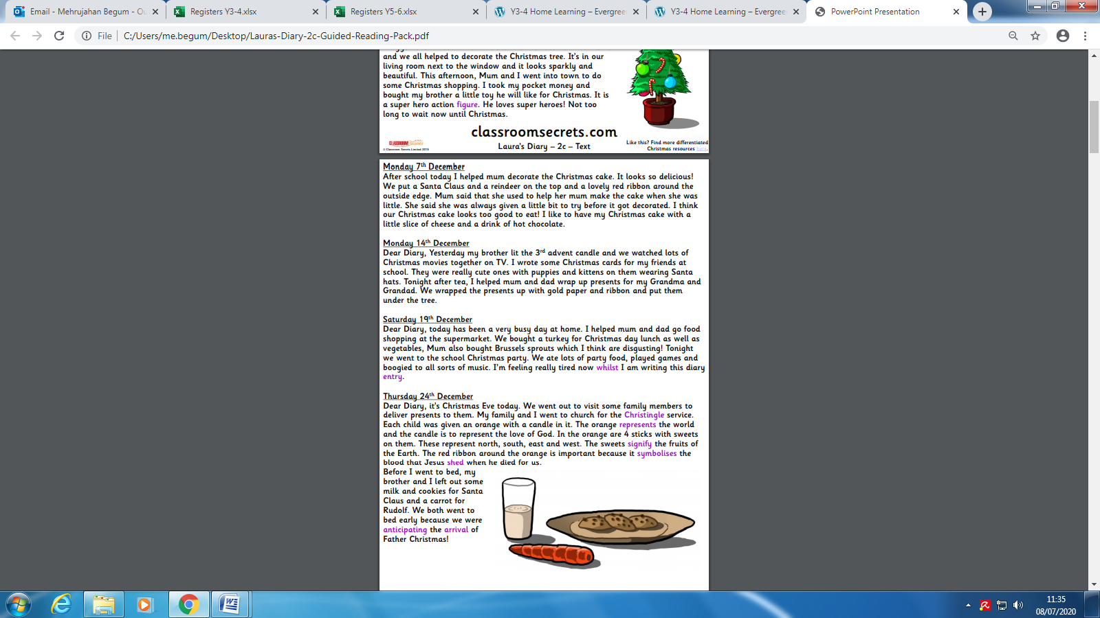
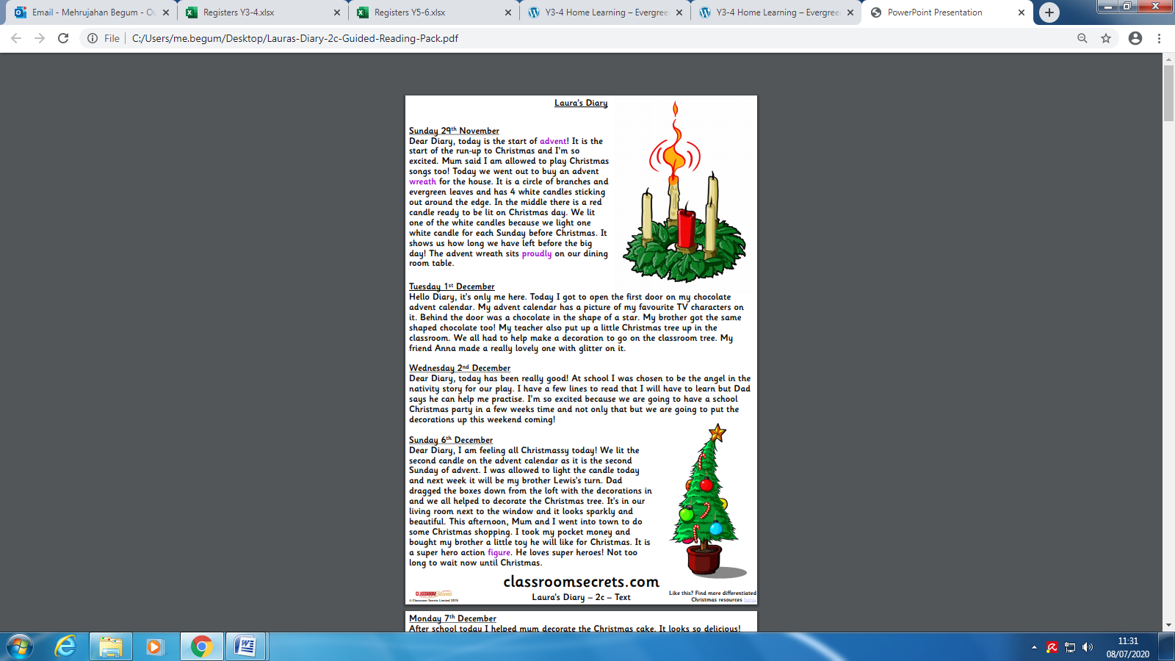
Challenge Task: To be completed by Year 3 and 4
