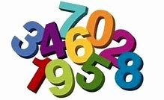
Numbers

Monday activity
Please practise writing numbers with your child.
Write the numbers big with a yellow colouring pencil and then place an arrow showing them where you want them to start from.
Repeat each number 10 times.
Here is an example what I mean…
1 1 1 1 1 1 1 1 1 1
2 2 2 2 2 2 2 2 2 2
3 3 3 3 3 3 3 3 3 3
4 4 4 4 4 4 4 4 4 4
Practise writing up to number 10

Count and match with correct number

Tuesday activity

1
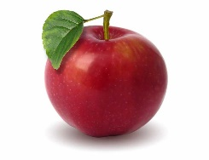
2
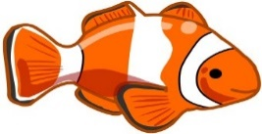
This Photo by Unknown Author is licensed under CC BY-ND
This Photo by Unknown Author is licensed under CC BY-ND
3


4
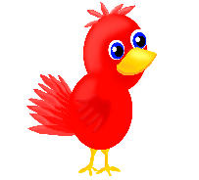
This Photo by Unknown Author is licensed under CC BY
5
This Photo by Unknown Author is licensed under CC BY
This Photo by Unknown Author is licensed under CC BY
This Photo by Unknown Author is licensed under CC BY
This Photo by Unknown Author is licensed under CC BY
This Photo by Unknown Author is licensed under CC BY
This Photo by Unknown Author is licensed under CC BY
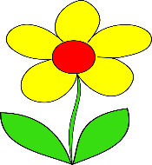
6


7

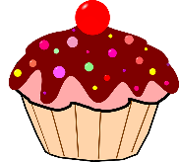
8


9

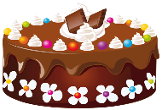
10
This Photo by Unknown Author is licensed under CC BY-NC
This Photo by Unknown Author is licensed under CC BY-NC
This Photo by Unknown Author is licensed under CC BY-NC
This Photo by Unknown Author is licensed under CC BY-NC
This Photo by Unknown Author is licensed under CC BY-NC
This Photo by Unknown Author is licensed under CC BY-NC
This Photo by Unknown Author is licensed under CC BY-NC
This Photo by Unknown Author is licensed under CC BY-NC
This Photo by Unknown Author is licensed under CC BY-NC

Wednesday activity
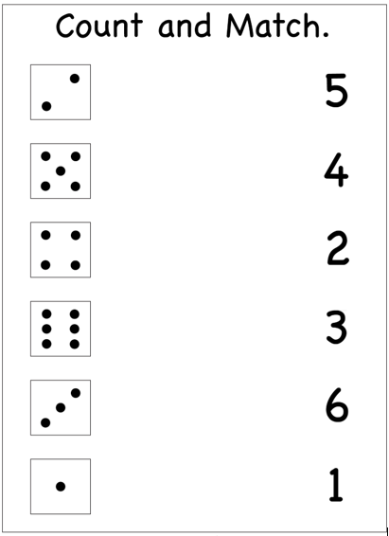

Thursday activity
Have a look in the kitchen
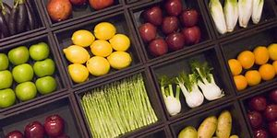
And see if you have any of the items below:
Eggs slices of bread
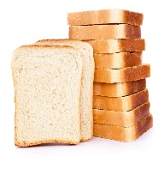
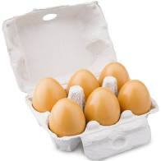
This Photo by Unknown Author is licensed under CC BY-NC-ND
How many did you find? How many did you find?

Apples Potatoes
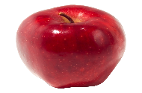
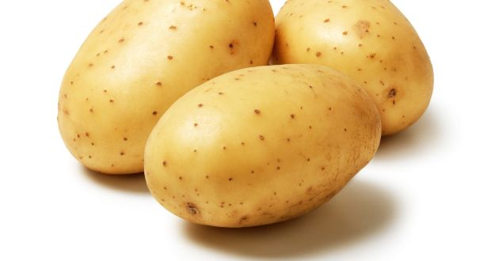
This Photo by Unknown Author is licensed under CC BY-SA
How many did you find? How many did you find?

Tomatoes Bananas
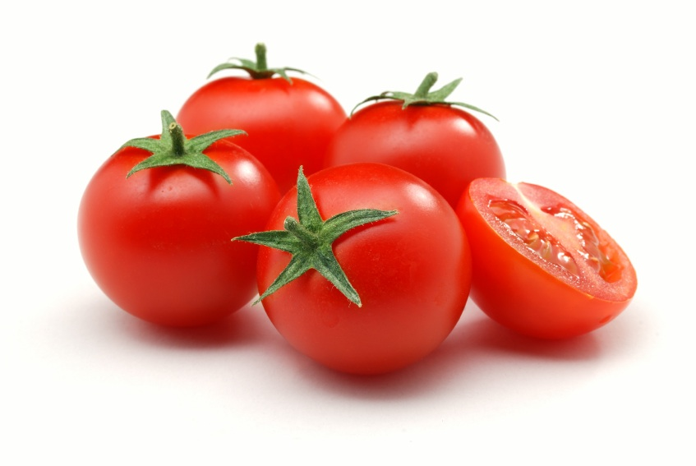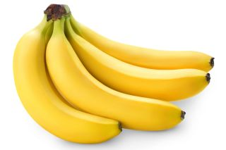
How many did you find? How many did you find?

Have a look around your house
Friday activity
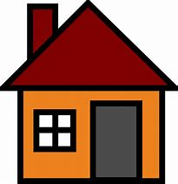

How many chairs do you have?
How many tables do you have?
Have many plates do you have?
Have many doors do you have?
Have many windows do you have?
Have many toilet rolls do you have?
Have many cups do you have?
How many toys do you have?

