Week 16
Monday 6th July 2020
English comprehension – Year 1 & 2
Shooting for the Stars

Our Planet
We live on planet Earth. Our planet is covered in land and water. In the water, there are lots of amazing fish and sea creatures. On land, we build houses, grow plants and take care of animals.

Our Solar System
The Sun is at the middle of our solar system. There are 8 planets in our solar system that all move around the Sun. The planet closest to the Sun is Mercury. The planet furthest away from the Sun is Neptune.

The Moon
The Moon travels around the Earth. Astronauts travelled to the Moon in a rocket to see what they could find.

Did you know?
The first astronaut to land on the Moon was Neil Armstrong in 1969.
Questions

- What is the name of the planet that we live on? Circle one.
Jupiter Earth Mars

2. Where do fish live? Circle one.
in water on land in trees

3.What is in the middle of our solar system? Circle one.
Mars on the moon the Sun

4. Who has travelled to the surface of the Moon? Circle one.
doctors astronauts firefighters

5. Draw a line to connect each sentence.

Mercury.

around the earth.

we build houses.
The planet closest to the Sun is

The Moon travels

On land,

Tuesday 7th July 2020 English Spag – Year 1 & 2
Spag - Task

Year 2 Challenge

Week 16
Tuesday 7th July 2020
Spellings
Write and learn the following words in your book.
Write the words 5 times.
Use each word in a sentence.
Do not forget to use a capital letter and full stop in your sentences.
Challenge- Can you use at least 2 of the words from the list in a sentence?
Example- 'Please push me on the swing' she said.
- unlock
- purse
- wanted
- parents
- where
- once
- water

Week 16
Wednesday 8th July 2020
English writing activity – Year 1 & 2

Go to https://www.youtube.com/watch?v=idUlDEOrJec&t=450s and listen to storyteller Adele Moss tell the tale of The River Race (14 mins).

- Using because to help express an opinion.
Think carefully about the two versions of the Jade Emperor’s story that you have read and heard.
  - On My Opinions, write a full, punctuated sentence in your best handwriting giving a reason you liked The Race Across the River.
  - In your sentence, use the word because to give reasons.
  - Now do the same for River Race.
  - Now say which you think was the best story, and why you feel that.

Being a storyteller
Now you are going to tell a simple version of the story of the animals’ race across the river!
  - Begin with the Jade Emperor’s birthday. Once upon a time...
  - When you get to the race, read from the Race Result Chart you completed yesterday to help get the animals in the right order.
  - Keep retelling the story till you feel confident. Speak in a big, strong storyteller voice. Try adding in some funny voices for the animals.

Now try this Fun-Time Extra
- When you are ready, perform your story for Mum or Dad. Ask them to record or film you telling the story so that other relatives can see and hear it too.

My Opinions
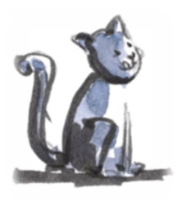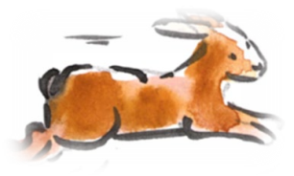

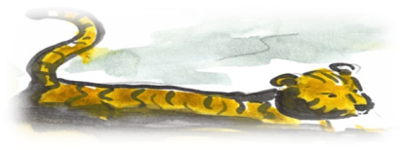

The word because joins together two independent clauses in a sentence.
I like The Race Across the River
and It has funny drawings
I like the Race Across the River because it has funny drawings.
Using because lets you explain or give a reason for something.
I think River Race is the best because you hear the animals speaking.
because
big elephants can always understand small elephant
Thursday 9th July 2020
Reading and book review – Year 1 & 2
Timeless Tales of Beatrix Potter by Beatrix Potter (click on the link below to listen to it)
https://stories.audible.com/pdp/B00IZMHQSE?ref=adbl_ent_anon_ds_pdp_pc_pg-1-cntr-0-3
What did you like about the book?

What was your favorite part? (Describe)

Who was your favorite character and why?

Draw a picture of your favorite scene.

Yr 2 challenge: What rating would you give out of 10 for this book and why?

Week 16
Friday 10th July 2020
English spelling
Spelling
Write and learn the following words in your book.
Write the words 5 times.
Use each word in a sentence.
Do not forget to use a capital letter and full stop in your sentences.
Challenge- can you use a question mark in your sentences?
Example- Do you like the colour violet ?
- things
- wanted
- bear
- untie
- flew
- cream
- violet

