Week 15
Monday 29th June 2020
Reading comprehension
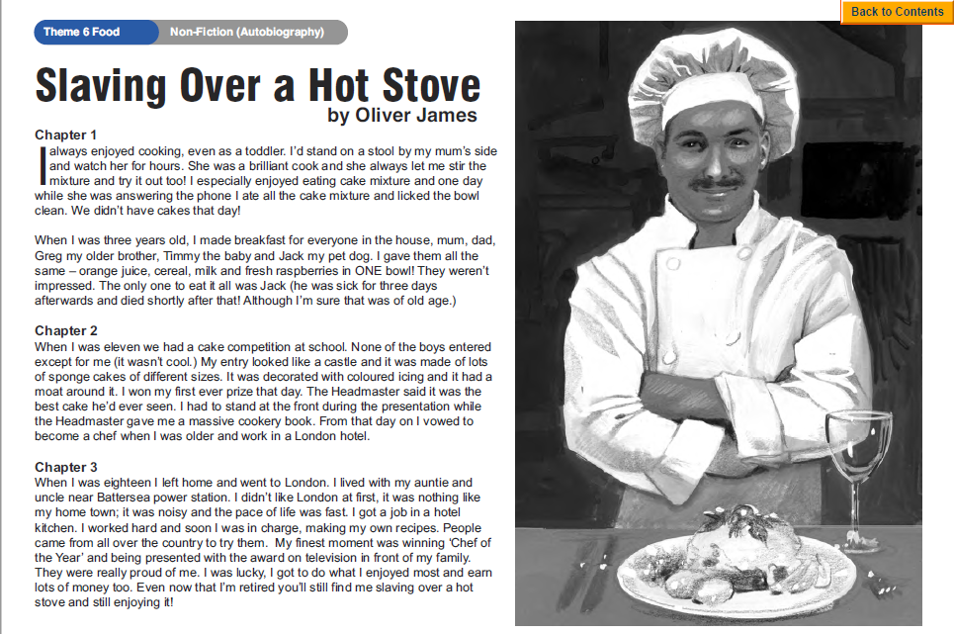
Questions
Year 5- Answer questions 1-6
Year 6- Answer questions 1-8

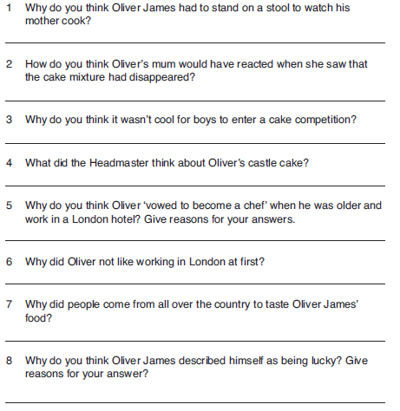
Tuesday 30th June 2020
English grammar
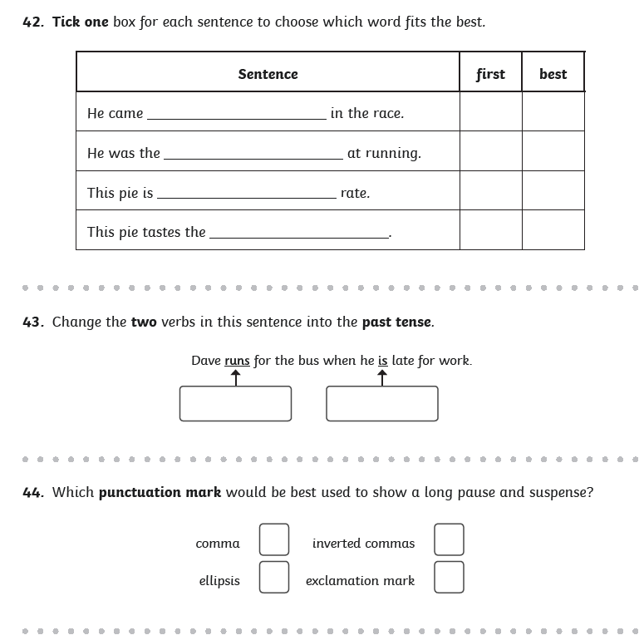
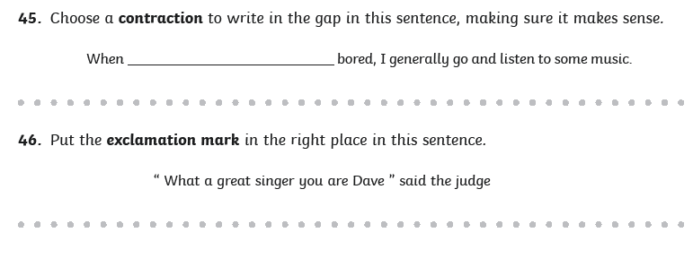
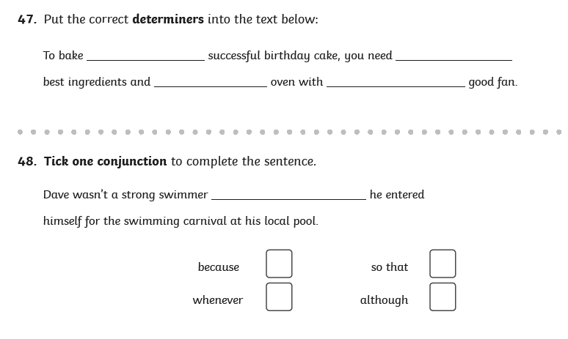
Wednesday 1st July 2020
English Writing

Story openings

The opening of any story has to hook the reader. An opening can begin with:
- dialogue
- description of setting
- description of character
- action
- rhetorical question

Look at the image and decide how to begin your story.
Examples:

Dialogue: ‘Help me! Help!’ The faint voice begged from a distance as the silhouette of a girl quickly faded into the thick heavy fog.

Description of setting: Dampness hung in the air as the fog began to clear. In the distance a vague silhouette of a young girl appeared. However, Ashley couldn’t be sure whether she was drifting into the thickness of the remaining fog or was standing still as daylight pierced through the hazy mist. He instantly froze unable to think or act upon this distant faded image.

Description of character: Ashley was heaving heavily and barely able to breathe. He stumbled on the branches and thick piles of leaves beneath his heavy feet. He wasn’t sure anymore what he was chasing. She had suddenly appeared up the long trail of leaves and faintly called out to him. He was sure of it. But now he doubted himself. He wasn’t sure anymore how long it had been that he was trying to gain on her, to reach this unknown mystical silhouette that taunted him.

Action: Ashley vaguely spotted her in the far distance and then she suddenly disappeared. He was sure he had heard her faintly whispering for him to follow. It only took him what seemed like a fraction of a second for him to decide...

Rhetorical question: Did Ashley actually hear her call out to him or was it just his wild imagination? How was it even possible for her to call him by his name? However, he didn’t have much time, her faint silhouette from a distance was fading quickly. He had to decide hurriedly...

Success Criteria:
- In the first paragraph, start with one of the types of openings using descriptive language (strong adjectives, powerful verbs, noun phrases or extended noun phrases, adverbials of manner or place or time)

- In the second paragraph, move the story on. Think about what could happen next without giving away the story (since it is still the opening) i.e. Ashley caught his breath. He gazed up and unable to see her. But he had to find her. He was determined now, almost crazed by her frail voice that still rang in his mind, when she had called out to him. He was certain of it and he knew this was the beginning of a quest...

- *Challenge: in the third paragraph, think about what happens to the main character or where he/she ends up (remember to continue to use descriptive language and try to leave the reader eager to know what will happen next

Thursday 2nd July 2020
Spellings
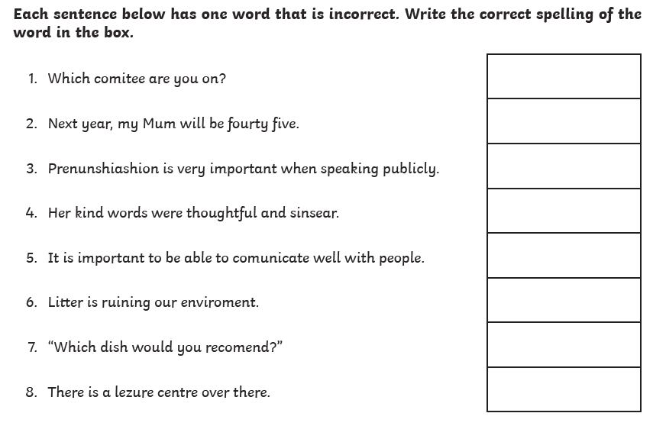
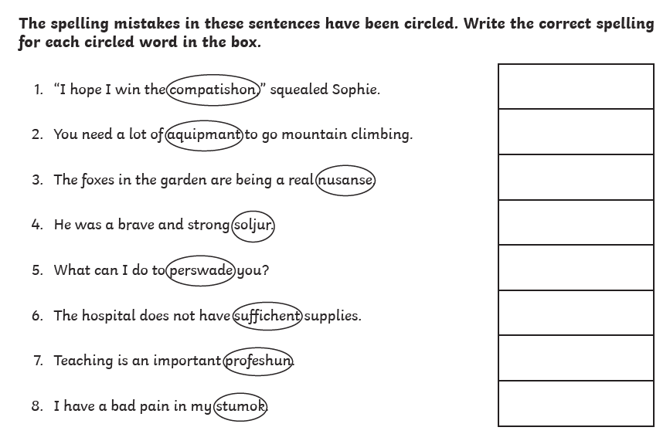
Now write a sentence using each word that you corrected. Make sure the word is written in the correct context.
Friday 3rd July 2020
Reading comprehension
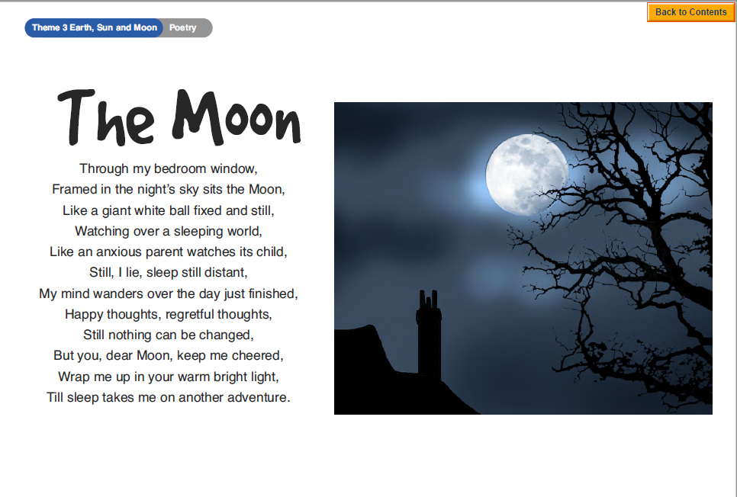
Questions
Year 5- Answer questions 1-7
Year 6- Answer questions 1-challenge
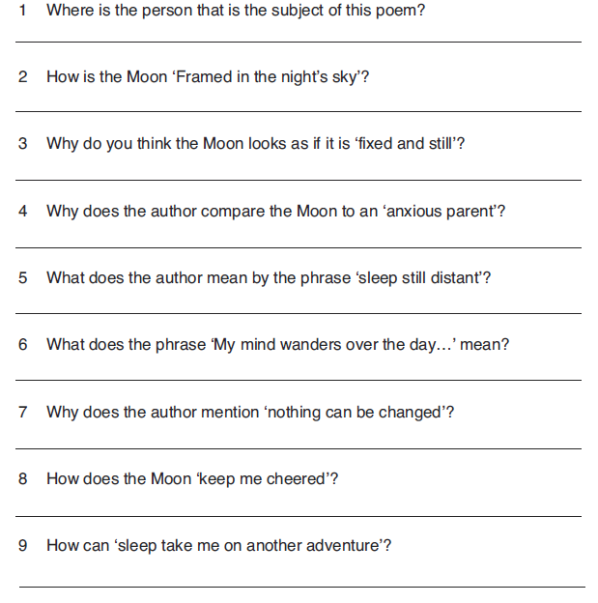
Challenge: Write your own poem about one of the following: The sun, the moon or the earth.

