Week 14
Monday 22nd June 2020
English reading comprehension
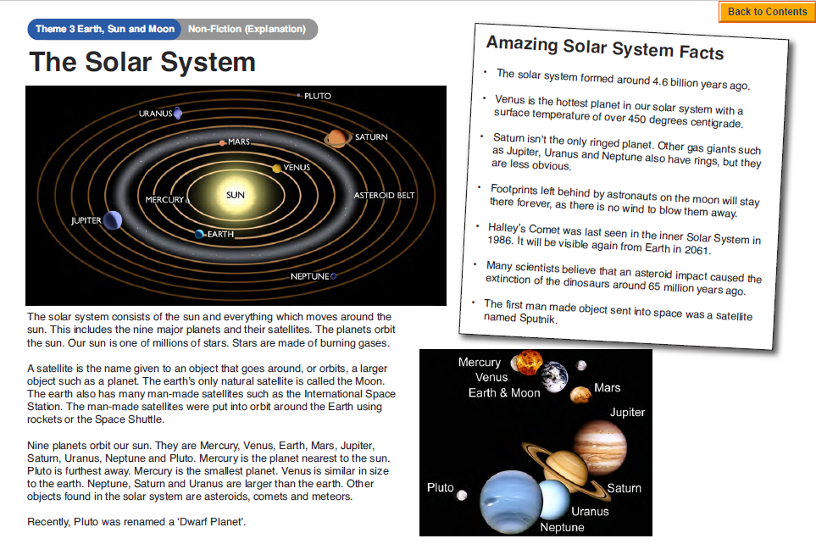

Questions
Year 5- Answer questions 1- 7
Year 6- Answer questions 1- challenge
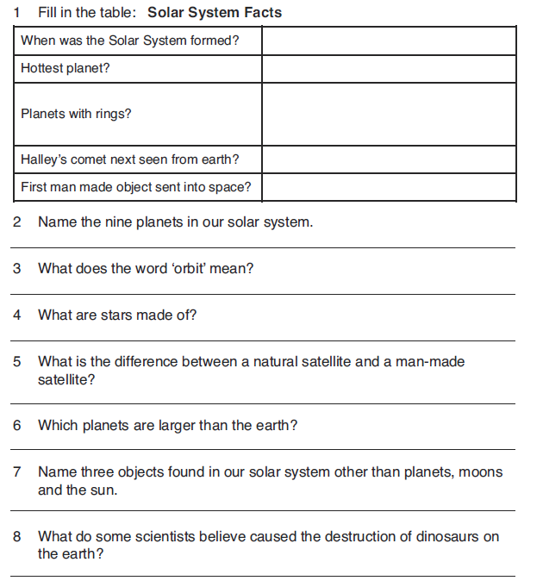
Challenge: Research which planets in our solar system have moons and record your results in a table.
Tuesday 23rd June 2020
English SPAG revision
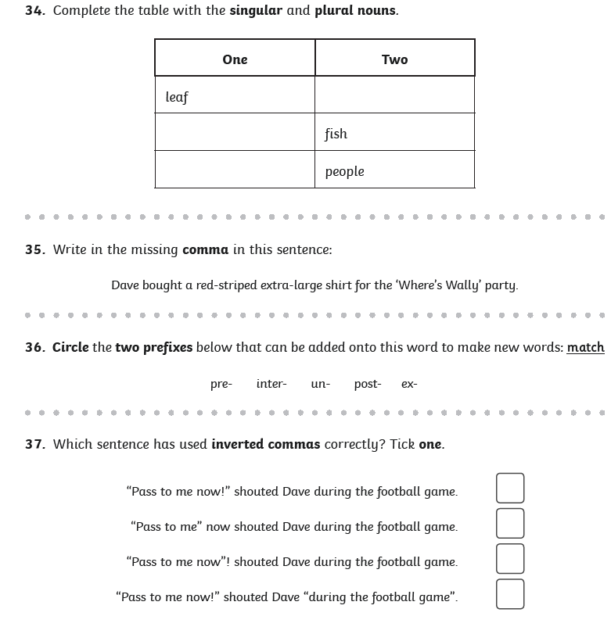
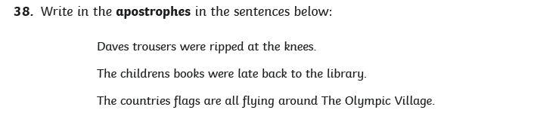
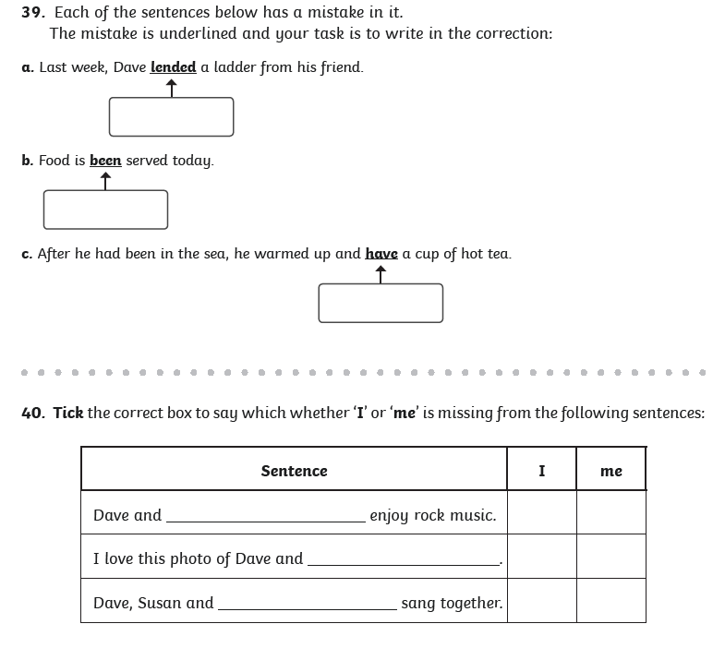
Wednesday 24th June 2020
English writing task
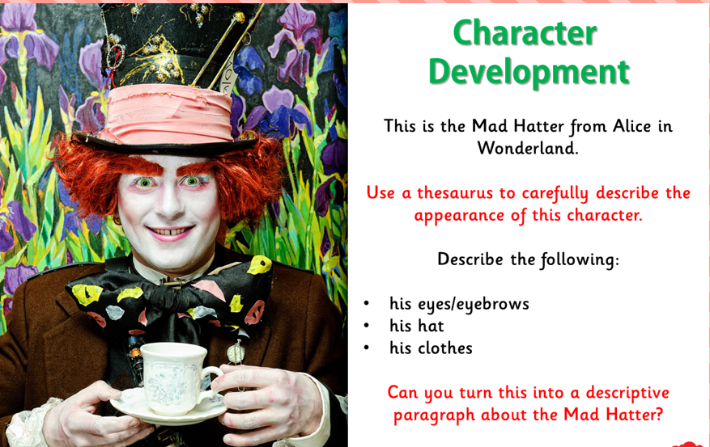
Please click on this link for revision: https://www.bbc.co.uk/bitesize/topics/zkgcwmn/articles/zd72scw
Year 5- Write 2 paragraphs
Year 6- Write 3 paragraphs
Success criteria
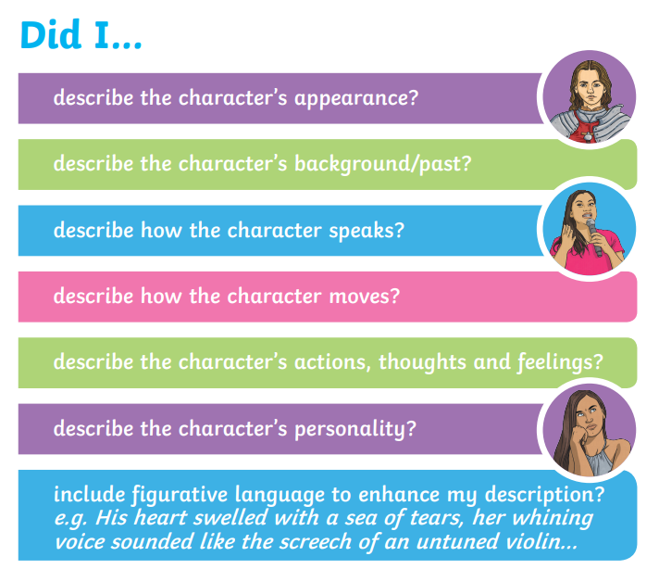

Thursday 25th June 2020
Spellings Task 1
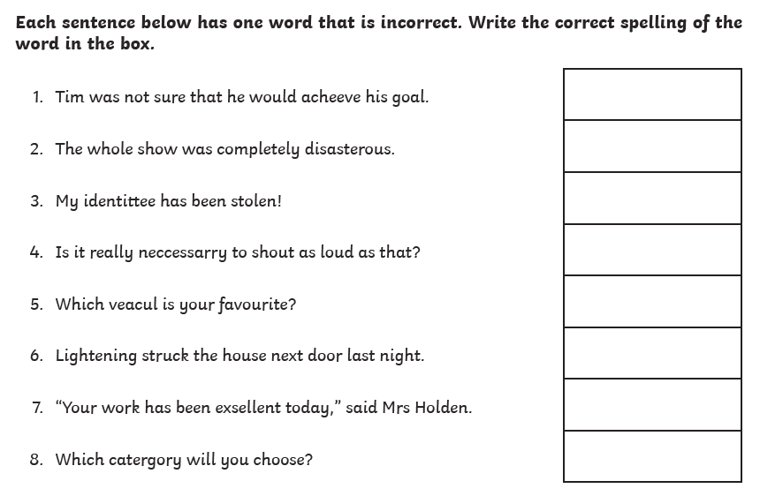

Task 2
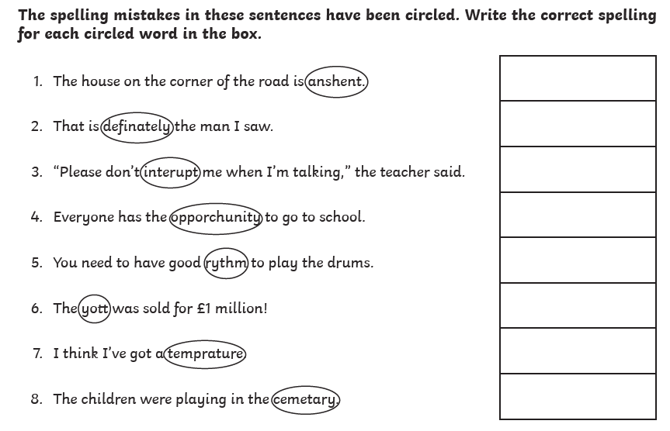

Now write a sentence using each word that you corrected. Make sure the word is written in the correct context.

Friday 26th June 2020
English reading comprehension
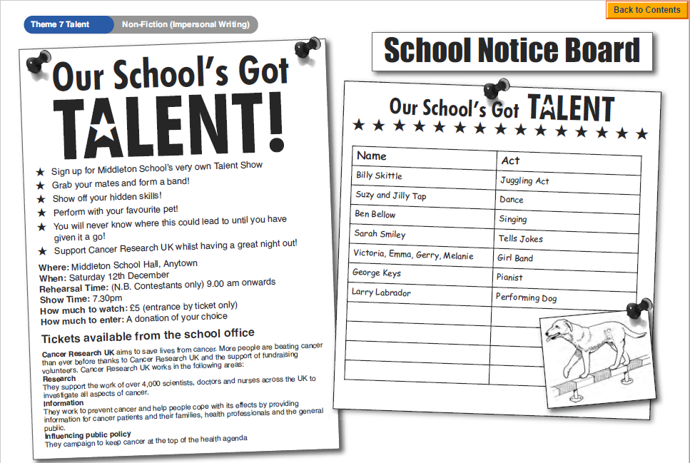
Questions
Year 5- Answer questions 1- 7
Year 6- Answer questions 1- challenge
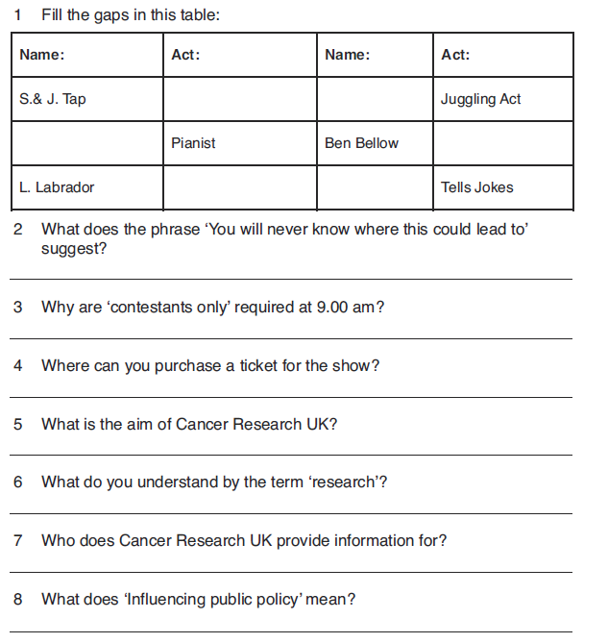Challenge: Imagine you decide to enter a talent show. Write a letter of application describing your act.

