Week 14
Monday 22nd June 2020 - English comprehension – Year 3 & 4
L.O: To answer reading comprehension questions by deducing and inferring information. Read the extract, then read the questions and find evidence from Usain Bolt biography to answer the questions.
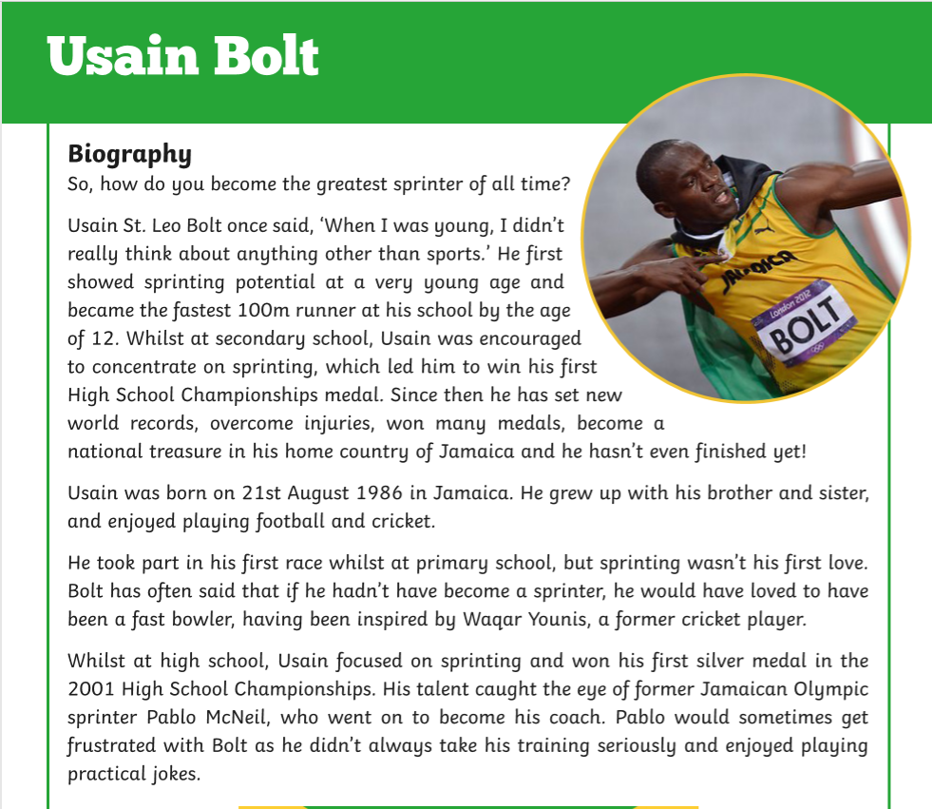
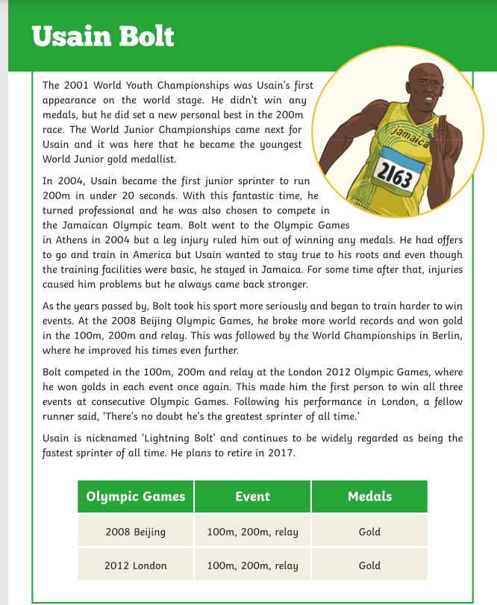
Questions- Year 3 answer questions 1 to 6
Year 4 should attempt to answer all the questions.
- Please answer in full sentences e.g. Who is he inspired by?
- Answer- The person who inspired Bold was_______________ because____________

- When and where was Usain Born?

- By what age had Bolt become the fastest 100m runner at this school?

- Who is he inspired by?

- Why did Pablo McNeil get frustrated with Bolt?

- How do you think Bolt felt when he was chosen to represent his country in the Olympic Games?

- Why do you think Usain Reacher a point in his life where he decided to take his sport more seriously and train harder?

- Why is Usain nicknamed ‘Lightning Bolt’?

8) Which do you think is Usain’s greatest achievement to date? Why?

Tuesday 23rd June 2020
Fronted Adverbials
LO: To place an adverbial phrase at the front of the sentence separated from the rest of the sentences with a comma.
Task: Re-write these sentences so that the adverbial phrase is at the front, separated from the rest of the sentences with a comma
Example: The Train is due to leave the station in five minutes.
In five minutes, the train is due to leave the station.
More frontal adverbial examples:
- I am going to the zoo later today.

- The slimy slug crawled along the path very slowly.

_______________________________________________________________________________________________________________

- The chef washed his knives very carefully.
__________________________________________________________________________________________________________________
- Amin Tiptoed down the stairs without making a sound.
___________________________________________________________________________________________________________________
- Issa goes to gym club twice a week.
___________________________________________________________________________________________________________________
- The mouse ran down the clock as the clock struck one.
____________________________________________________________________________________________________________________
- Yahya flew his kite at the edge of the beach.
___________________________________________________________________________________________________________________
- The snow covered peaks could be seen in the distance
___________________________________________________________________________________________________________________

Tuesday 23rd June 2020
Spellings
Write and learn the following words in your book.
Write the words 5 times.
Use each word in a sentence.
Do not forget to use a capital letter and full stop in your sentences.
Challenge- can you use at least 2 of the words from the list in a sentence?
Example- I often get along with ordinary as well as popular students from my school.
- opposite
- ordinary
- particular
- peculiar
- perhaps
- popular
- often

Week 13
Wednesday 24th June 2020
English writing – Year 3 & 4: Task: LO: To write a story with the title ‘Keep Out of the Mud’. It tells how George tries to join his friends to help build the den and look after Alfie at the same time.

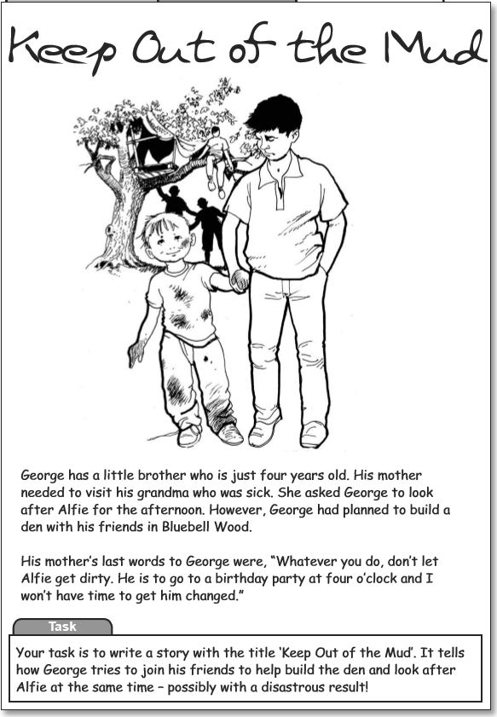
Your task: to write a story with the title ‘Keep Out of the Mud’. It tells how George tries to join his friends to help build the den and look after Alfie at the same time.

Do not forget to:
- Use capital letters and full stops.
- Include lots of adjectives (describing words) and adverbs (to describe the verbs)
- Read each sentence to check if it makes sense.
- Use a wide range of punctuation including at least 3 of the following: full stop and capital, question mark, exclamation mark, apostrophe and comma.
- Use more sophisticated connectives, (e.g. although, however, nevertheless, despite, contrary to, as well as etc).

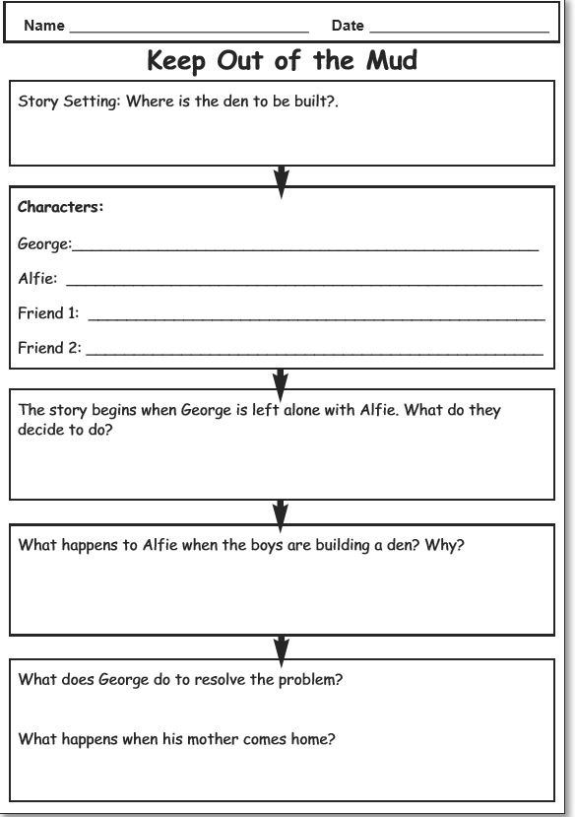

Week 14
Thursday 25th June 2020
Reading and book review – Year 3 & 4
Click on the link and listen to the story of ‘The Adventures of Angus the Mouse’. Write A book review about the story.
https://stories.audible.com/pdp/B01MSZY3JO?ref=adbl_ent_anon_ds_pdp_pc_pg-1-cntr-0-25

Book review by: ________________________________________________________
Title:_____________________________________________
Author: ___________________________________________
Non-fiction Fiction
What is the book about?
______________________________________________________________________________________
_____________________________________________________________________________________
Who would this book be suitable for? Age/interests

______________________________________________________________________________________
What was your favourite part? (Describe)
______________________________________________________________________________________
Year 4 challenge: Would you/would you not recommend the book to someone else? Why?

Week 14
Friday 26th June 2020
Comprehension: Read the recount and answer the questions in your home learning book. Make sure you date your work and write the title. Remember answers should be written in full sentences.
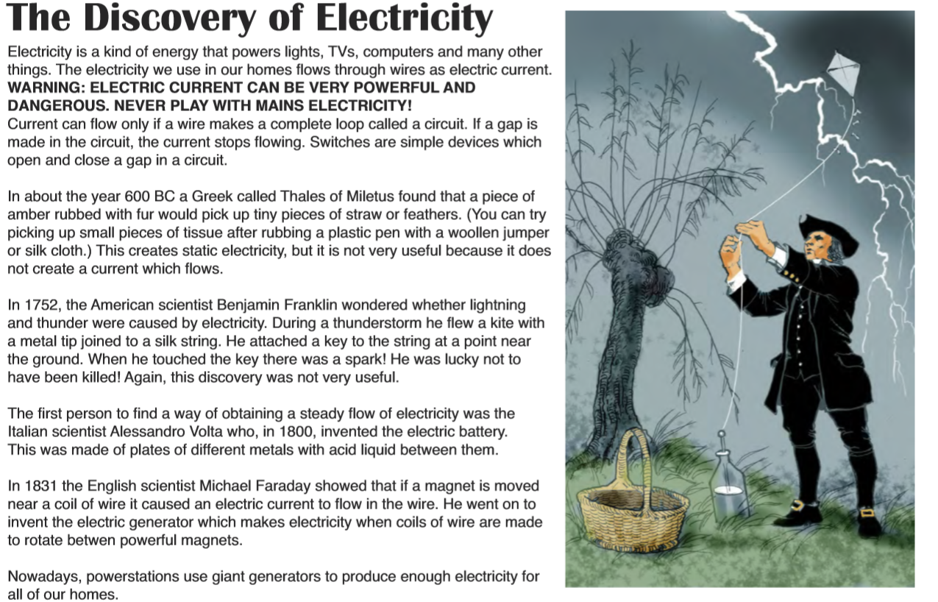

Questions:
- Electricity is a kind of energy that powers
a) lights b) cheese c) glass d) wood
and many other things. Electric current flows through a wire in a complete loop called a
circle. current. circuit. circus.
- A Greek called Thales of Miletus discovered
Standing stationery static stationary

- 