Week 13 - Monday 15th June 2020
Year 4
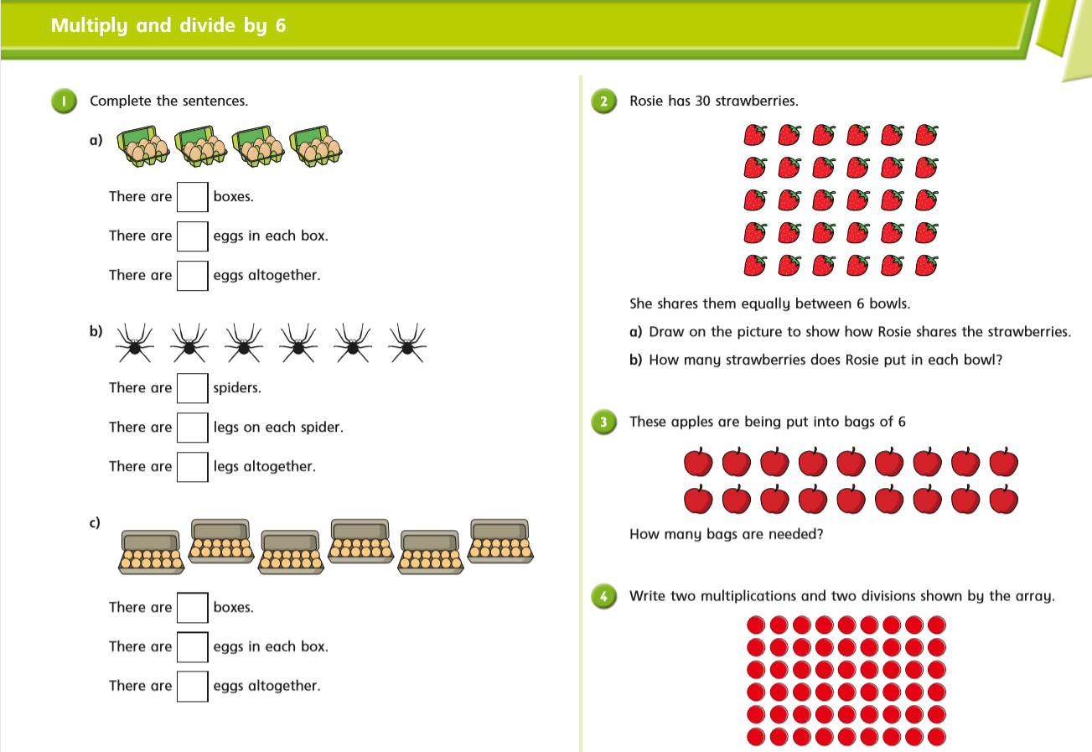

Year 4 Challenge
