Week 13
Monday 15th June 2020
Reading comprehension
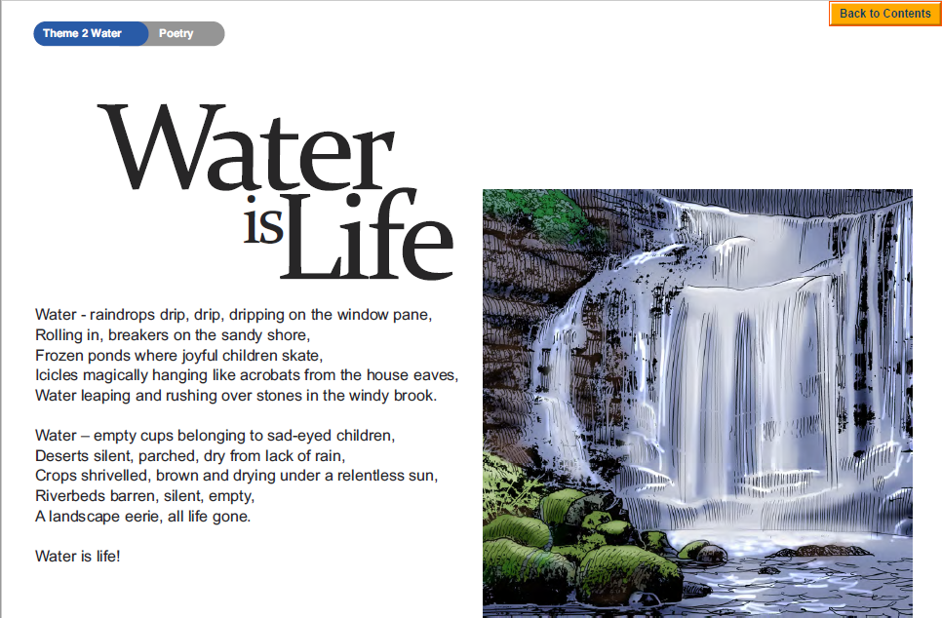

Questions
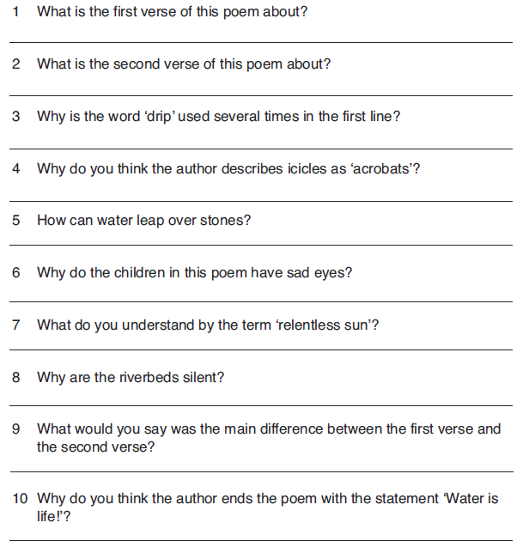

Challenge: Write your own poem about water.
Tuesday 16th June 2020
English SPAG-Revision
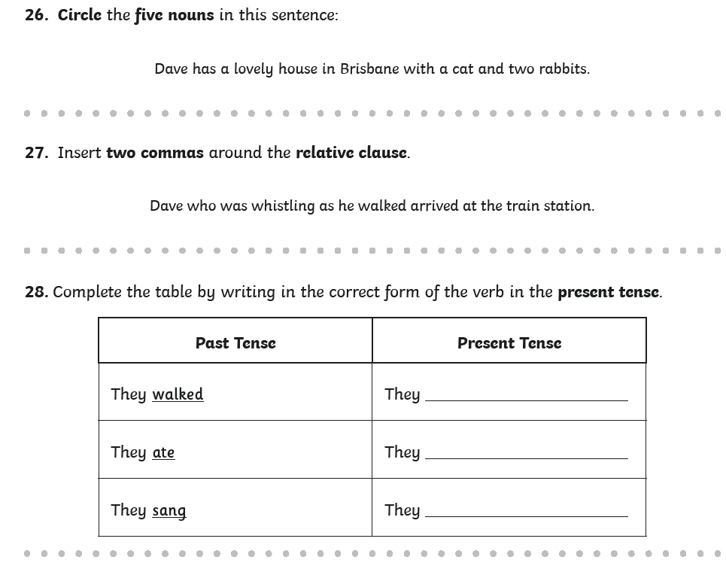

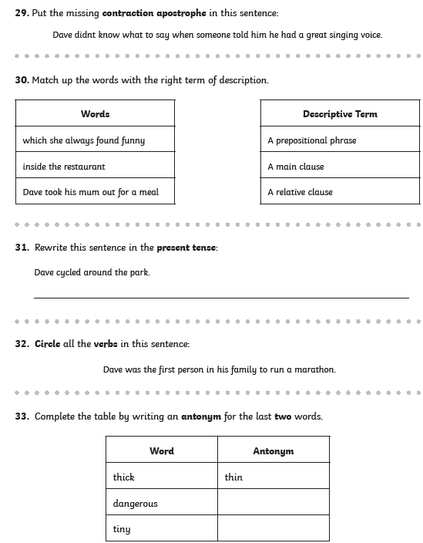
Wednesday 17th June 2020
Writing task
Read the information about Honey Badgers
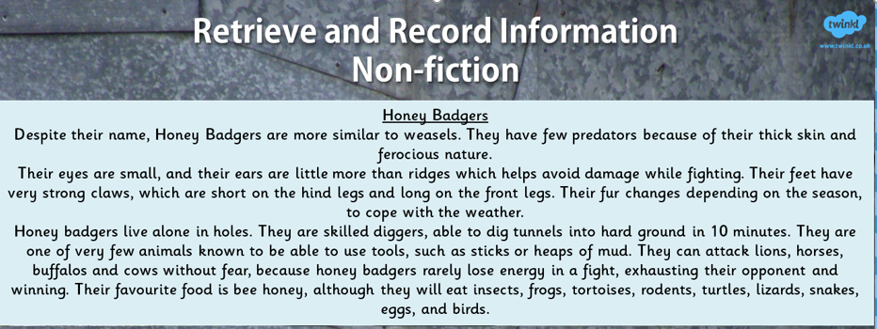

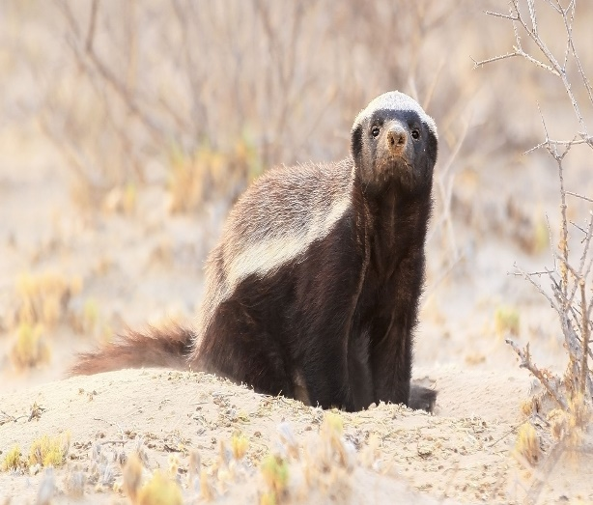
Instructions
- Think of a main heading for this text to attract readers.
- Think of sub- headings to separate the information.
- Without reading the text again, summarise what you have learnt about Honey Badgers.
Challenge
Write some safety instructions for visitors to a new Honey Badger farm.

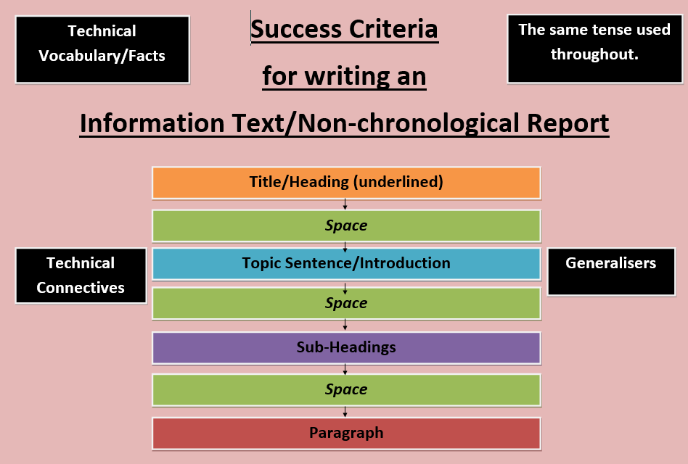
Thursday 18th June 2020
Spelling task 1

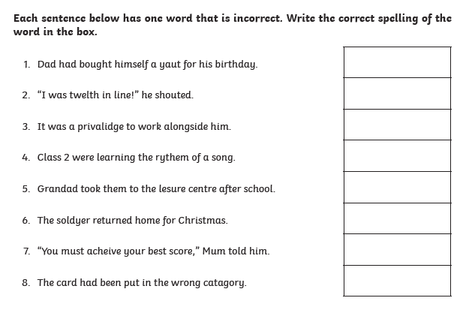

Task 2
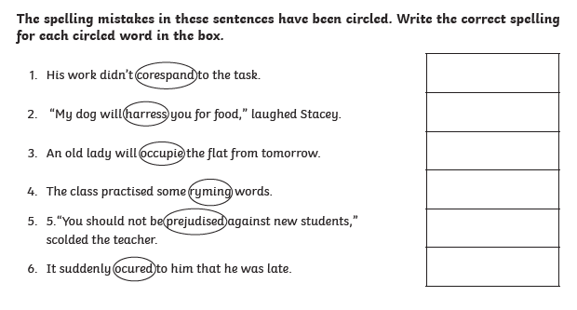

Now write a sentence using each word that you corrected. Make sure the word is written in the correct context.

Friday 19th June 2020
Reading comprehension
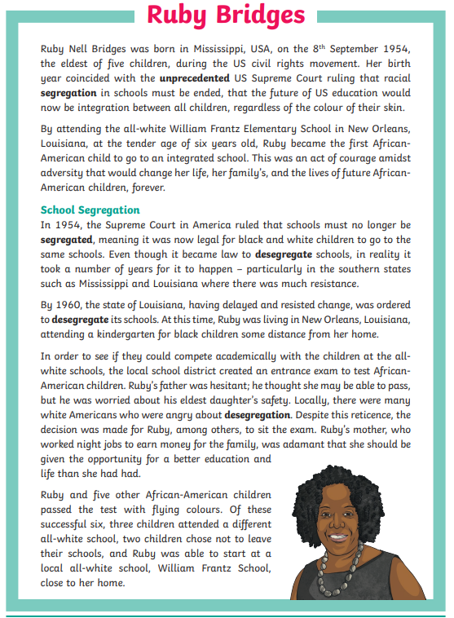
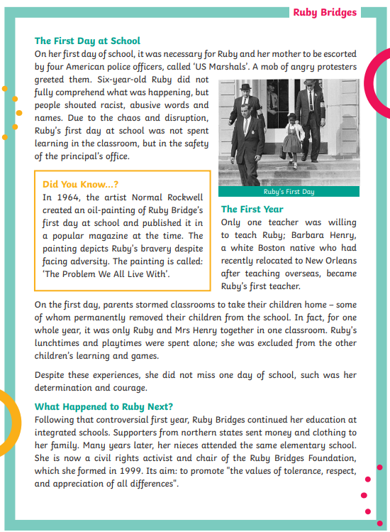
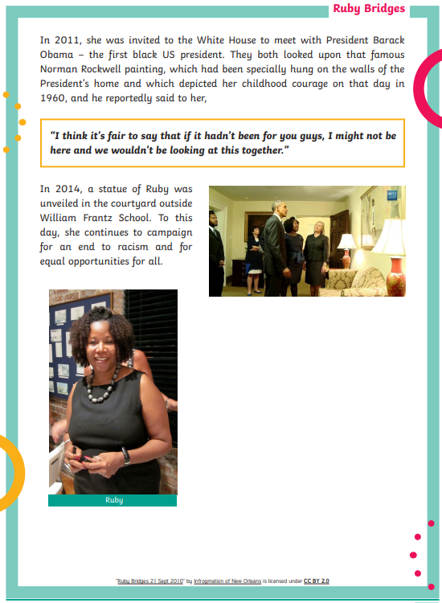
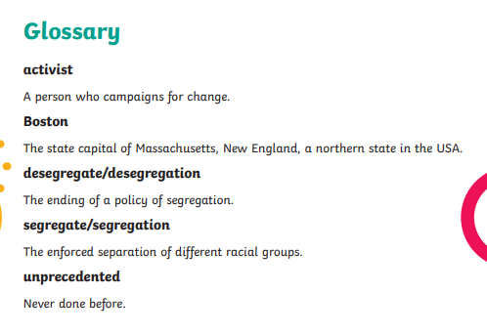

Questions
Year 5- Answer questions 1-7
Year 6- Answer questions 1-10
