Week 12
Monday 8th June 2020
Year 5 and 6 Reading comprehension
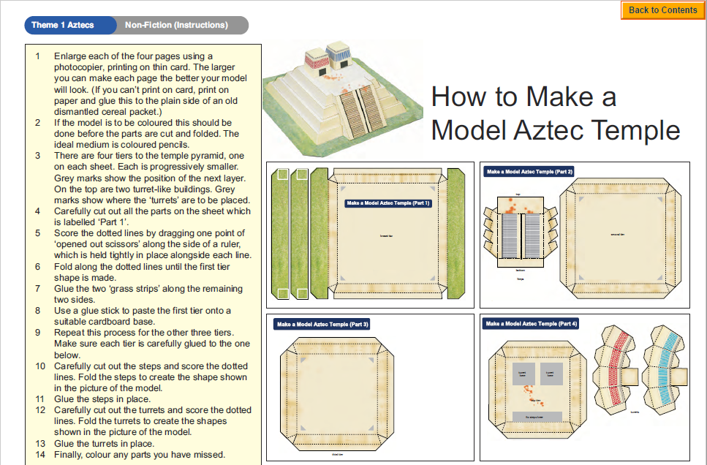
Questions
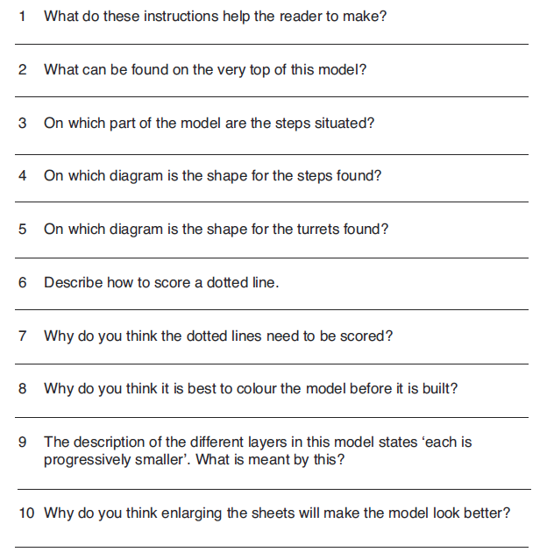
Challenge: write a brief set of instructions telling how to dismantle a breakfast cereal packet and reassemble it inside out so the outside surfaces are completely blank.
Tuesday 9th June 2020
English SPAG- revision
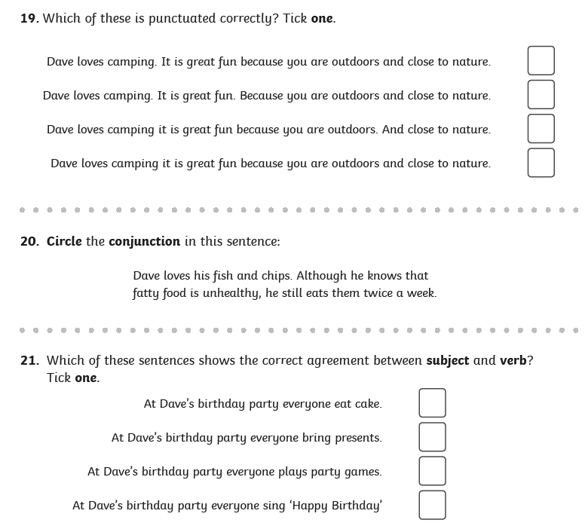

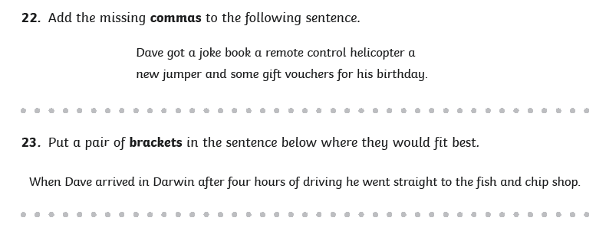
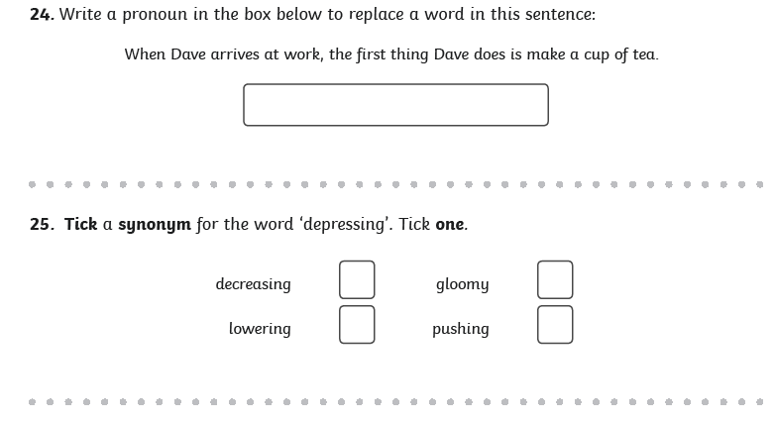
Wednesday 10th June 2020
Writing task
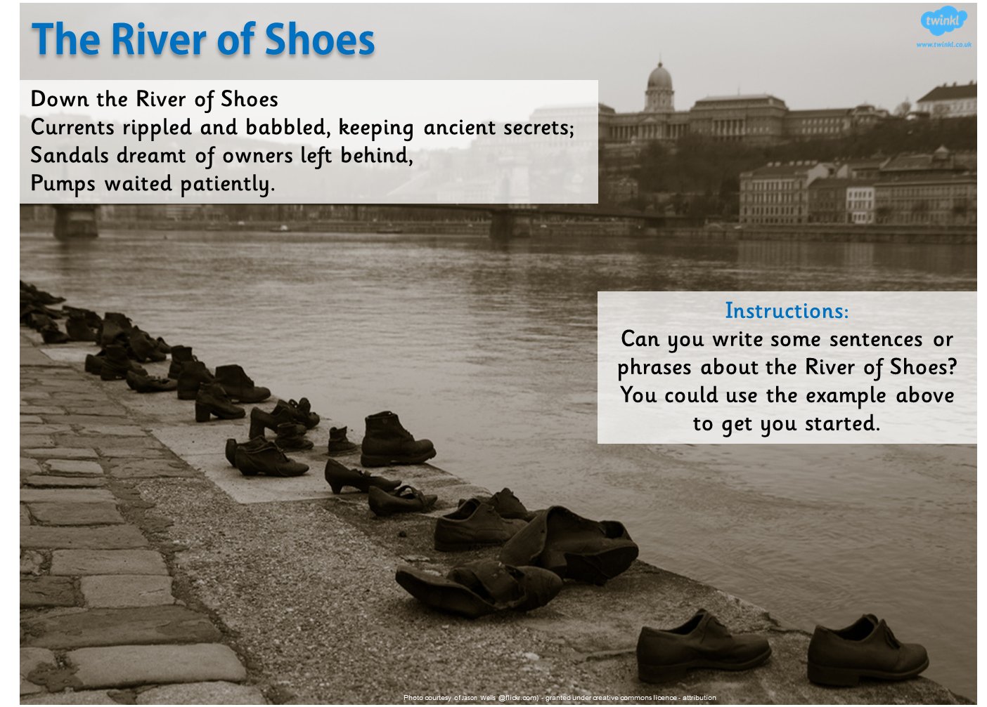

Things to think about:
Where have these shoes come from?
Why have they been left there?
Who they may belong to? Adults, children?
Was there a tragedy that happened?
Thursday 11th June 2020
Spellings
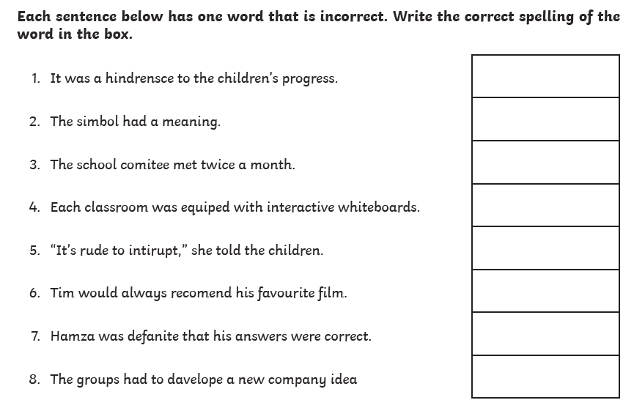

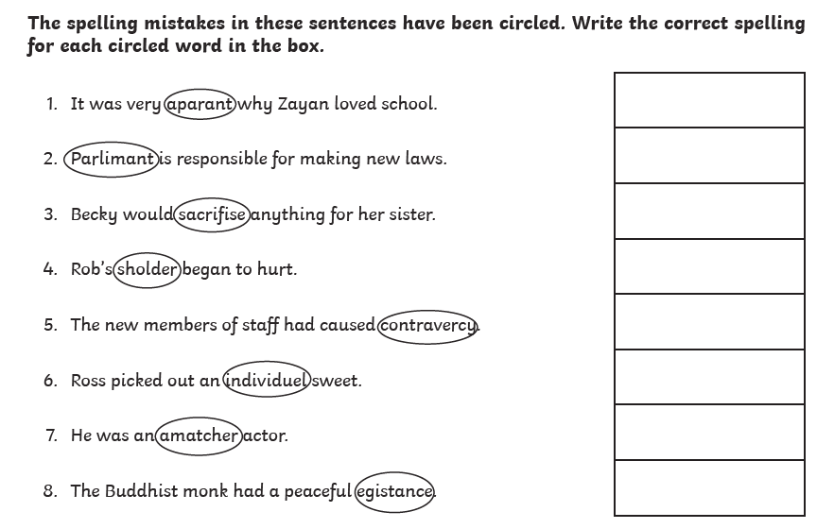
Now write a sentence using each word that you corrected. Make sure the word is written in the correct context.

Friday 12th June 2020
Reading comprehension
Questions
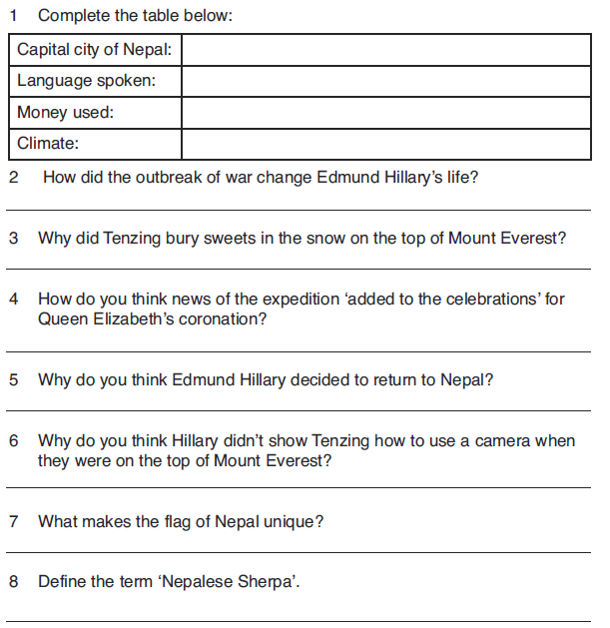
Challenge:
