Week 12
Monday 8th June 2020
English comprehension – Year 1 & 2
Dolphins
What do dolphins look like?
A dolphin is a sea animal. They have two fins on the side and one on the back to help them to swim fast. They can be a mix of black, white and gray. Dolphins have fat under the skin to keep them warm in the cold seas. They breathe out of a nostril on the top of their head called a blowhole.
Where do dolphins live?
Dolphins live in seas and rivers. They live together in groups called ‘pods’.
What do dolphins eat?
Dolphins eat fish. They wait for the fish to jump out of the sea into their mouth.
What do dolphins do? Dolphins can jump out of the water and flip over to land on their back, belly or side. This is called ‘breach’. They breach to let other dolphins know about food nearby.
Questions
- Why do dolphins have two fins on the side and one on the back? Tick one.
to help them to jump out the water
so they can swim on their back
to help them to swim fast

- Why do dolphins have fat under the skin? Tick one.
to keep them warm to make them bigger
to help them swim down

- What is the name of the nostril on the top of their head? Tick one.
horn hole blowhole spray hole

- What do dolphins eat? Tick one.
plants toast fish

- What is it called when dolphins jump out of the water and flip over to land on their back, belly or side? Tick one.
breach splash
spin
Week 12
Tuesday 9th June 2020 English Spag – Year 1 & 2

Spelling, Grammar and Punctuation
Task 1
Read the text below
Can you work out where the sentences should begin and end and add in the full stops?
Task 2
Can you write sentences to describe what is happening in this picture using adjectives? Do not forget to put a capital letter at the beginning of your sentences and a full stop at the end.

For example:
The tall man is cooking sausages on the barbecue.
The boy with brown hair is gardening next to him.
Week 12
Tuesday 9th June 2020
Spellings
Write and learn the following words in your book.
Write the words 5 times.
Use each word in a sentence.
Do not forget to use a capital letter and full stop in your sentences.
Challenge- Can you use at least 2 of the words from the list in a sentence?
Example- People need to drink water in school when they feel thirsty.
- water
- people
- school
- where
- who
- even
- some

Week 12
Wednesday 10th June 2020
English writing – Year 1 & 2

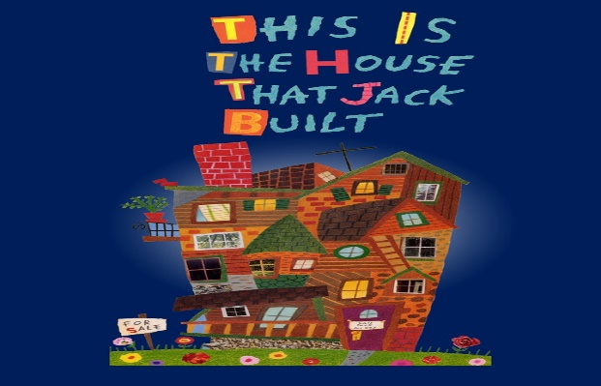

Watch/re-watch This is the House that Jack Built by Simms Taback at https://www.youtube.com/watch?v=qYymDq0muDI.
  - What food is the Rat so fond of? Cheese!
  - What words are used to describe the cheeses that Rat eats? (Stinky, smelly, yummy, gooey.)

Listing favourite foods
Think about 5 things you really like eating and 1 thing that you really don’t enjoy scoffing! Only 2 of your favourites can be sugary things like chocolate, sweets or biscuits.
  - Draw each of your 6 things in the boxes on My Best and Worst Foods.
  - Follow the instructions.

Let’s get ready for writing
Read what Rat says about what he likes to eat on Food, Glorious Food. Show how we use the words but and to join together two independent clauses in a sentence.
  - Copy Rat and write 3 sentences with the words but and then and in them to talk about your favourite (and least favourite!) foods. I like yummy pasta but I love delicious roast potatoes, etc.
  - Remember to use proper sentence punctuation and word spaces.

Now try these Fun-Time Extras
- Label the picture of Rat’s Cheese with lots of good describing words
- Create a Menu for the Rat's supper

My Best and Worst Foods
  - Draw each of your 6 things in the boxes on My Best and Worst Foods. The red box is for the thing you do not like.
  - Write each one’s name with a good describing word for it (tasty chocolate, yummy pasta/ horrible eggs, nasty yoghurt, etc.)

Food Glorious Food!
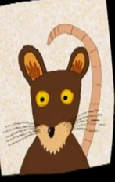

Rat says....
I like smelly cheddar but I love delicious gouda.
I love gooey camembert but I adore beautiful Swiss cheese.
I adore tasty Port Salut...and I hate boring sprouts!

What do you say about your foods?

but
and
like love adore
hate

Rat’s Cheese

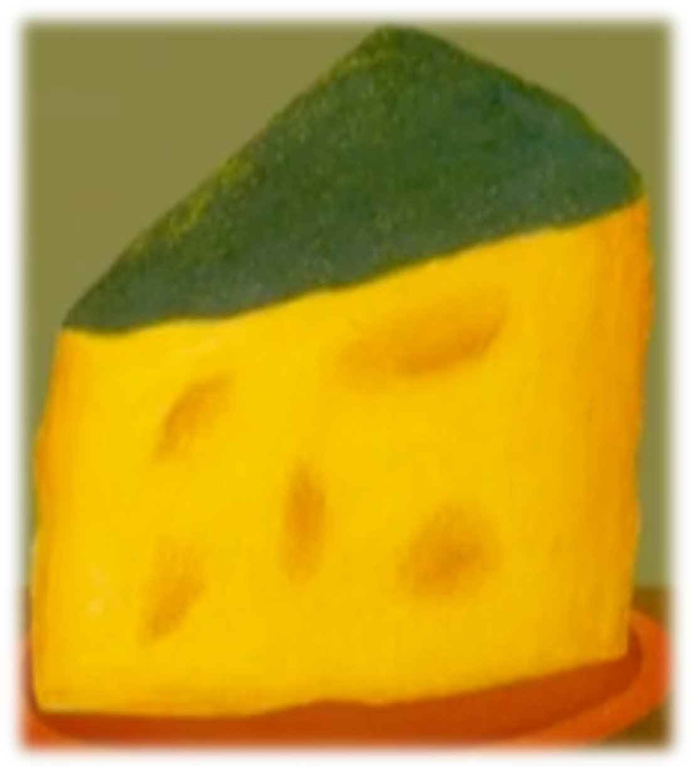

A Menu for Rat

Can you create a lovely dinner menu for Rat? Use lots of good describing words to make the food sound extra tasty.

Starters
Main courses
Side orders
From the sweet trolley
To drink

Thursday 11th June 2020
Reading and book review – Year 1 & 2

Cockroach Party: Stories for Dancing, Drumming, and Moving All About! Written By: Margaret Read MacDonald
(click on the link below to listen to it)
https://stories.audible.com/pdp/B002V0M2N0?ref=adbl_ent_anon_ds_pdp_pc_pg-1-cntr-0-35Answer these questions below
What did you like about the book?

What was your favorite part? (Describe)

Who was your favorite character and why?

Draw a picture of your favorite scene.

Yr 2 challenge: What rating would you give out of 10 for this book and why?

Week 11
Friday 12th June 2020
English spelling
Spelling
Write and learn the following words in your book.
Write the words 5 times.
Use each word in a sentence.
Do not forget to use a capital letter and full stop in your sentences.
Challenge- can you use a question mark (?) or exclamation mark (!) in your sentences?
Example- Can I go out once today?
- child
- today
- house
- once
- are
- most
- has

