Summer 2
Rec Maths

Notes for parents
(Remember gold prizes from me for neat outstanding work)

If you do not have access to a printer, provide your child with an exercise book to do their work in.

- Write the short date (today's date)
- Write the L.O:
- Miss a line
- Question numbers in the margin and write answers on the line.

(I will be asking your parents if your work looks neat and to send me a picture of your amazing work. I myself will check your work once you come back to school in sha Allah)

Monday 8th June 2020

Can you write your numbers 0-20 in the correct order? Make sure your numbers are facing the correct way!

Once you have finished, try and write the number words for each number from 0-10.

Tuesday 9th June 2020

I have accidently mixed these numbers up, can you help me by putting them in the correct order?

9, 1, 6, 0, 3, 7, 2, 5, 8, 4, 10

7, 3, 5, 10, 0, 4, 2, 8, 6, 1, 9

Wednesday 10th June 2020

Which number is bigger 2 or 7?

Which number is bigger 3 or 8?

Which number is bigger 10 or 5?

Which number is smaller 12 or 15?

Which number is smaller 20 or 6?

Which number is smaller 9 or 11?

Which number is bigger 16 or 19?

Which number is smaller 0 or 4?

Thursday 11th June 2020

What numbers are missing on the number line?
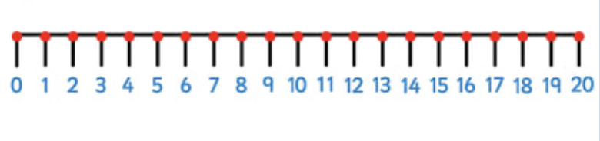

Friday 12th June 2020
