Phonics Phase 1: Alliteration - week 12
Model as per example below to teach your child the letter and the initial sound it makes. Ask your child to name each letter and the initial sound then say the sound and the pictures. Write each letter out showing them how to hold the pencil in a tripod grip. You can use dot-to-dot to start with but eventually they should be able to copy it by themselves. Children to also practice writing their name.

E.g- This is the letter 'm'. It makes the initial sound 'm'.
u, u, umbrella u, u, udder u,u, underpants
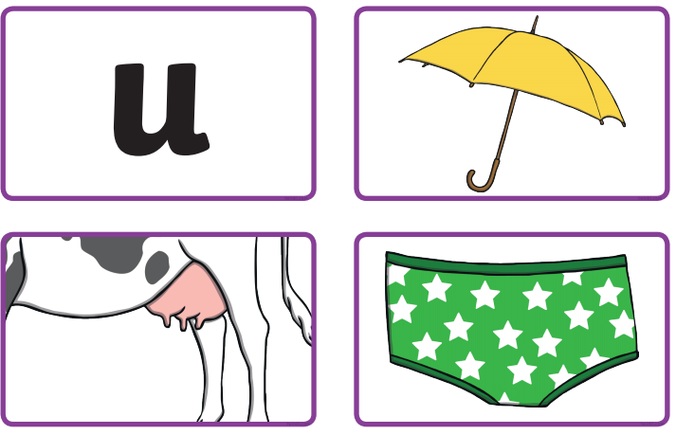

This is the letter 'n'. It makes the sound 'n'
v,v, volcano v,v, vulture v,v,van
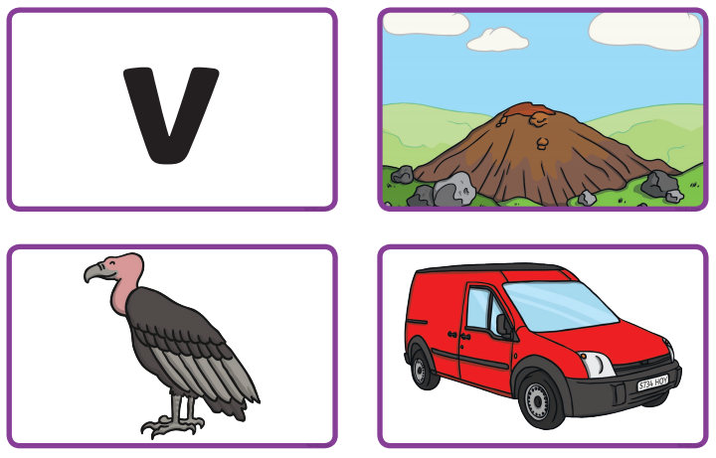

This is the letter 'o'. It makes the sound 'o'
w,w, watch w,w, witch w,w, web
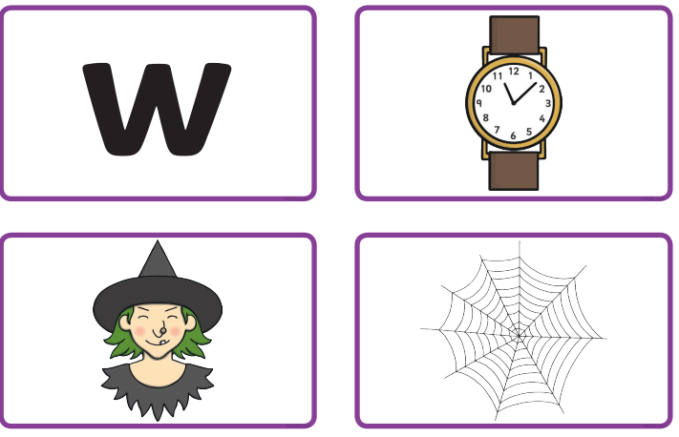

This is the letter 'p'. It makes the sound 'p'
x,x, Fox x,x, axe x,x, box
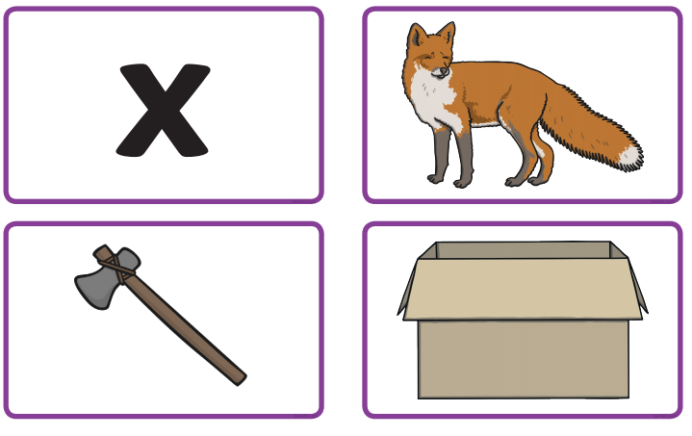
This is the letter 'o'. It makes the sound 'o'
y,y, yoyo y,y, yellow y,y, yoghurt
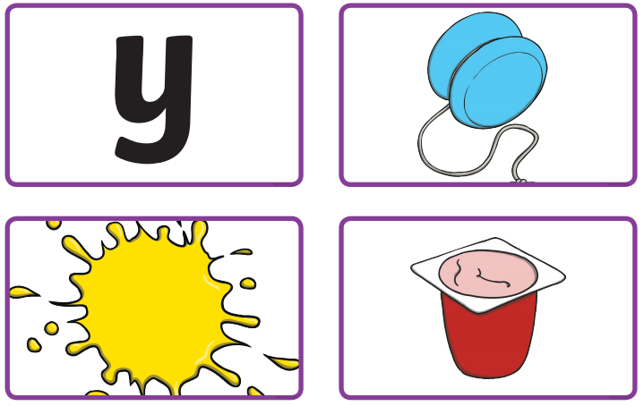

This is the letter 'o'. It makes the sound 'o'
z,z, zoo z,z, zip z,z, zebra
