Numbers

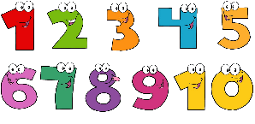
This Photo by Unknown Author is licensed under CC BY-NC

This week work is a little bit different from other weeks. There is some exciting activity that I would like you can do with your child.

Monday activity

Listen to these number videos on YouTube with your child. Do some counting with them

https://www.youtube.com/watch?v=y2upEzm0MTg

https://www.youtube.com/watch?v=yxAIBFsRpqU&list=PL0UT132RpIWzc7xeZ8gNf9tJytgBCGxc_

https://www.youtube.com/watch?v=7WF8yySJjTo

https://www.youtube.com/watch?v=jR6KbE_aGWw

Tuesday activity

Create these two fun activities with your child. Very easy to do. If you don’t have sticker use paint.

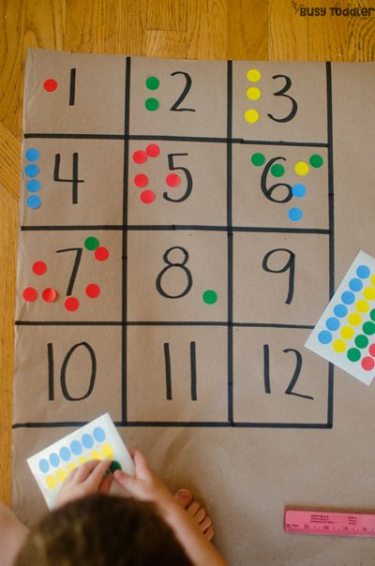
See if they can write the numbers 1 -12 and place the correct amount of dots in the correct number. Do the same below.

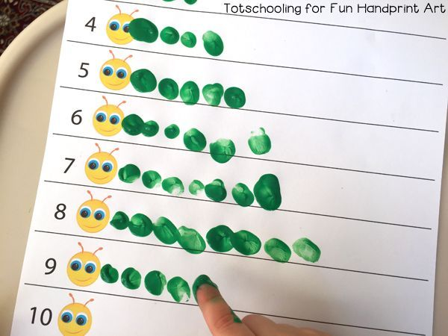

Wednesday activity

Another fun activity for you to do with your child. Create this…
Resources needed: paint, cotton bud, paper and pen

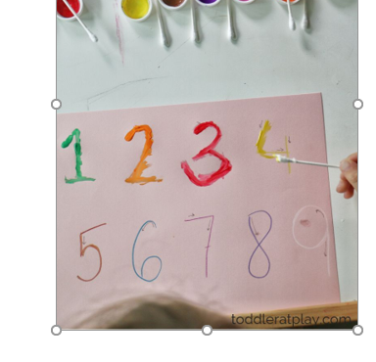

Thursday activity

Task for the day: Create a number wheel with your child. Below is a picture of it. See if your children can match the peg with the correct number of stars.

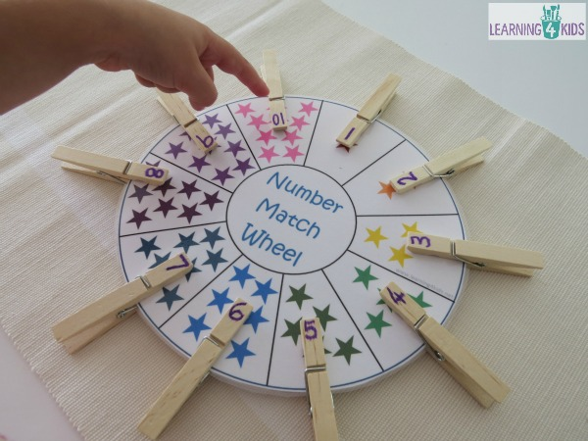

Friday activity
Practise writing numbers from 1 to 10.

