Week 9
Wednesday 20th May 2020
Year 6- Problem solving

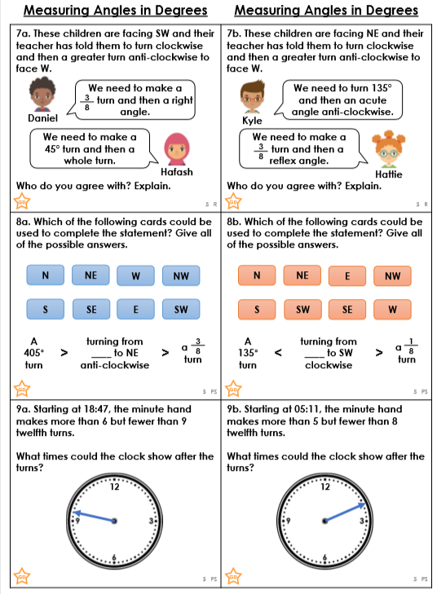

Revision- Please complete

