Summer 1
Rec Maths

Notes for parents
(Remember gold prizes from me for neat outstanding work)

If you do not have access to a printer, provide your child with an exercise book to do their work in.

- Write the short date (today's date)
- Write the L.O:
- Miss a line
- Question numbers in the margin and write answers on the line.

(I will be asking your parents if your work looks neat and to send me a picture of your amazing work. I myself will check your work once you come back to school in sha Allah)

Monday 18th May 2020
LO: To be able write numbers 1-20 in order
LO: To be able to find one more and one less than a given number.
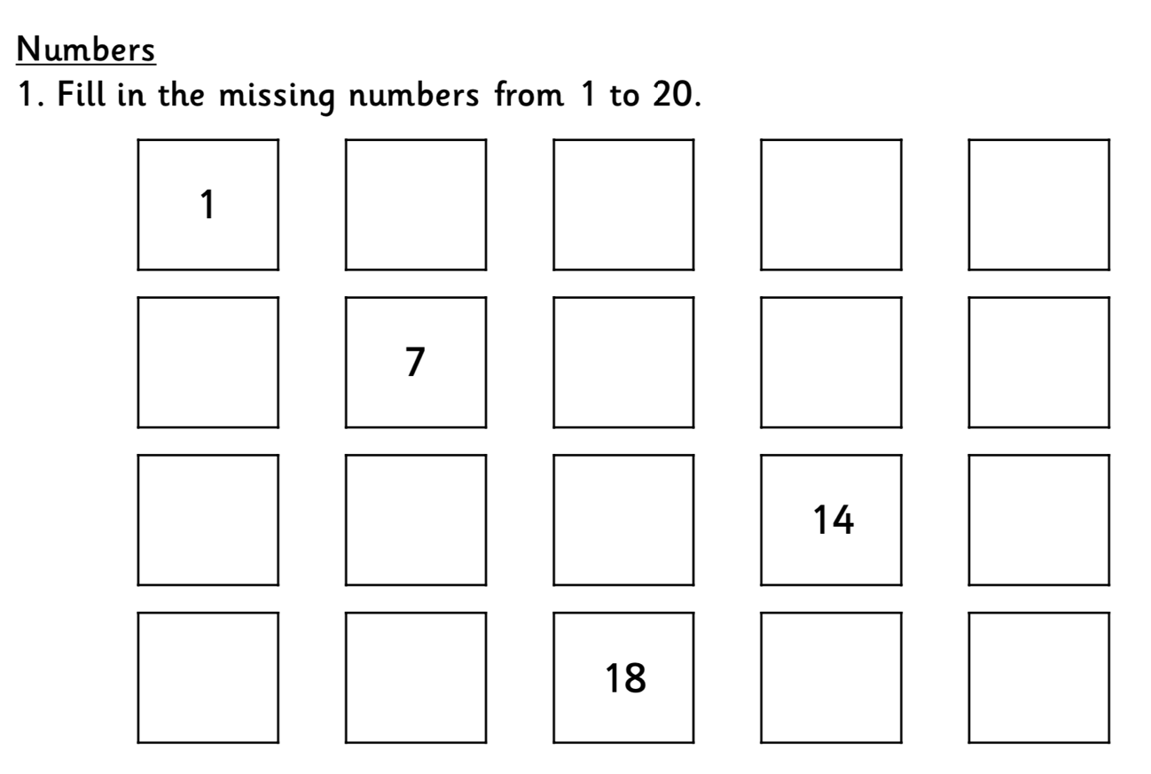

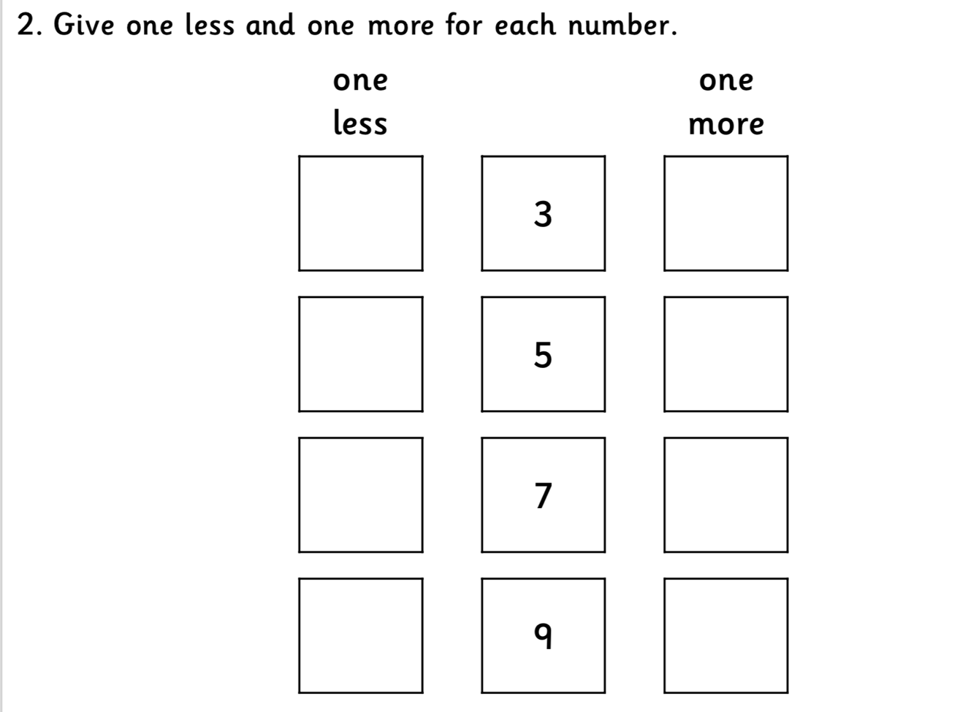

Tuesday 19th May 2020

LO: To be able to complete simple addition and subtraction sums.

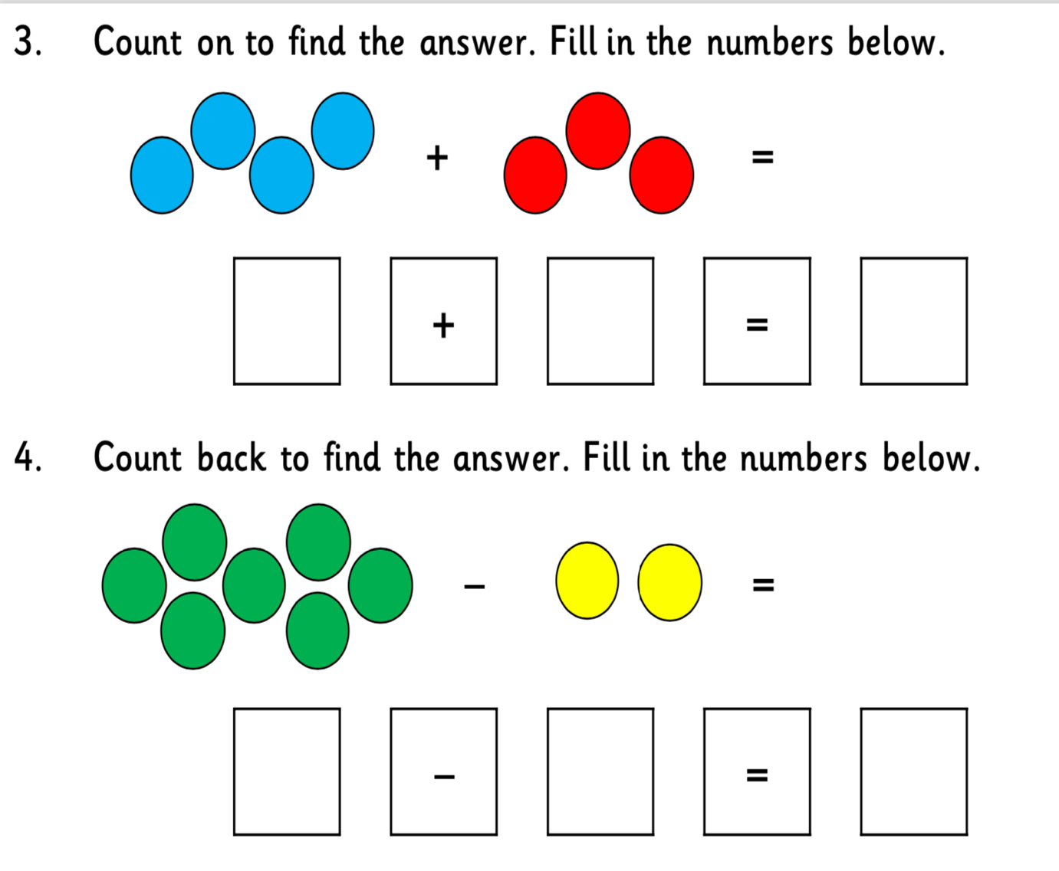

Once you have finished, have a go at working these out:

7+5= 10-5=

6+7= 9-4=

3+6= 11-7=
Wednesday 20th May 2020
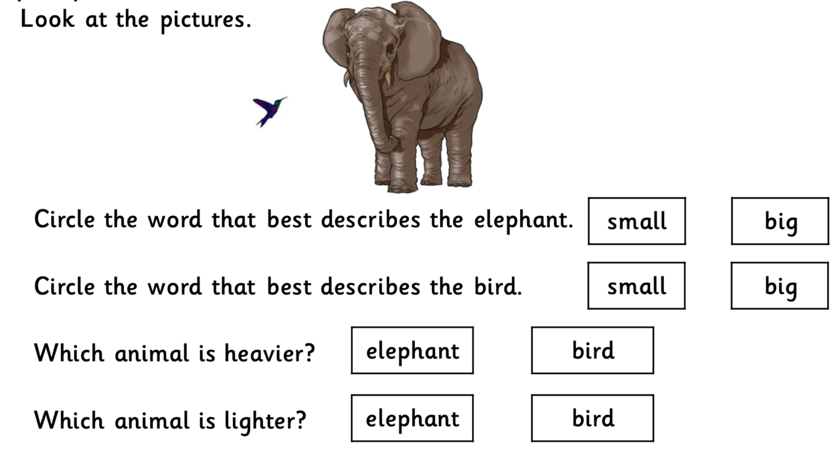

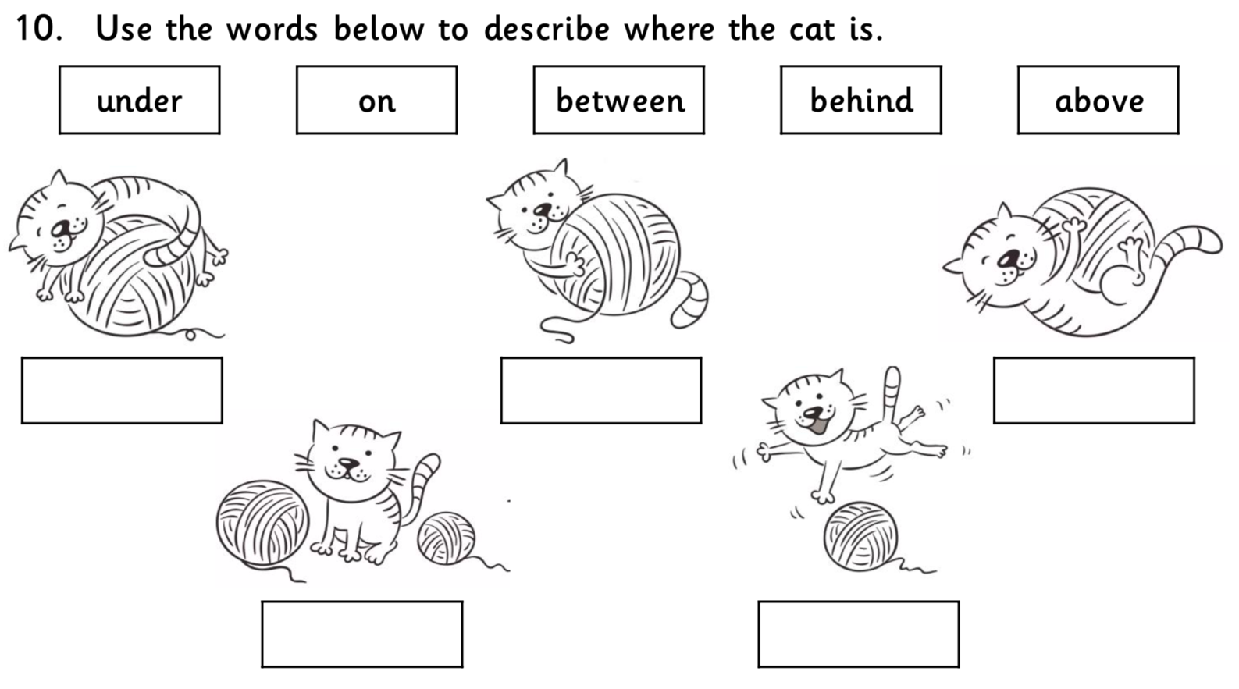

Thursday 21st May 2020

L.O: To be able to complete repeating patterns
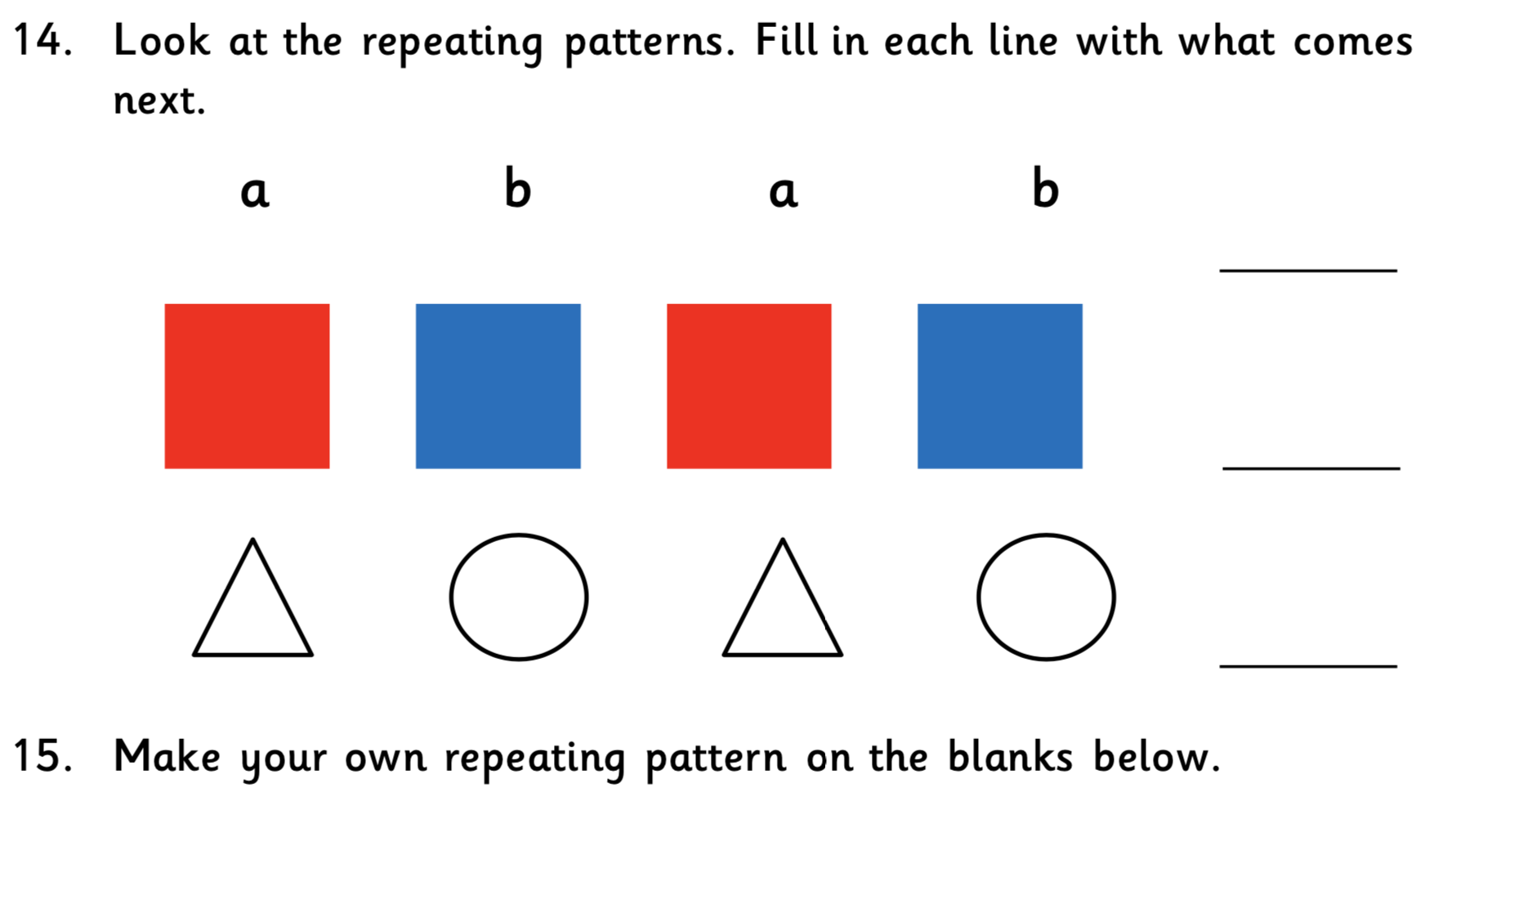

Can you make your own repeating pattern in the space below?

Friday 22nd May 2020
