Week 9 Reception Handwriting

Encourage your child to practice writing a letter a day in their neatest handwriting. Once your child has completed each letter, get your child to practise writing the following words below using cursive handwriting. For more information on how you could support your child with their handwriting, please visit: https://www.teachhandwriting.co.uk/how-to-teach-handwriting.html

Monday 18th May 2020

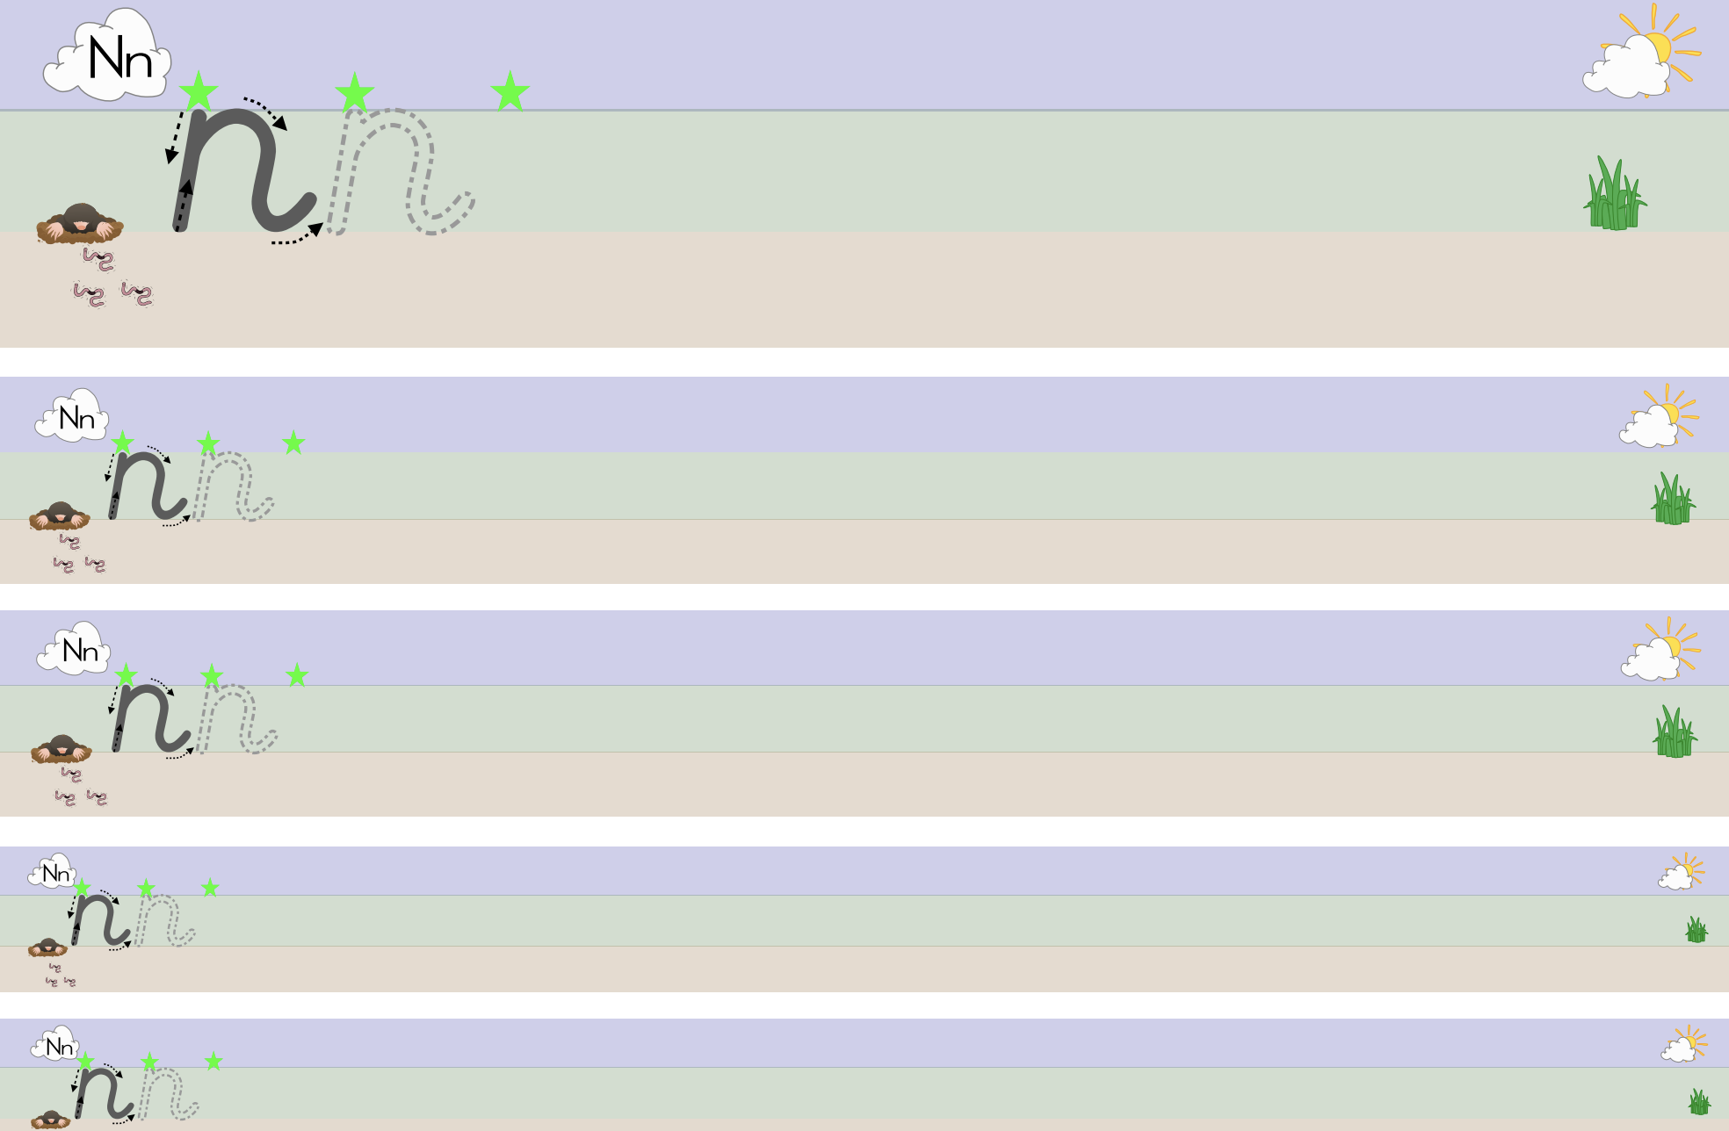

Tuesday 19th May 2020

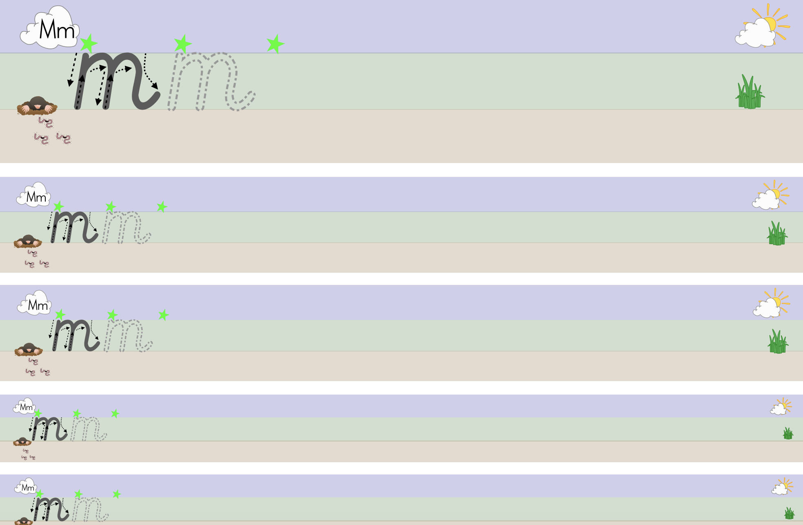

Wednesday 20th May 2020

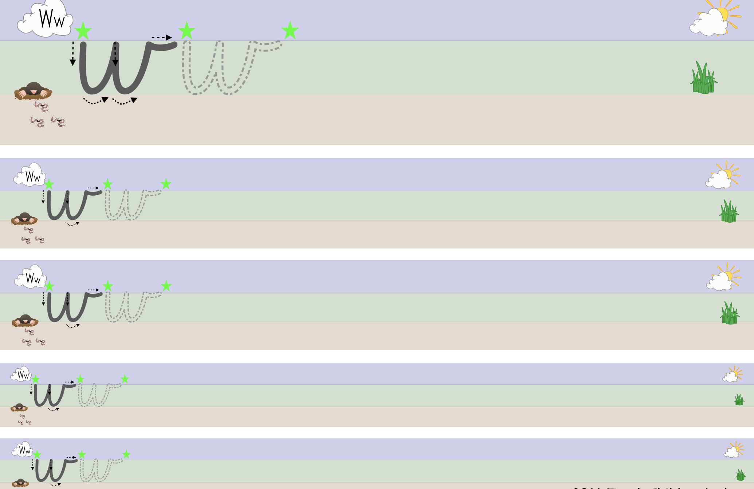

Thursday 21st May 2020

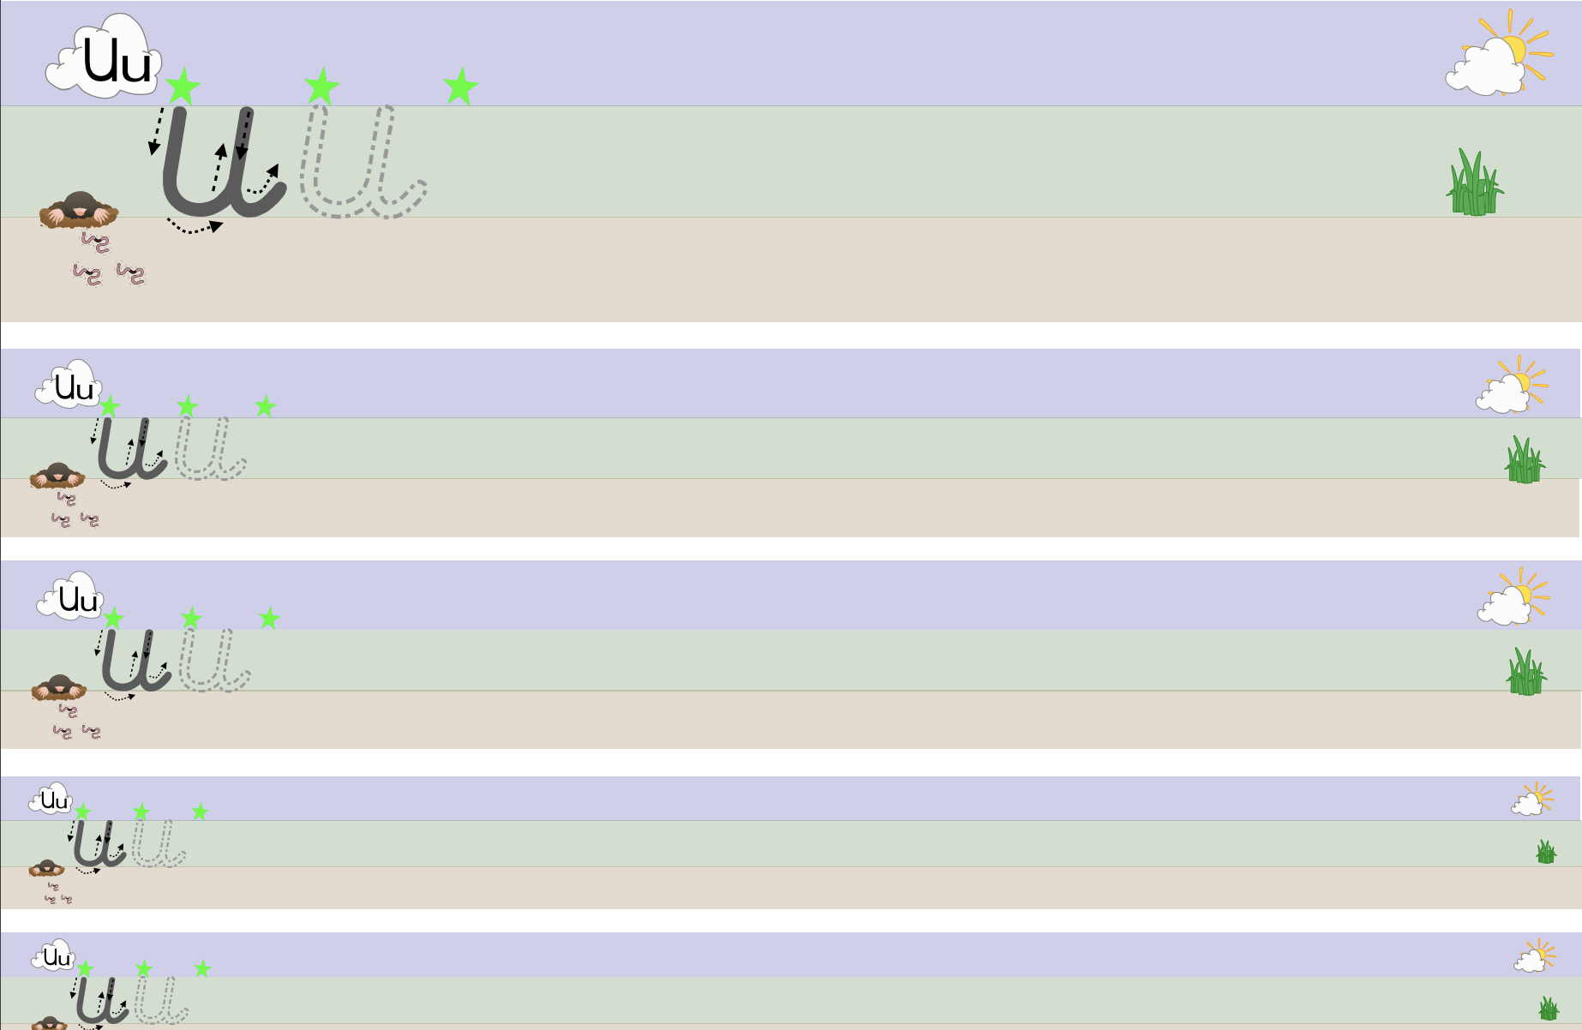

Friday 22nd^{th} May 2020
