Week 8
Tuesday 12th May 2020
Year 6
Please press on this link for more information: https://www.youtube.com/watch?v=nxA2mt27lM0
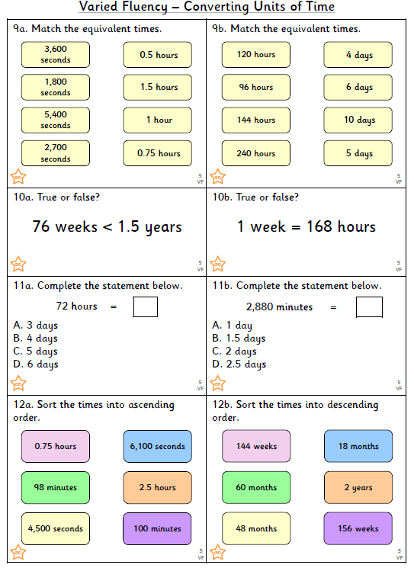

Challenge

