Summer 1
Maths- Telling the Time

Notes for parents
(Remember gold prizes from me for neat outstanding work)

If you do not have access to a printer, provide your child with an exercise book to do their work in.

- Write the short date (today's date)
- Write the L.O:
- Miss a line
- Question numbers in the margin and write answers on the line.

(I will be asking your parents if your work looks neat and to send me a picture of your amazing work. I myself will check your work once you come back to school in sha Allah)

Rec Maths
Monday 11th May 2020
LO: To be able to use time language
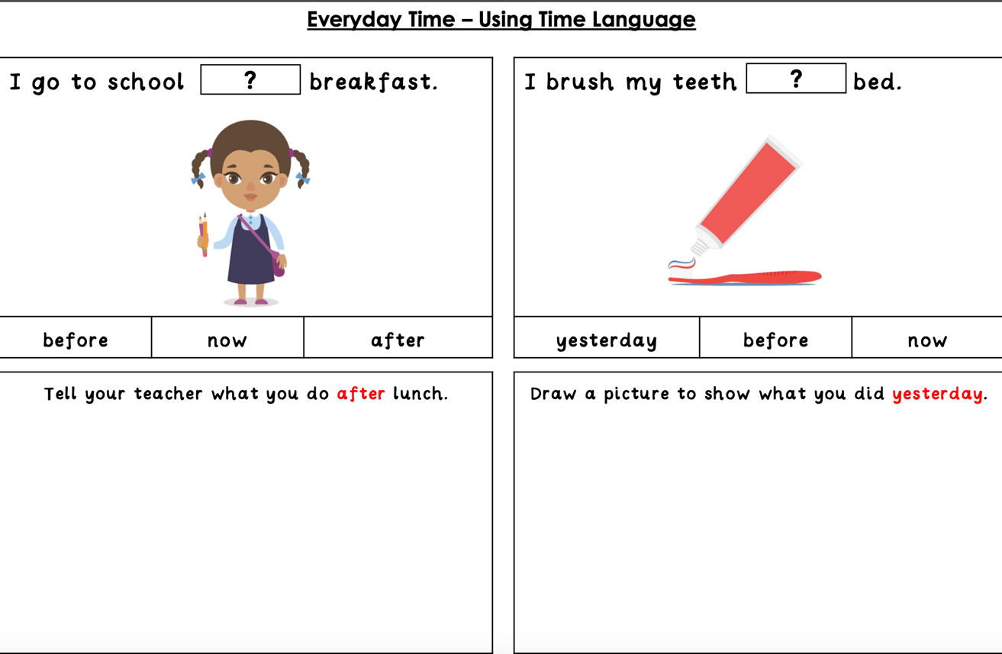

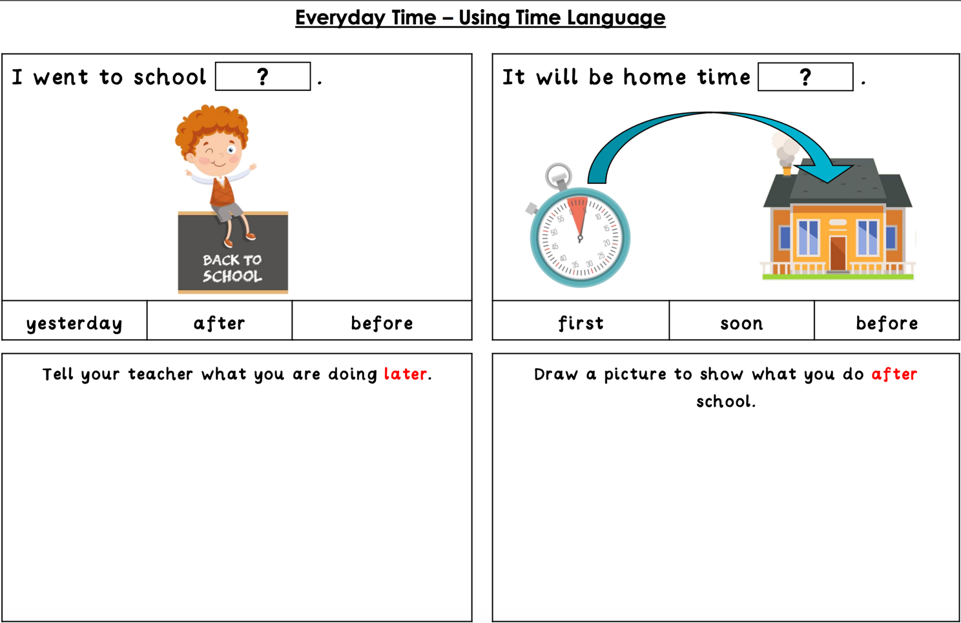

Tuesday 12th May 2020

LO: To be able to put dates in order
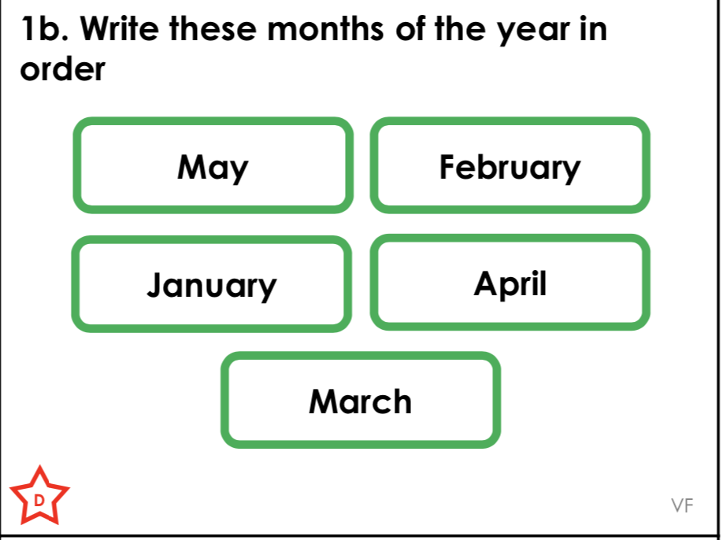
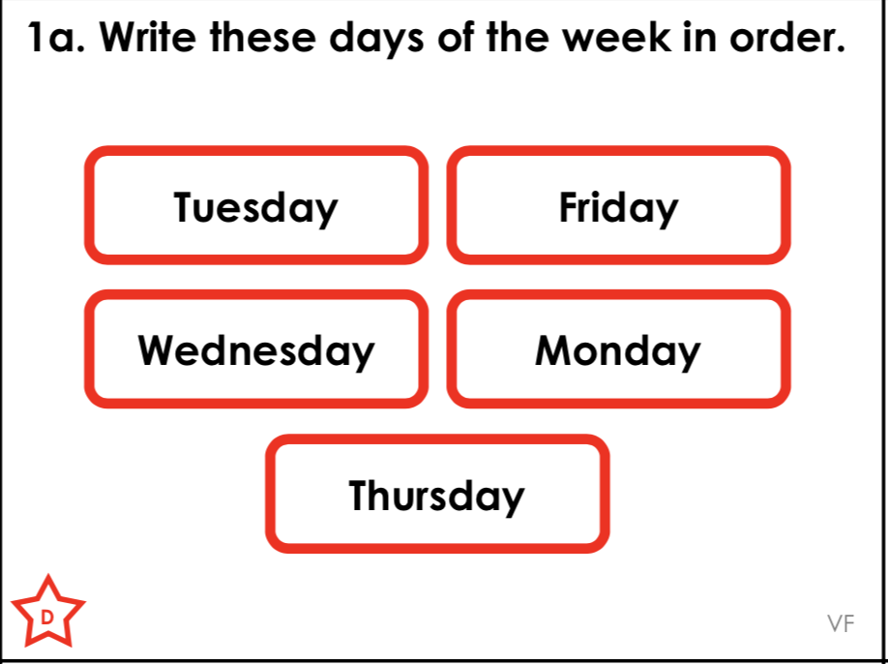

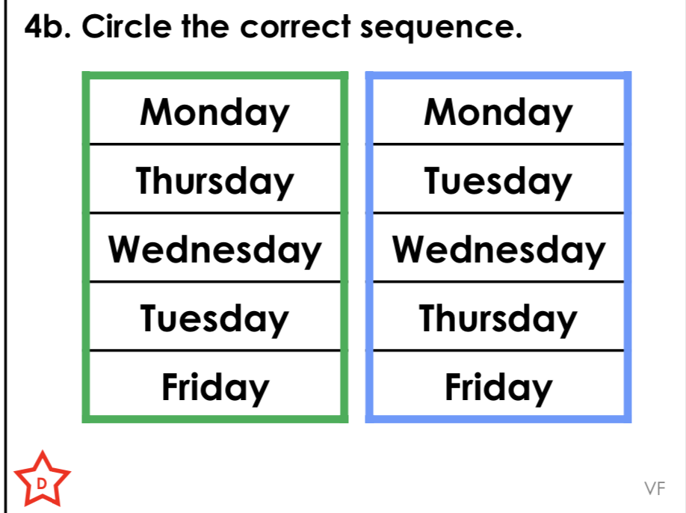
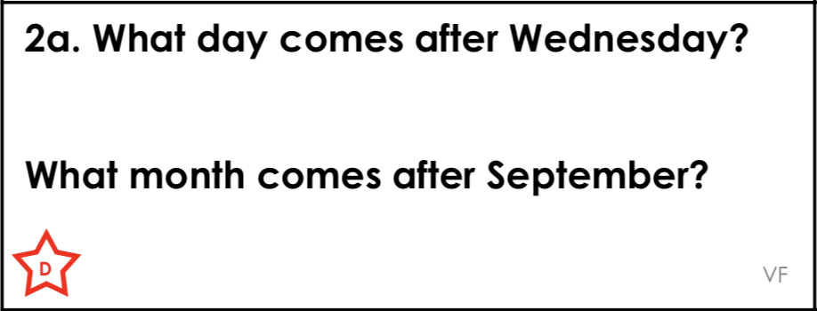

Wednesday 13th May 2020

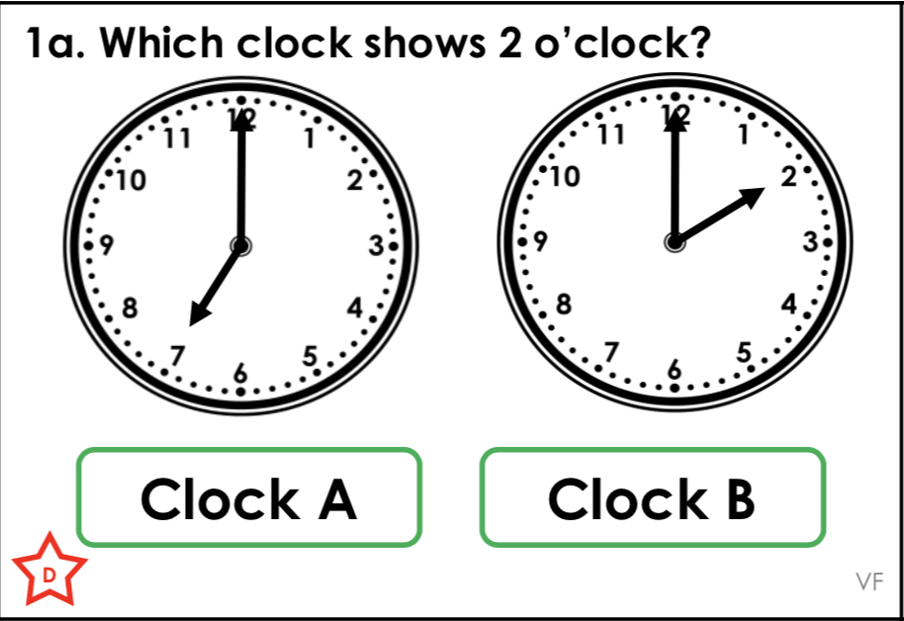
LO: To be able to read the time

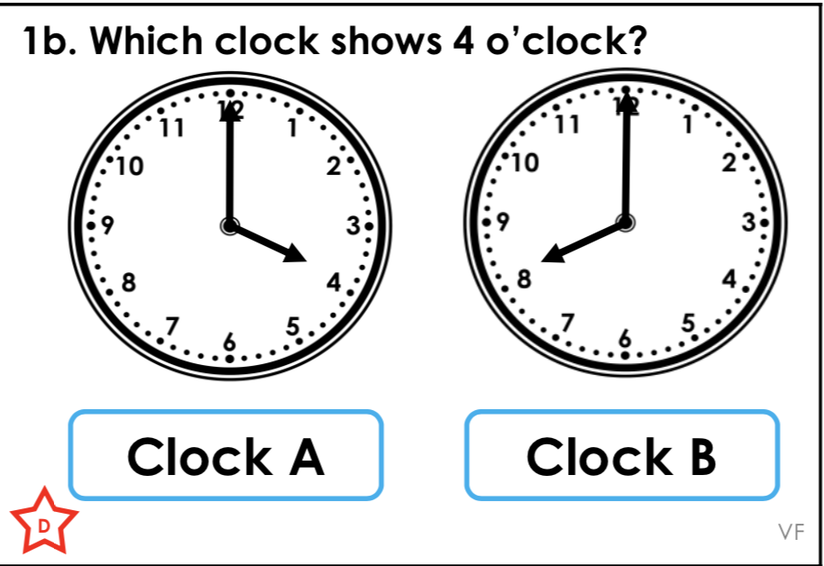

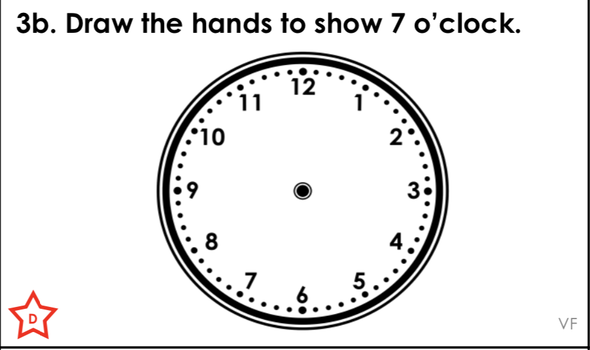
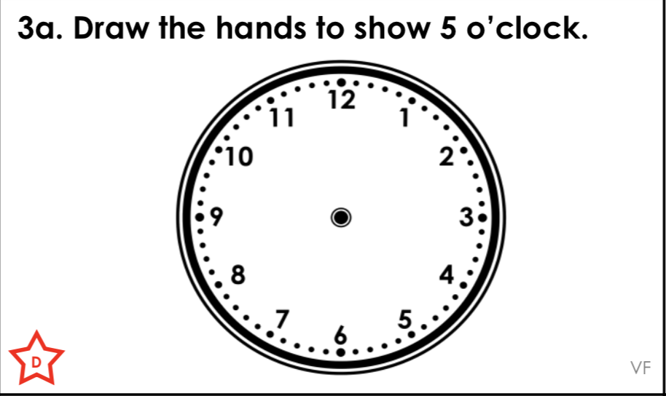

Thursday 14th May 2020

L.O: To be able to read the time
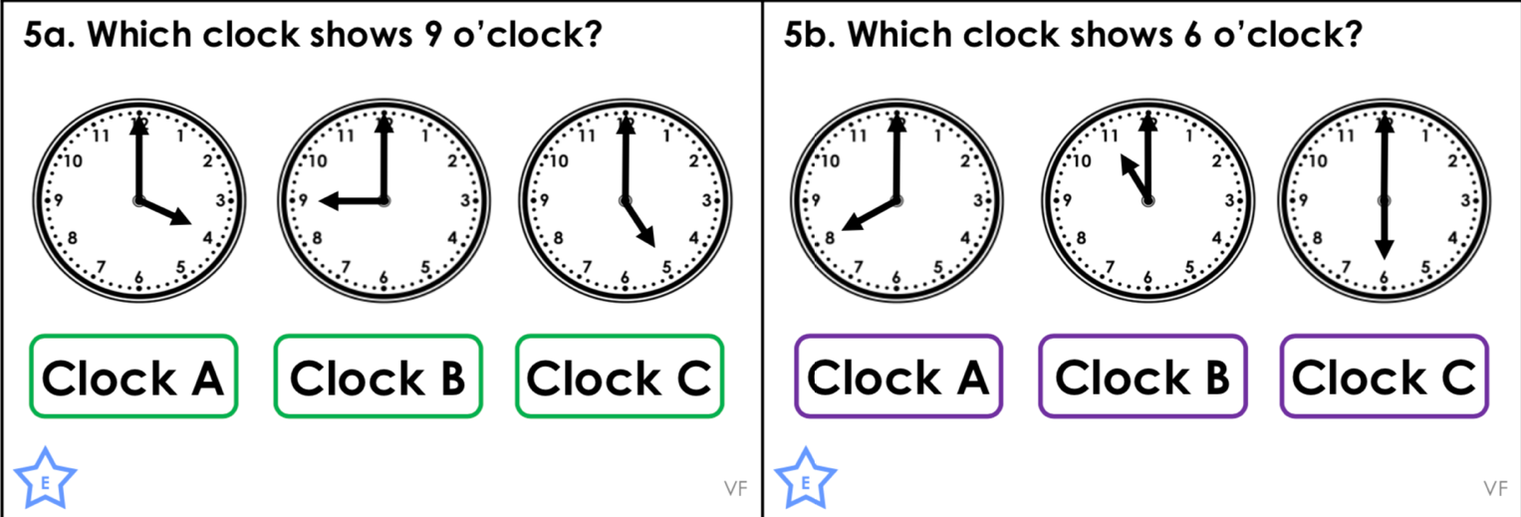

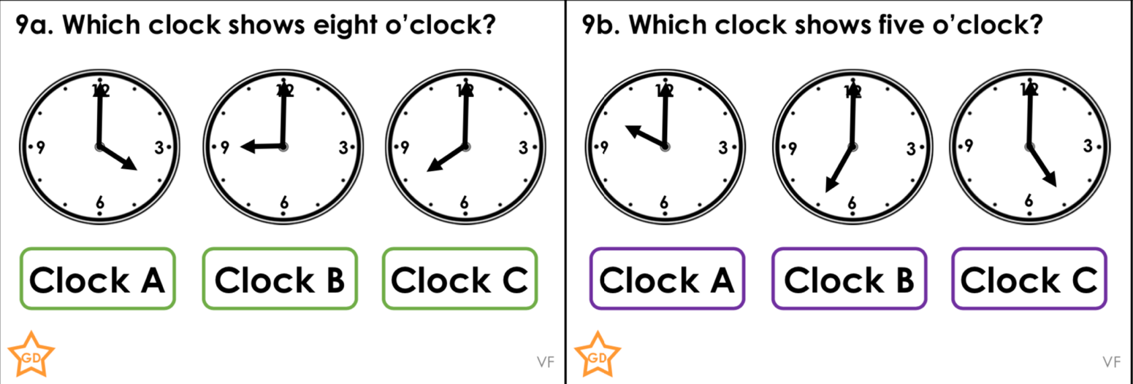

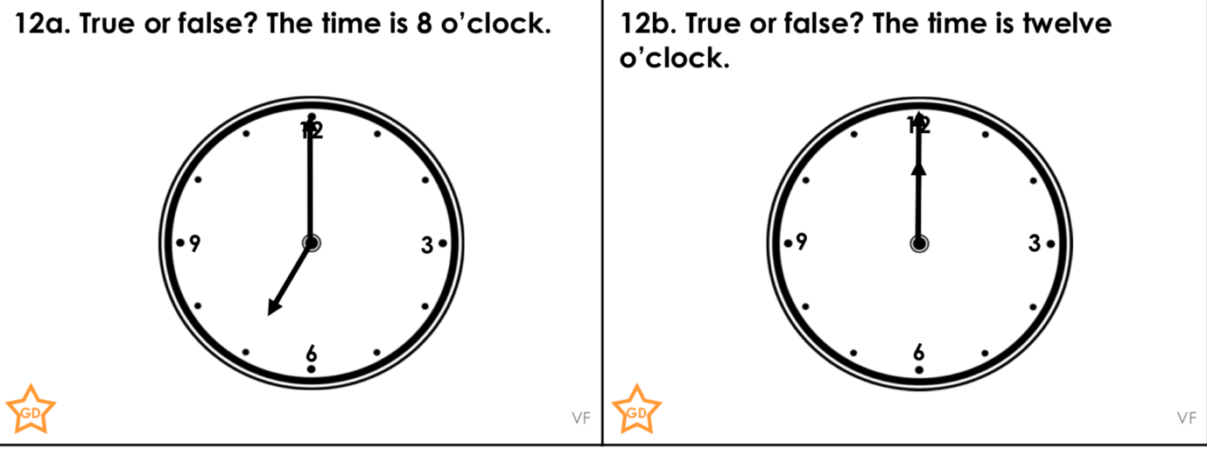

Friday 15th May 2020
