Week 8 Reception Handwriting

Encourage your child to practice writing a letter a day in their neatest handwriting. Once your child has completed each letter, get your child to practise writing the following words below using cursive handwriting. For more information on how you could support your child with their handwriting, please visit: https://www.teachhandwriting.co.uk/how-to-teach-handwriting.html

Monday 11th May 2020

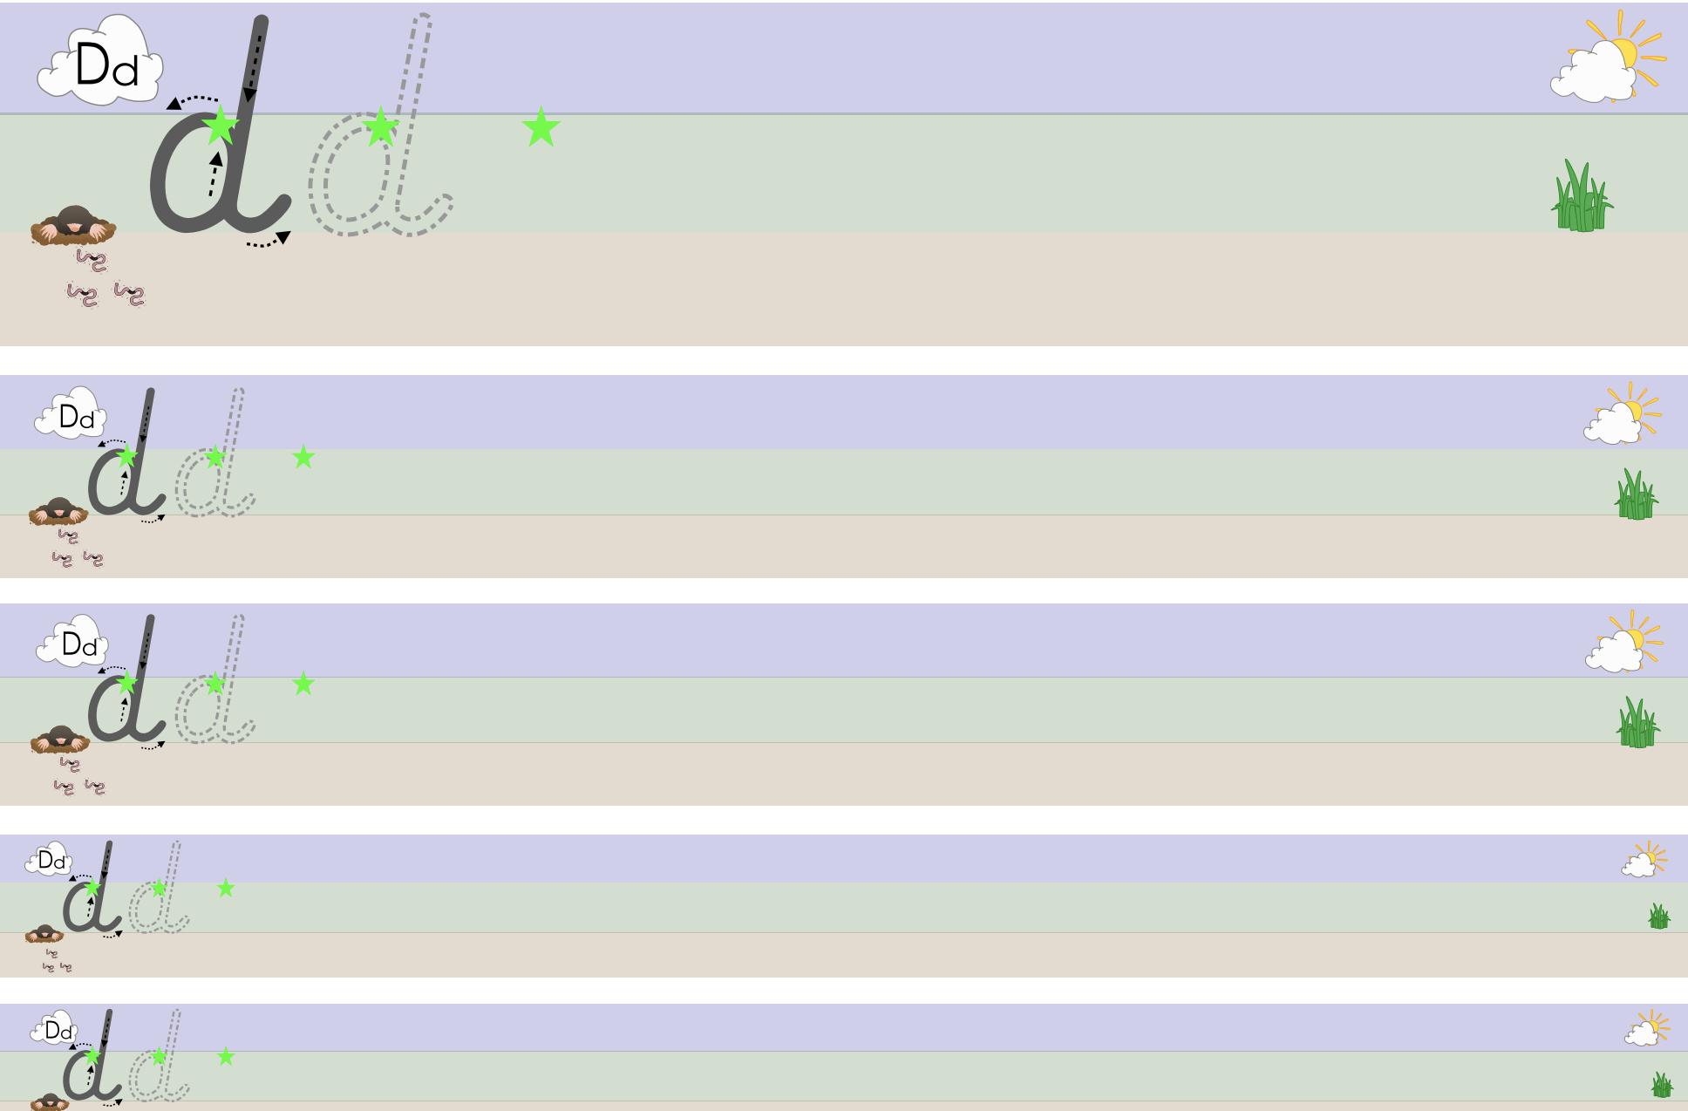

Tuesday 12th May 2020

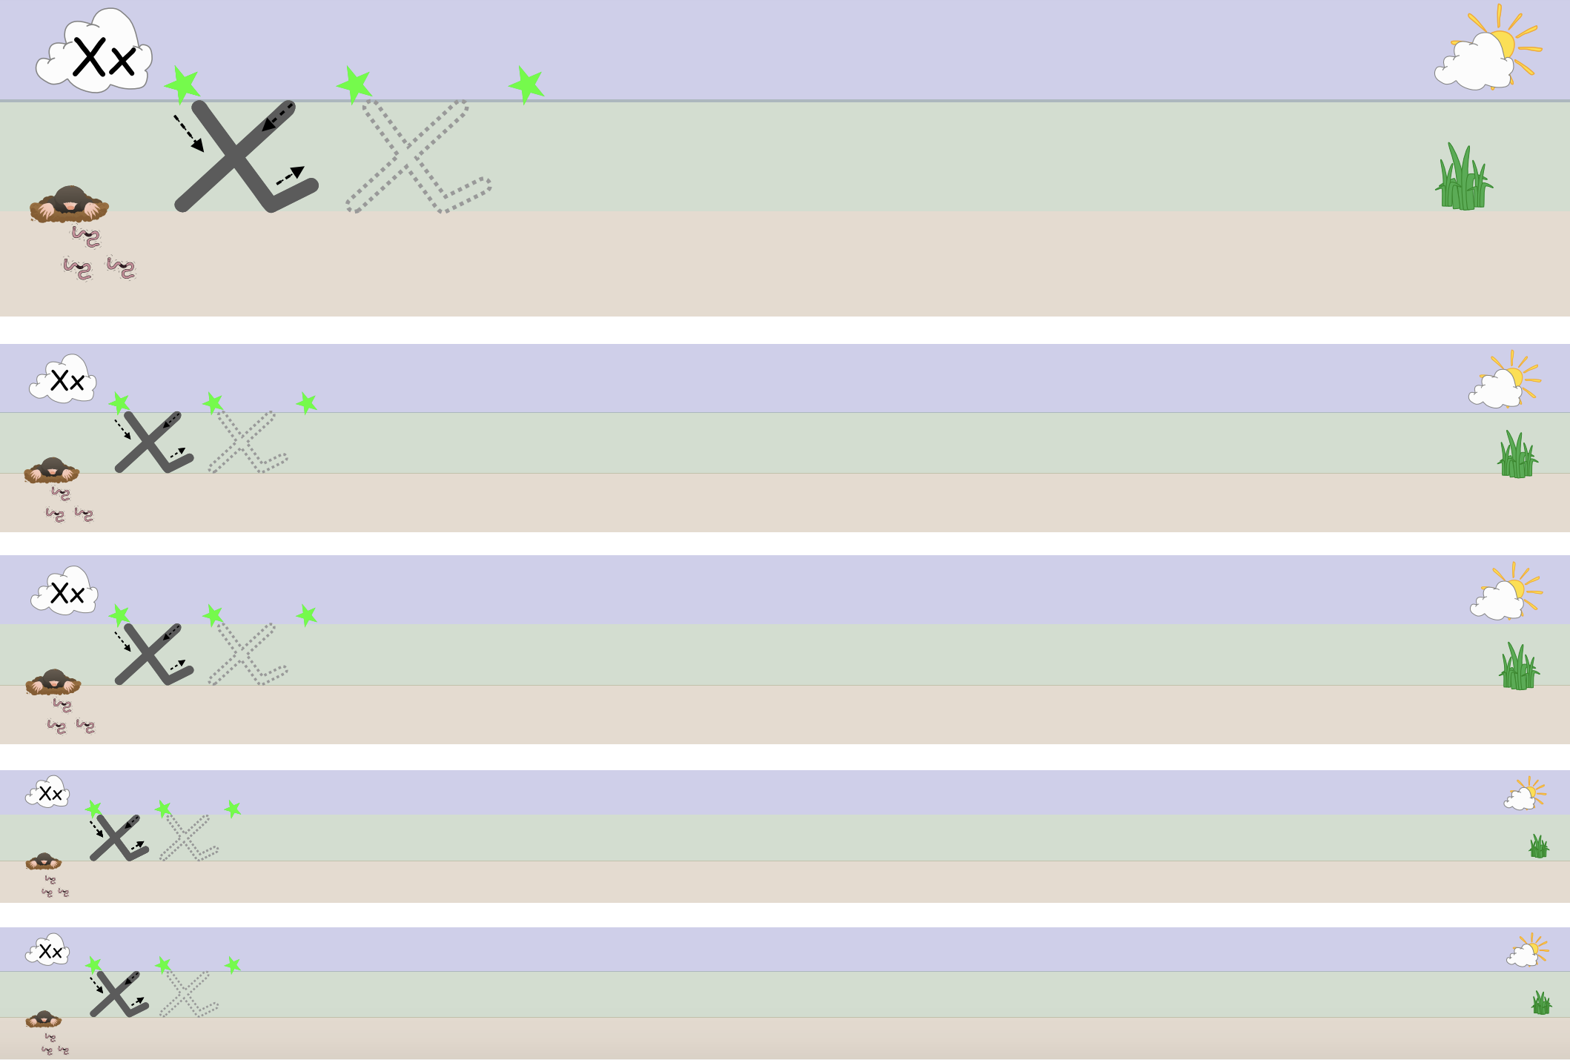

Wednesday 13th May 2020

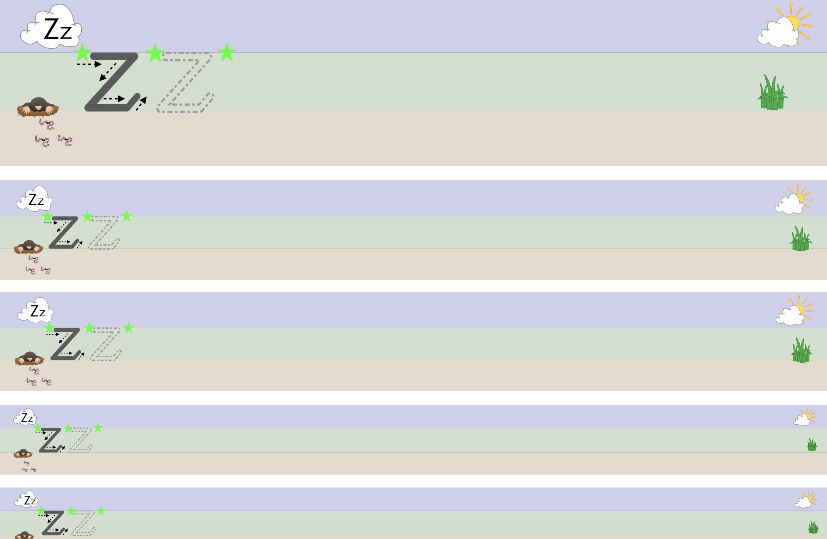

Thursday 14th May 2020

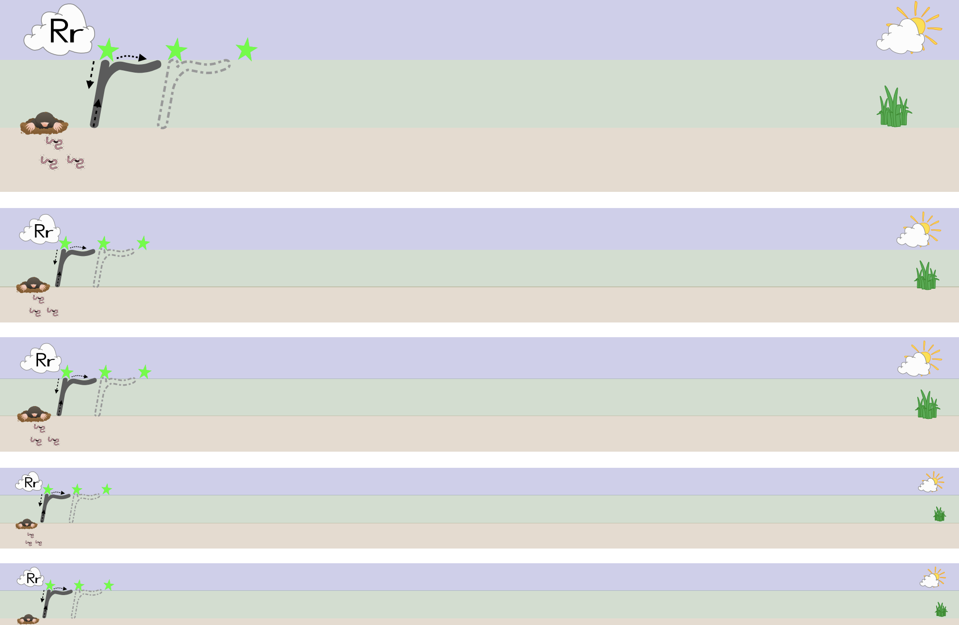

Friday 15th May 2020

