Summer 1
Reception Writing Tasks

Dear Parents/Carers,

Your child will be expected to complete one writing tasks each day. Please ensure your child is writing in full sentences independently.

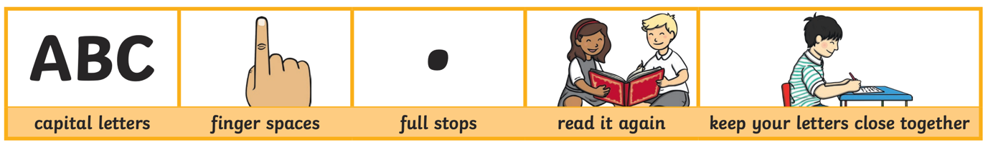

Encourage your child to use the above key when writing their sentences.

Success Criteria:
Has your child used capital letters?
Has your child used finger spaces after each word?
Has your child used a full stop at the end of their sentence?
Can your child read what they have written, and does it make sense?
Has your child made sure they have written their letters correctly in a way that can be understood and read by others?

Reception High Frequency Words
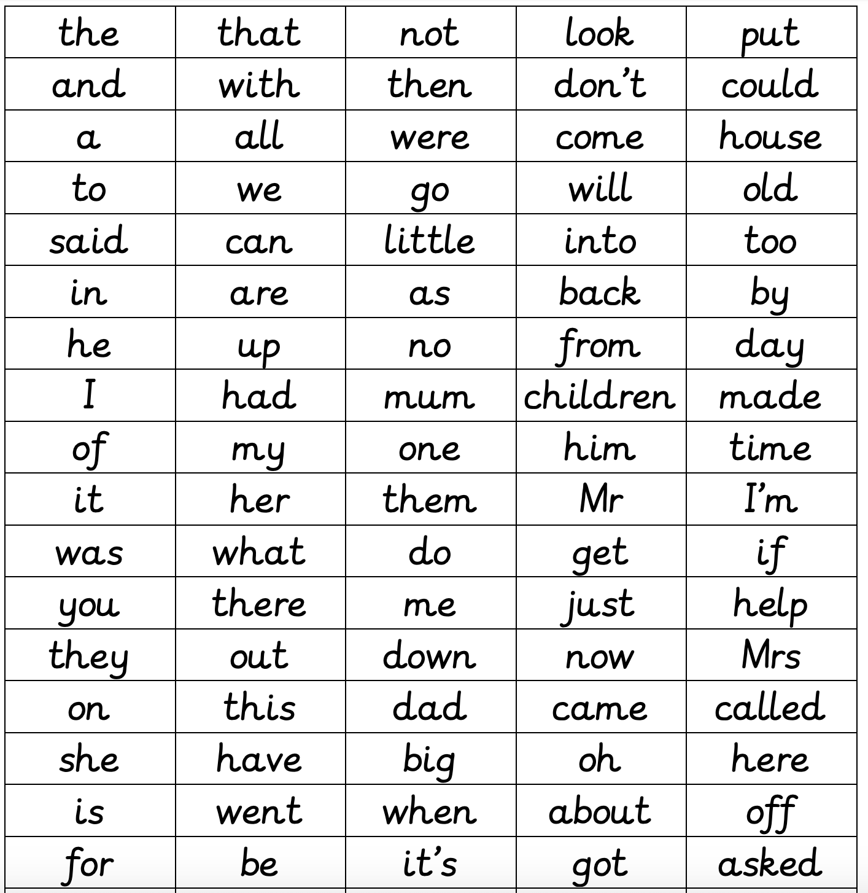
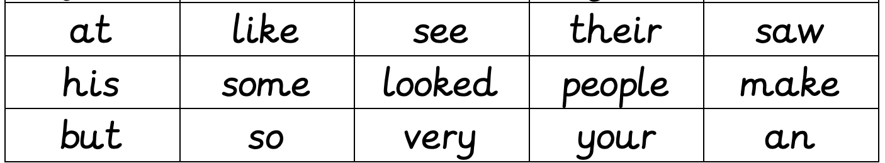

By the end of Reception, your child should know all or majority of these high frequency words and should be using them in their writing. How many words does your child know so far?

Monday 11th May 2020

Shopping list
Go through your cupboards and fridge and call out different items that you need to buy from the shops, get your child to write the list for you.

Use your phonics to sound out the words you want to write

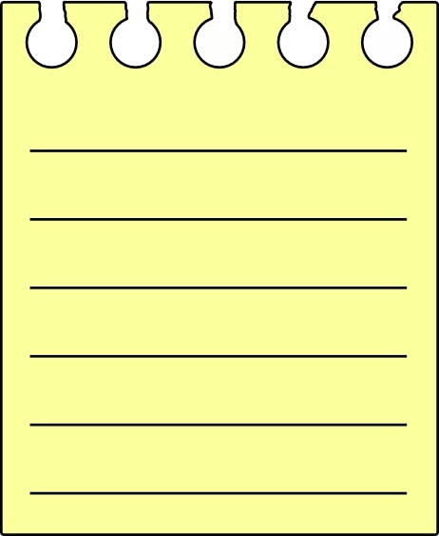

Tuesday 12th May 2020

Write a sensory poem

Choose a scene: At the park/cinema/in spring/At home

Next write about what you could see, hear, feel, touch and smell from your chosen scene. Make sure you are writing in full sentences.

I see….

I hear….

I feel….

I touch….

I smell…

Wednesday 13th May 2020

Fun envelopes

Ask your children to write letters to family members or friends they cannot see at the moment and tell them you will post them. If you do not have any envelopes you could make some.

Remind them of tricky words, to use their phonics to sound out words, writing on top of the line, finger spaces, a capital letter for a name or beginning of a sentence and to finish with a full stop.

Who do you miss and cannot wait to see?

Dear __________________________________,

Love from ___________________________________

Thursday 14th May 2020

Role play

Ask your child to take your lunchtime order, can they write down everything you would like using their phonics knowledge.

For example, I would like… a burger, ketchup and some crisps.

Expect them make phonetically plausible attempts for example they may write ‘sum’ crisps rather than ‘some’.

Lunchtime Order

___________________________________________________________

Friday 15th May 2020

Choose an activity to do:

Activity 1: Decorating the alphabet

Give your child a letter from the alphabet to write down and see what they can turn it into, an animal, a car, a castle.

Can they label their picture?

Activity 2: Sorting initial sounds

Have 3 sounds in three separate piles s,t,p (for example)

Can you write any 2 words that have that initial sound and put it in the correct pile?

Sock, sand, soap, tap, toast, tin, pan, pizza, popcorn.

Can you find something/object in your house that starts with that sound to add to your pile?

Feel free to do both activities!

