Week 7
Monday 4th May 2020
English comprehension – Year 3 & 4
L.O: To answer reading comprehension questions by deducing and inferring information.
Read the extract, then read the questions and find evidence from the text to answer the questions.
Arthur and the Sword in the Stone
The legend of King Arthur dates back to Anglo-Saxon times. There may have once been a leader called Arthur but over thousands of years the story has been added to and we can’t be sure which parts are fact and which are fiction. Here is the story of how Arthur became king:
Sadness descended over Britain as news spread of the death of King Uther. But after the sadness, quickly came anger and arguments about who should be the next king. None of the powerful knights or nobles knew about Uther’s son, Arthur, who had been sent away to keep him safe from attacking Saxon armies.
Fights raged for many months until one freezing morning when the frost covered the trees like a crystal white blanket, a great stone appeared. It lay in front of the ancient church of St Paul and thrust deep into the stone was a glittering sword. When the knights came closer, they could read a message carved into the shining metal of the blade saying, “Whoever pulls this sword from the stone is the rightful King of England.”
Many times they tried to wrench the sword from the stone. They tugged and heaved and strained with all their might. But it was no use. The sword would not budge for any of them.
Years passed and young Arthur was dashing through the city, looking for a sword. His foster brother Kay was due to fight in a competition but had lost his sword. Suddenly, Arthur’s eyes fell upon the stone, the metal of the sword glistening in the early morning sunlight. He stepped towards the sword, fallen leaves crunching under his steady footsteps. Reaching out, he clasped the jewelled handle of the weapon and pulled. The sword slid out like a knife gliding through butter.
Questions-
Year 3 can answer questions 1 to 5
Year 4 should attempt to answer all the questions
- Please answer in full sentences e.g. Why didn’t people know who should be the next king?
- Answer- people didn’t know who the next king should be because……….

- Why didn’t people know who should be the next king?
____________________________________________________________________________________________________________________________________________________________________
____________________________________________________________________________________________________________________________________________________________________
__________________________________________________________________________________

- Where was the sword in the stone?
____________________________________________________________________________________________________________________________________________________________________
__________________________________________________________________________________

- What time of year did the sword appear? Explain how you can tell.
__________________________________________________________________________________________________________________________________________________________________

- Why do you think that the sword in the stone might have appeared?
____________________________________________________________________________________________________________________________________________________________________
____________________________________________________________________________________________________________________________________________________________________
__________________________________________________________________________________

- The author uses lots of other words for ‘pulled’. List the ones that you can find:
____________________________________________________________________________________________________________________________________________________________________
__________________________________________________________________________________

- Was it easy or hard for Arthur to pull the sword out? Explain how you know.
___________________________________________________________________________________________________________________________________________________________________
___________________________________________________________________________________________________________________________________________________________________
____________________________________________________________________________________________________________________________________________________________________
__________________________________________________________________________________

- Why you think Arthur was able to pull the sword out when all the other men couldn’t?
____________________________________________________________________________________________________________________________________________________________________
____________________________________________________________________________________________________________________________________________________________________

Week 7
Tuesday 5th May 2020
LO: To recognise and use different types of conjunctions.
Write the following 10 sentences in your book using the correct conjunction.
Please click on this link for more information: https://www.bbc.co.uk/bitesize/topics/zwwp8mn/articles/z9wvqhv
Choose a coordinating conjunction from the box to complete these sentences.
and but or so

- I went to bed very late _______________ I am tired today.
- I listened to the weather forecast _________ put an umbrella in my bag.
- I enjoy playing hockey _________________ it’s not my favourite sport.
- We could go to the park ________________ to the cinema.
Choose a subordinating conjunction from the box to complete these sentences.
although because so that even if whenever

- My dad has fixed my bike _________________ I can take it to the park.

- My brother is grumpy ______________ he has to take the garbage out.

- I will always support my local team, ______________ they always lose!

- He goes abroad on holiday, __________________ he doesn’t like flying.

Choose a correlative conjunction from the box to complete these sentences.
Whether/or either/or both/and not only/but

- I’m not sure _____________ I’m going to the match ____ not.
- My mum is ________ a brilliant cook, ______she is a great teacher too!
______________________________________________________________________________________________________________
______________________________________________________________________________________________________________

Challenge:
Name the type of conjunction used in each of these sentences

Week 7
Tuesday 5th May 2020
Spellings
Write and learn the following words in your book.
Write the words 5 times.
Use each word in a sentence.
Do not forget to use a capital letter and full stop in your sentences.
Challenge- can you use at least 2 of the words from the list in a sentence?
Example- I completed my homework in the centre before I left.
- decide
- describe
- different
- difficult
- disappear
- early
- earth
- eight

Week 7
Wednesday 6th May 2020
English writing – Year 3 & 4 – Continue the story

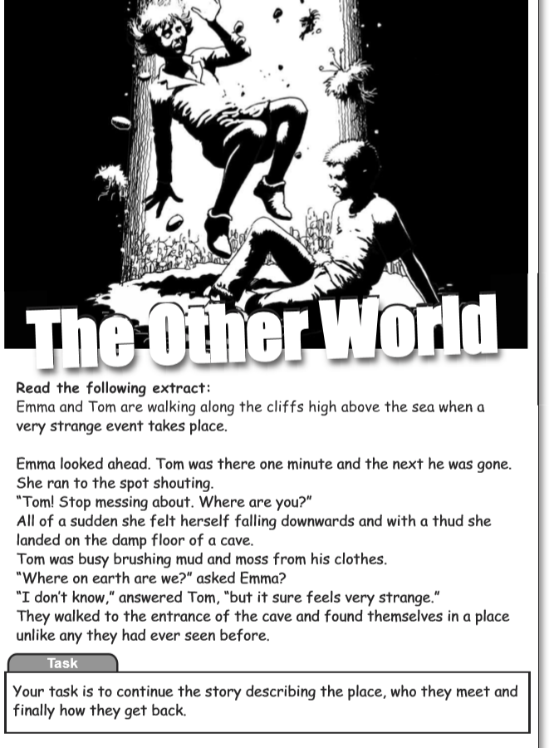

__________________________________________________________________________________________________________________________________________

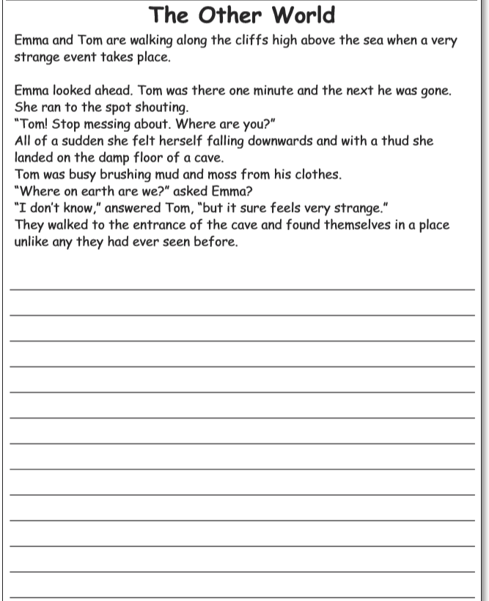

Do not forget to:
- Use capital letters and full stops.
- Include lots of adjectives (describing words) and adverbs (to describe the verbs)
- Read each sentence to check if it makes sense.
- Open sentences in a wide range of ways for interest and impact.
For example, you can write: I went to school with my mum and we were late. My friends were waiting for me at the door. Suddenly, Miss Sultana came out of the classroom and yelled us to go straight to the assembly hall.
Notice how my sentences do not always start with I
This is what I mean by using different sentence openers.

- Use a wide range of punctuation including at least 3 of the following: full stop and capital, question mark, exclamation mark, apostrophe and comma.
- Use more sophisticated connectives, (e.g. although, however, nevertheless, despite, contrary to, as well as etc).
- Use paragraphs although may not always be accurate.
- Use nouns, pronouns and tenses accurately and consistently throughout.

Year 4 challenge

Think of another setting that you know very well and compare it with this setting. What are the similarities and differences?

Week 7
Thursday 7th May 2020
Reading and book review – Year 3 & 4
Choose a book to read and answer the following questions about your book.
Book review by: ________________________________________________________
Title:_____________________________________________
Author: ___________________________________________
Non-fiction Fiction
What is the book about?
______________________________________________________________________________________
_____________________________________________________________________________________
Who would this book be suitable for? Age/interests

______________________________________________________________________________________
What was your favourite part? (Describe)
______________________________________________________________________________________
Year 4 challenge: Would you/would you not recommend the book to someone else? Why?

Week 7
Friday 8th May 2020
Comprehension: Read the playscript and answer the questions in your home learning book. Make sure you date your work and write the title. Remember answers should be written in full sentences.

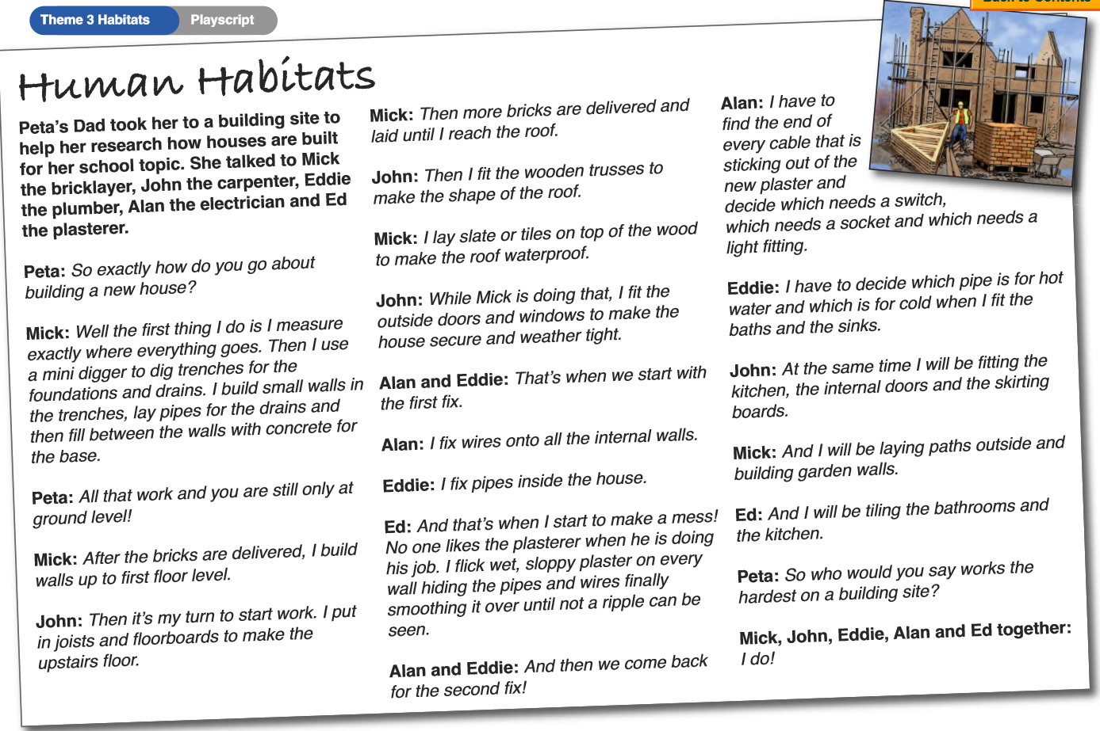

Questions:
  - Peta was finding out how a house is built. She talked to Mick who was a
- bricklayer
- carpenter
- plumber
- electrician
  - Mick said he used a mini digger to dig
- roads
- holes
- trenches
- paths
  - For the foundation, John said he put in
- doors
- floorboards
- kitchens
- windows
  - Which tradesman fits doors and windows?
  - Why do you think ‘no one likes the plasterer when he is doing his job’?
  - What does the phrase ‘until not a ripple can be seen ‘describe?
  - What is ‘the foundation ‘of a house?
  - What is a ‘second fix’?
  - Which tradesman do you think the hardest job? Give a reason for your answer.

Year 4 challenge: Draw a plan for your ideal home. Write down what each room would be used for.
Include:
- Number of rooms and their purpose.
- What type of furniture would you have in your home? Where would you built in your ideal home? In the city or countryside and why?
- How is your ideal home different/similar to your current home?

