Notes for parents
(Remember gold prizes from me for neat outstanding work)

If you do not have access to a printer, provide your child with an exercise book to do their work in.

- Write the short date (today's date)
- Write the L.O:
- Miss a line
- Question numbers in the margin and write answers on the line.

(I will be asking your parents if your work looks neat and to send me a picture of your amazing work. I myself will check your work once you come back to school in sha Allah)

Rec Maths
Monday 4th May 2020

LO: To be able to identify 2D shapes in everyday objects
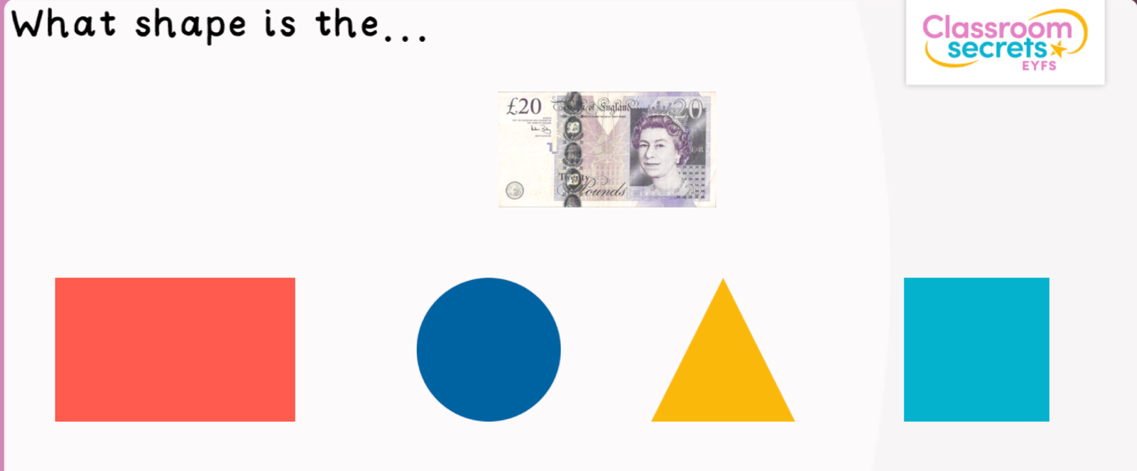

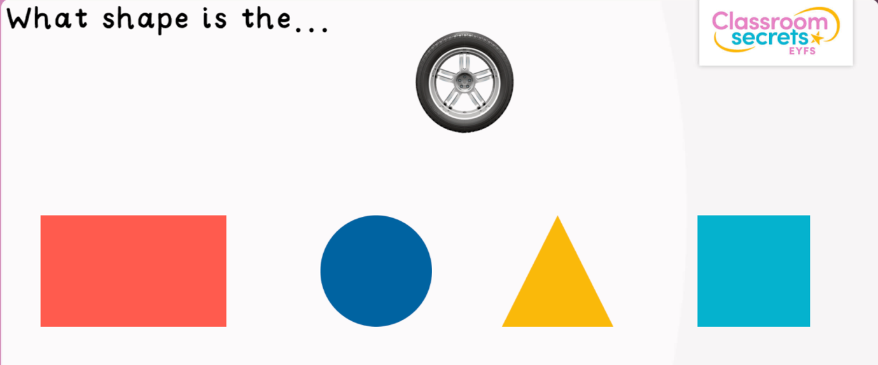

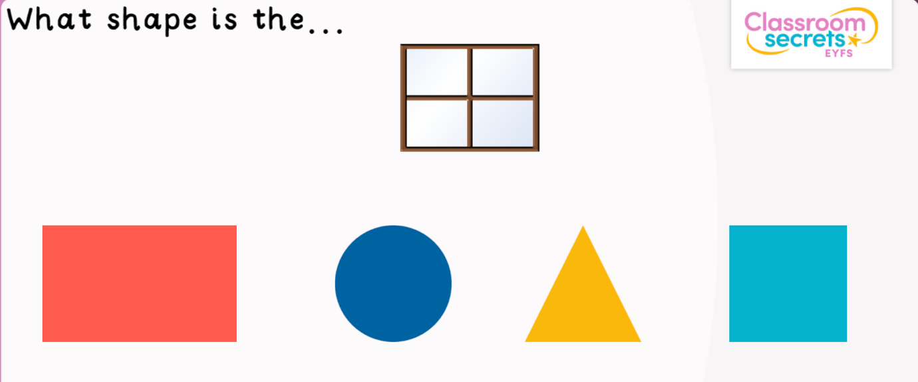

Tuesday 5th May 2020

LO: To be able to name different 2D shapes

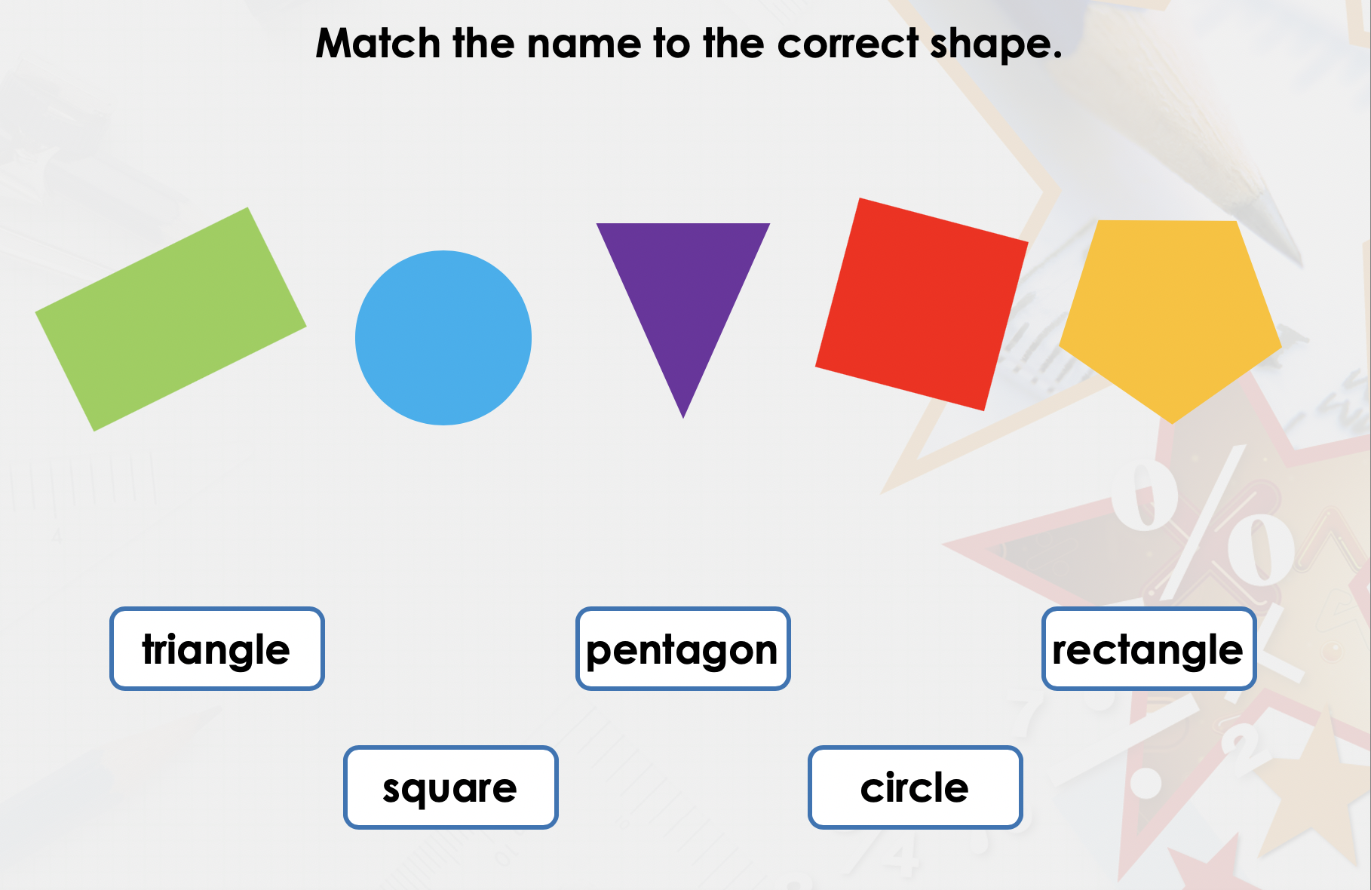

Wednesday 6th May 2020

LO: To identify the properties of 2D shapes.

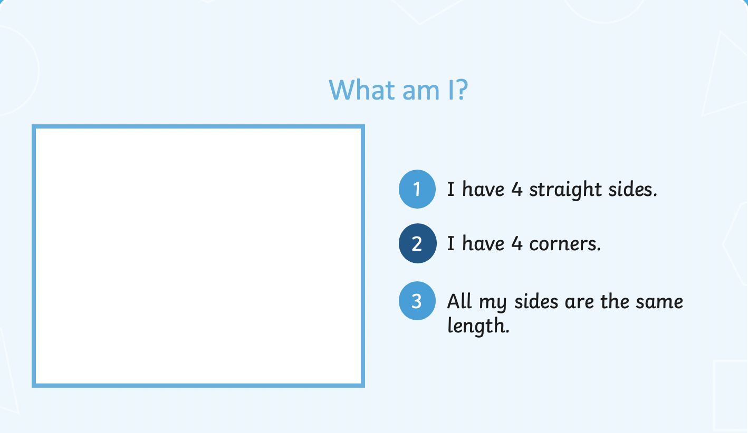

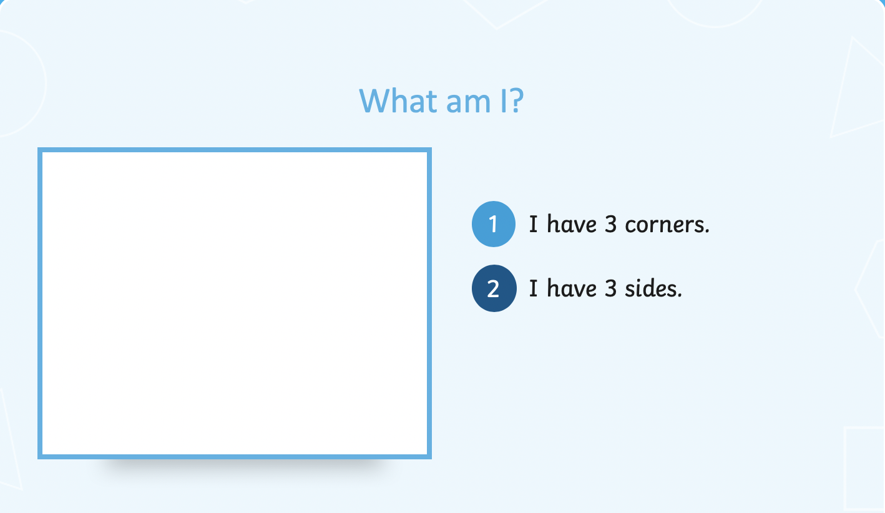

Thursday 7th May 2020
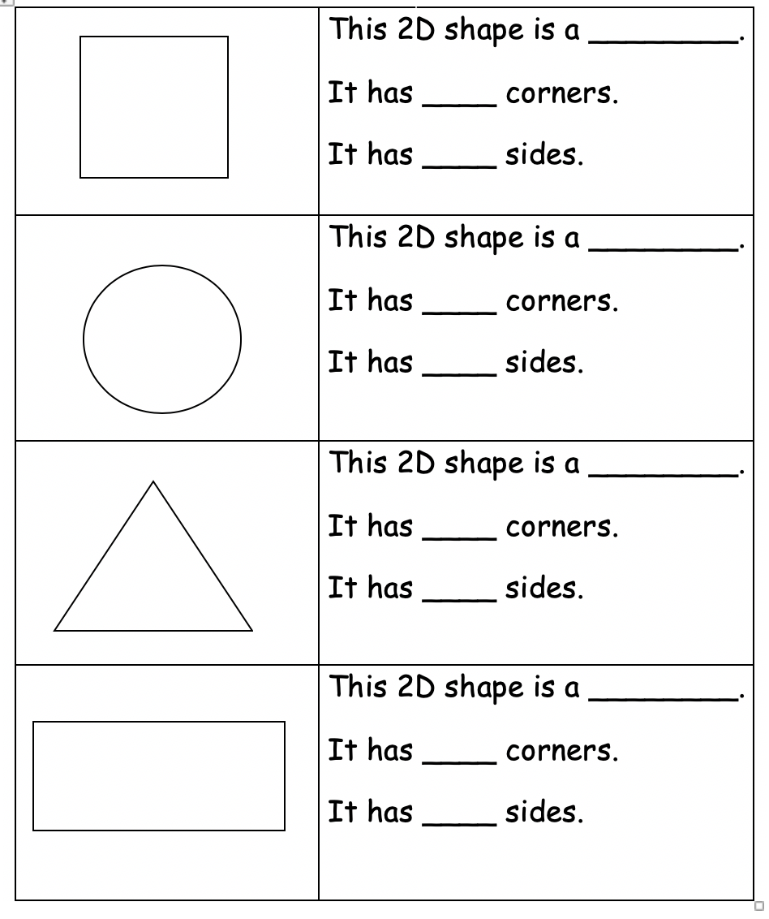

Friday 8th May 2020
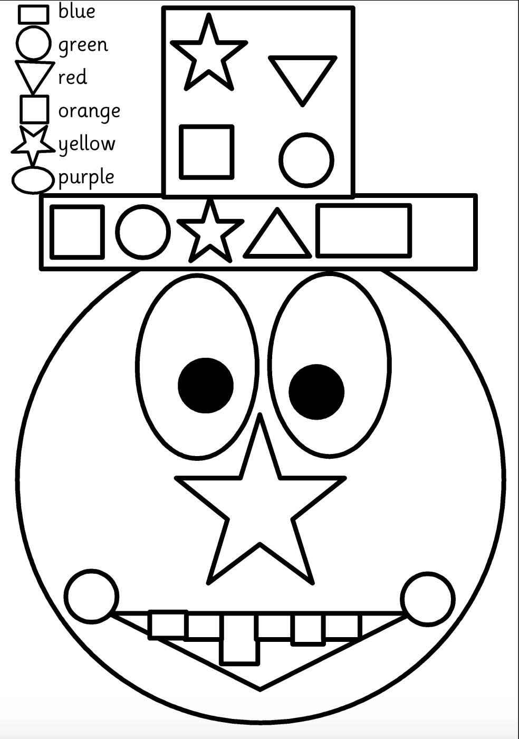

Why not draw your own picture using different shapes!

