Week 7 Reception Handwriting

Encourage your child to practice writing a letter a day in their neatest handwriting. Once your child has completed each letter, get your child to practise writing the following words below using cursive handwriting. For more information on how you could support your child with their handwriting, please visit: https://www.teachhandwriting.co.uk/how-to-teach-handwriting.html

Monday 4th May 2020
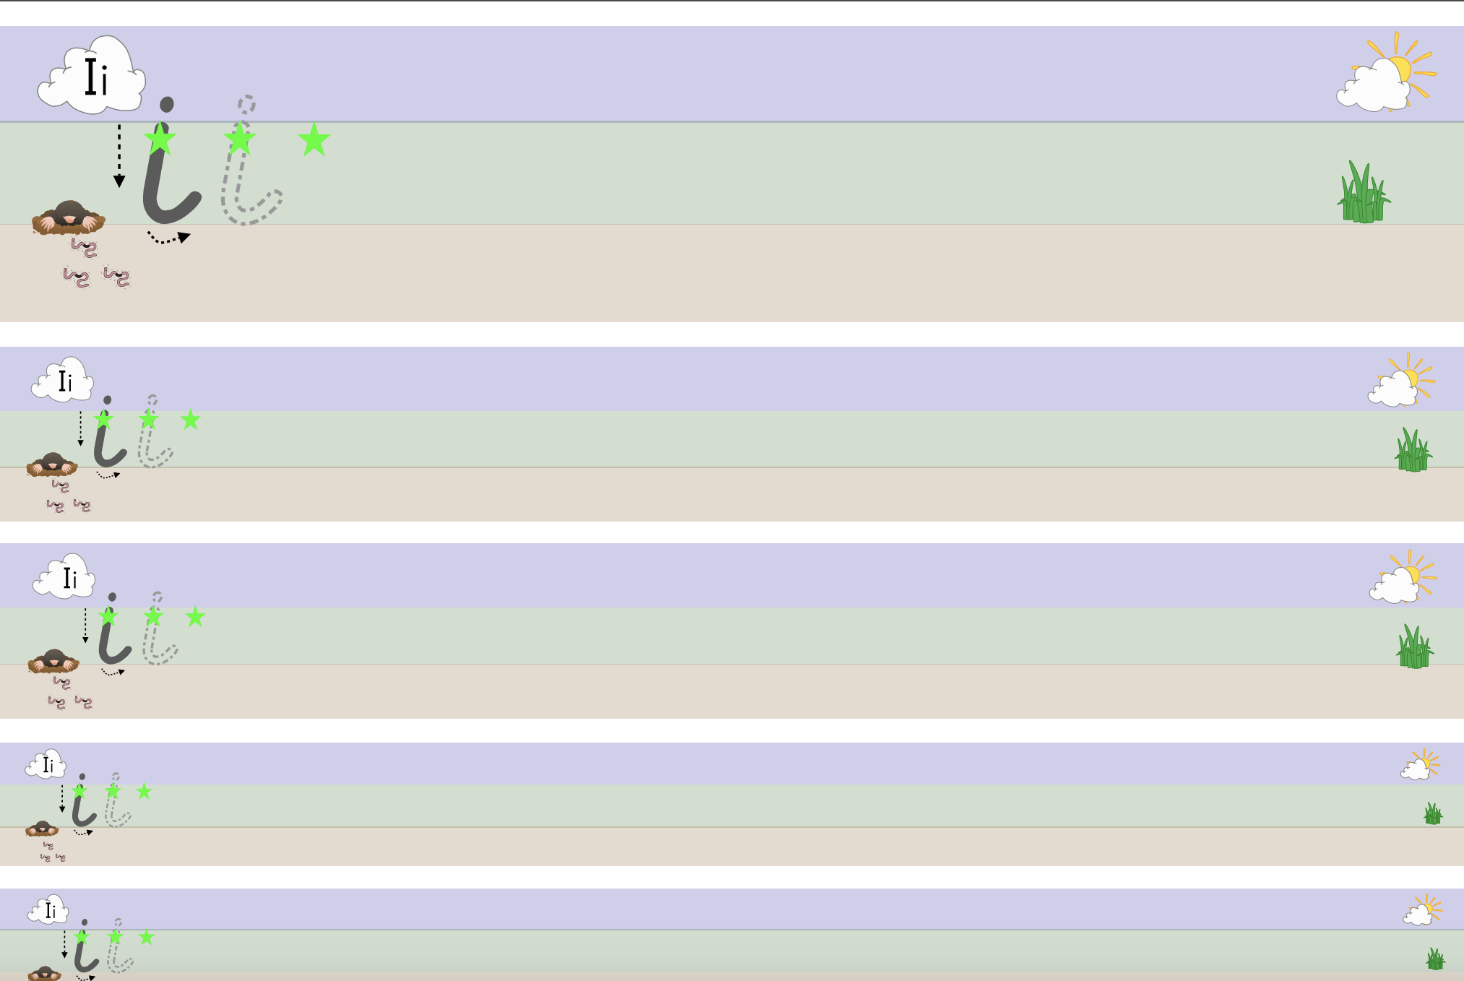

High frequency word to practice- in, it, is,
Tuesday 5th May 2020

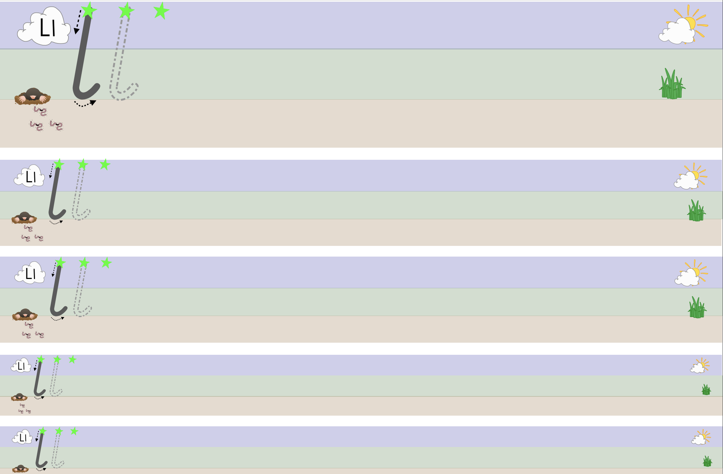

High frequency word to practice- look, like

Wednesday 6th May 2020

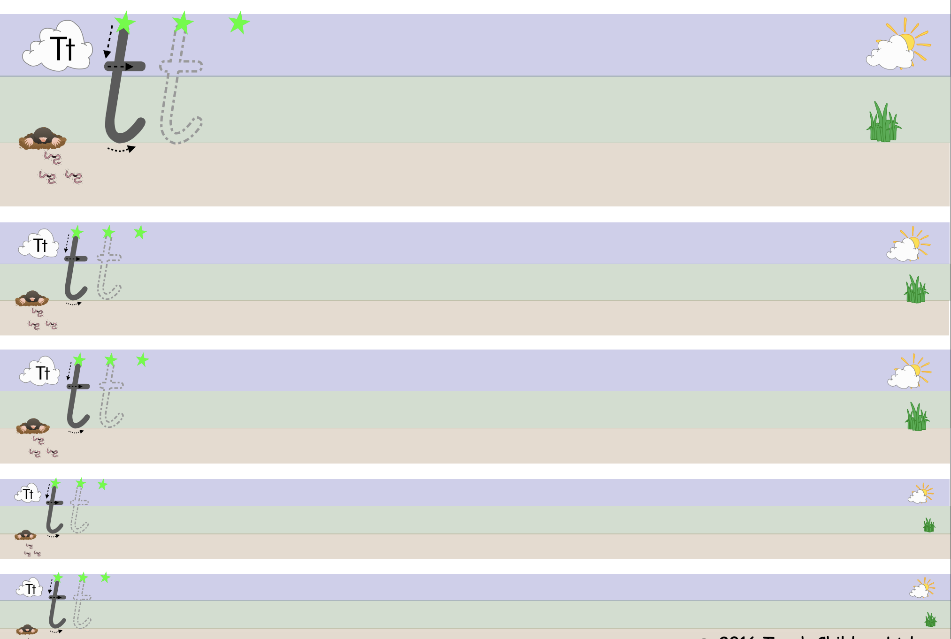

High frequency word to practice- the, this, that, they
Thursday 7th May 2020
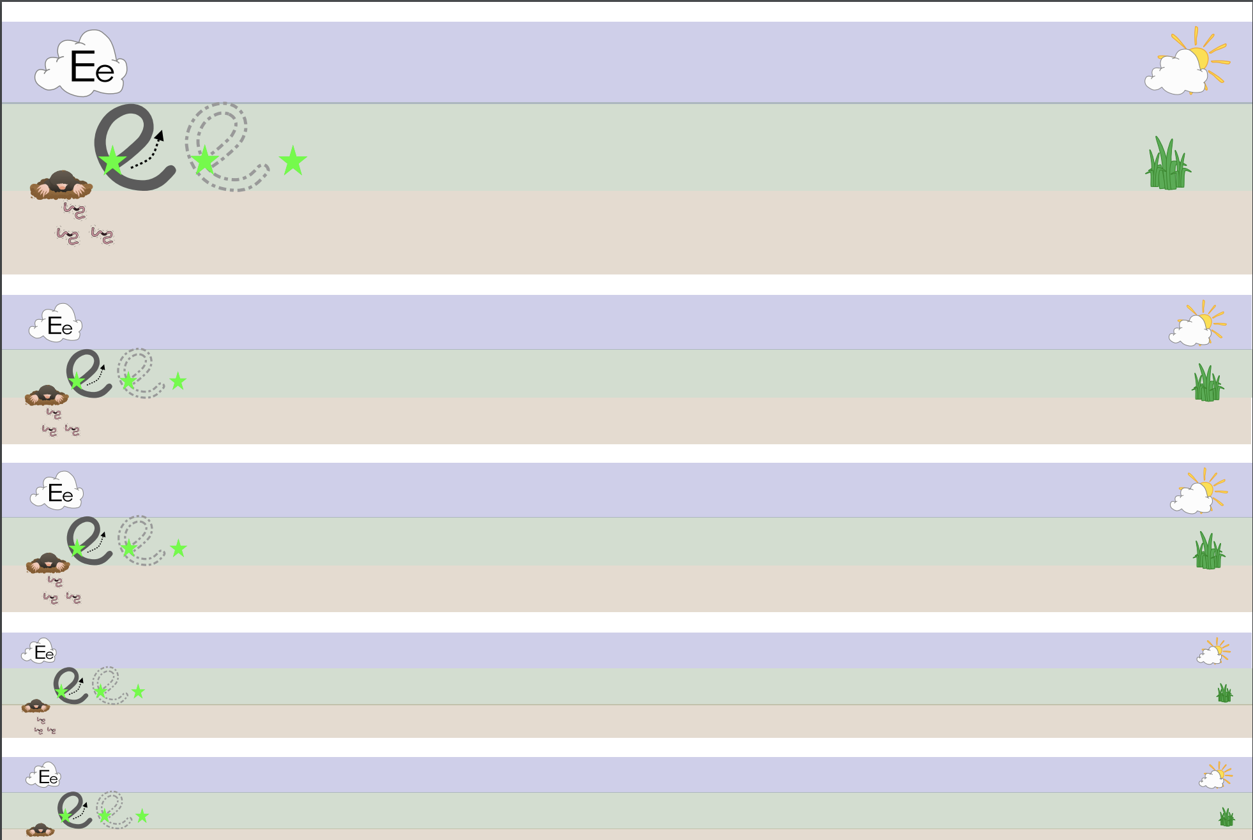

High frequency word to practice- he, see, be, me, we

Friday 8th May 2020

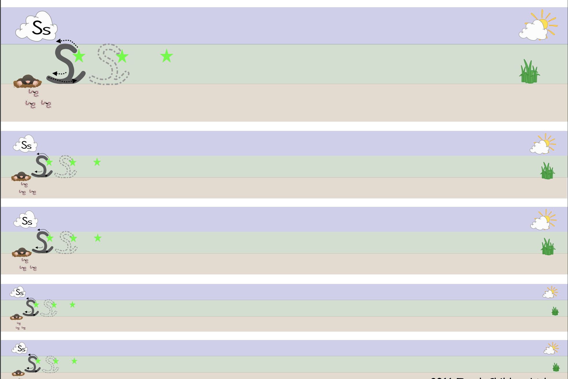

High frequency word to practice- she, so, some, see

