**Week 11- Monday 1st June 2020**

**Year 3 & 4**

**6 Times Table**

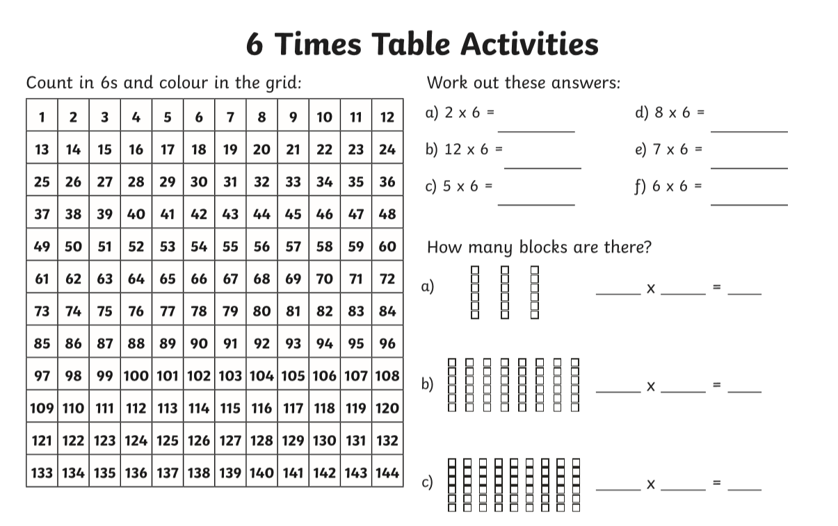

**Year 3 – Challenge**

**66 divide by 6 =**

**42 divide by 6 =**

**30 divide by 6 =**

**36 divide by 6 =**

**Now learn and answer the 12 times table questions!**

**Year 4**

**Year 4 Challenge**

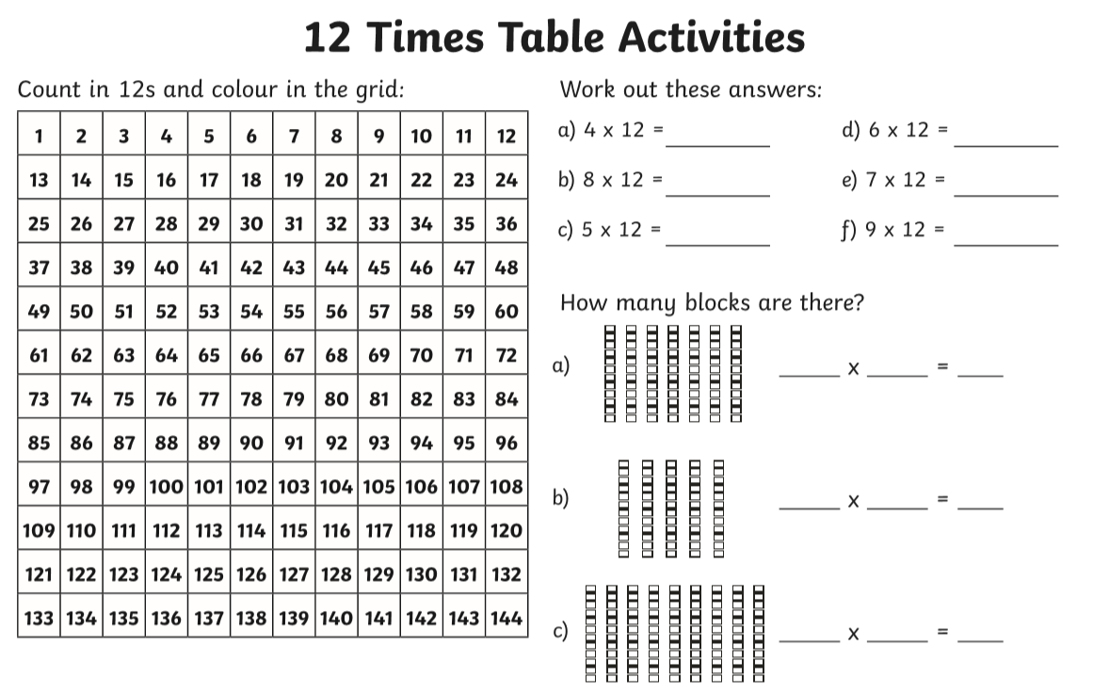

96 divide by 12 =

36 divide by 12 =

84 divide by 12 =

60 divide by 12=

72 divide by 12 =